Project ID: 2021-1-CZ01-KA220-SCH-000034484

COURSE FOR ENVIRONMENTAL EDUCATION
e-Modules: Teaching Learning activities and their technology enhanced material set to develop

DISCLAIMER
Funded by the European Union. Views and opinions expressed are however those of the author(s) only and do not necessarily reflect those of the European Union or the European Education and Culture Executive Agency (EACEA). Neither the European Union nor EACEA can be held responsible for them.

COURSE AUTHORS
Lubomír Hájek, Petra Garay

COURSE SHARING LICENSE
You are free to:
- Share — copy and redistribute the material in any medium or format for any purpose, even commercially.
- Adapt — remix, transform, and build upon the material for any purpose, even commercially.

MODULE 1 | HUMAN AND NATURE
PART 3 | The positive and negative effects of nature on human being ; The natural and artificial environment
Lesson 2 | The natural and artificial environment – part 1 - Hydrosphere

SUMMARY

1. COURSE TIME, TARGET AND TOPIC 3

2. COURSE OBJECTIVES 3
Competences promoted in this lesson: 3
Lesson objectives: 3

3. LEARNING – TEACHING PROCESSES 3

4. EVALUATION 3

5. DOCUMENTS 4
ENGAGE 4
EXPLORE 5
EXPLAIN 6
EXTEND 7
EVALUATE 8

1. COURSE TIME, TARGET AND TOPIC
- Age of target students: 15+
- Teaching time: 1 hour
- Disciplines: Biology, Geography, Human sciences
- Title: Hydrosphere

2. COURSE OBJECTIVES

Competences promoted in this lesson:
- Communication in foreign languages competency
- Digital competency
- Mathematical competency
- Learning to learn competency
- Cultural awareness

Lesson objectives:
- The students learn about irrigation, its rules, and possibilities.
- The students explore the natural and artificial state of rivers and its impact on the environment.
- They apply the knowledge in practical activities.

3. LEARNING – TEACHING PROCESSES
There are 4 activities in this lesson:
Hydrosphere:
- ENGAGE: irrigation
- EXPLAIN: discuss the terminology – dams, meanders, ponds
- EXPLORE: straightening of rivers
- EXTEND: advantages and disadvantages

4. EVALUATION
Hydrosphere – revision of the terminology, true/false sentences, matching

5. DOCUMENTS

ENGAGE
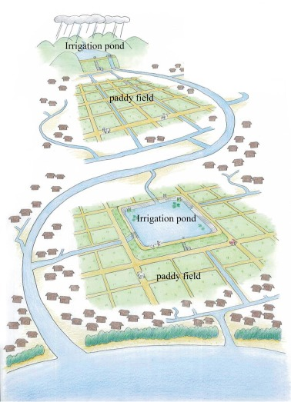
Q: Discuss the significance and benefits of irrigation

IRRIGATION
- is the agricultural process of applying?
- controlled amounts of water to land

Possible answers:
What is good about irrigation?
- helps grow agricultural crops
- maintains the landscape
- protects from frost
- suppresses weed growth in cereal
- prevents soil consolidation
- wastewater disposal and extraction

EXPLAIN
Q: Study and discuss the following topics – dams, ponds, meanders

DAMS
- The dam = barrier that stops or restrict the flow of surface water or underground streams
- reservoirs created by dams – suppress floods, provide water for activities such as irrigation, human consumption, industrial use, aquaculture, and navigability.
- hydropower – often used in conjunction with dams to generate electricity.
- dam can also be used to collect or store water which can be evenly distributed between locations
- dams generally serve the primary purpose of retaining water.
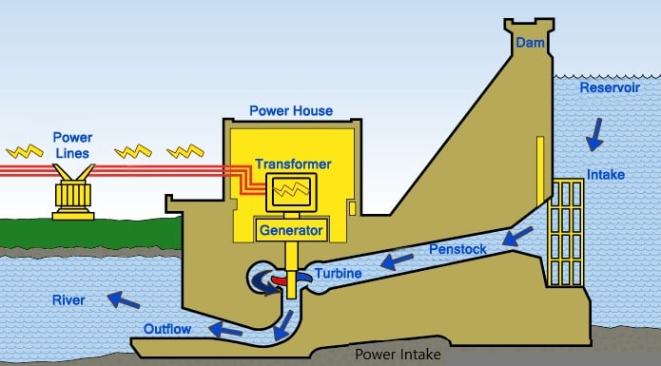

Advantages:  - prevent flooding  - prevent water from wastage  - irrigation  - supply drinking water  - electricity generation  - hydropower | Disadvantages:  - risk of flash flooding  - high price  - problems for aquatic life  - deforestation  - stopped water kills a lot of ecosystems

PONDS
- pond = a man-made discharged water tank designed for the foresight of fish farming
also performs the function of natural water retention in the landscape.
FISH FARMING
- fish farming and fish meat production has been and is a fundamental objective of pond construction.
- further ponds arise from flood, environmental or aesthetic reasons.
- maintenance and cleanability is cost-demanding.
FLOOD PROTECTION
- the size of ponds makes it possible to capture huge amounts of water.
- among the negative effects – erosions of soil layers, deforestation
WATER SUPPLY, MICROCLIMATE
- ponds retain and accumulate flowing surface water, creating a water supply, serving all living organisms.
- also participate in the small water cycle, which has a positive effect on the microclimate.
FISHING SURFACE WATER
- a problem are excessive inflows of nutrients and substances from other areas of human activity -> EUTROPHICATION OF WATER

MEANDERS
- meanders = curves in the channel of a river formed by erosion
THE SIGNIFICANCE OF MEANDERS: improved water quality, more diverse and healthy ecosystems, reductions in flooding and soil erosions

EXPLORE
WHY DO WE STRAIGHTEN RIVERS?
- to reduce the risk of floods
Q: HOW IS STRAIGHTENING OF RIVERS DONE?
- Bends, curves and other obstacles in a rivers path are removed
- by that in some places the river becomes twice as wide and deep as it should

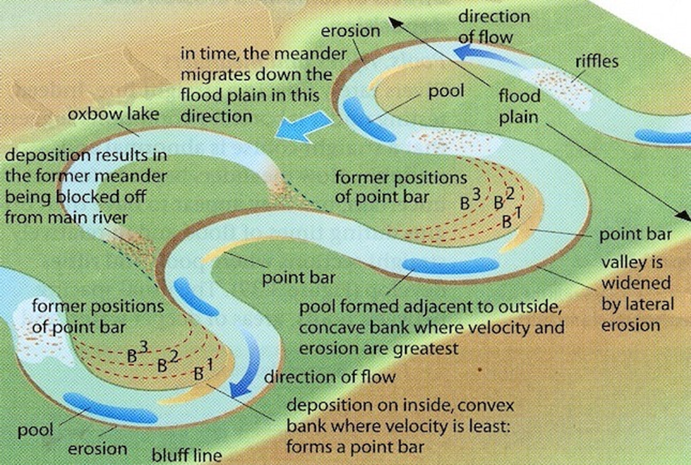
Q: ADVANTAGES AND DISADVANATGES OF STRAIGHTENING OF THE RIVERS
Possible answers:
Advantages:  - risk of floods is reduced  - erosion levels are reduced | Disadvantages:  - increase of erosion by faster flow of water  - increase in risk of flooding further downstream,  - natural from of water flow will cause meanders in the future once again.

EXTEND
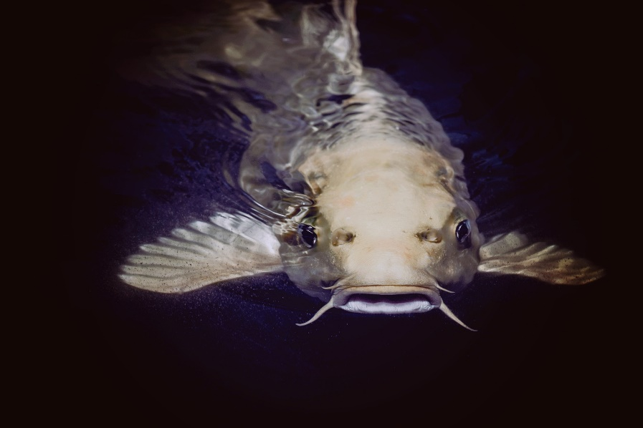
picture: pixabay.com

Q: Watch the video about rainwater harvesting, discuss the information and the statements below:
https://www.youtube.com/watch?v=7GuCoz-aak0
FISH FARMING
- fish farming and fish meat production has been and is a fundamental objective of pond construction.
- further ponds arise from flood, environmental or aesthetic reasons.
- maintenance and cleanability is cost-demanding

EVALUATE
Task 1: What are the main causes of meandering?
Task 2: match the term and the definition
1.Meander | The part of river made while meandering that separates after time.
2.Irrigation | Curve in the channel of a river formed by erosion
3.Dam | Barrier that stops the flow of surface water
4.Flood plains | Process of applying amounts of water
5.Oxbow lake | Area where it is prohibited to live due to frequent floods

Task 3:
True or False?

1. Stopped water helps many ecosystems
2. Ponds make it possible to capture huge amounts of water
3. Dams provide humidity to the atmosphere
4. When rivers are straightened the risk of floods increased

ANSWERS – true or false
1. FALSE
The bacteria in the water actually produce large amounts of Carbon dioxide and Methane gas
2. TRUE
3. TRUE
4. FALSE
Water flows faster in straight rivers so when we straighten them, the risk of floods is decreased.

Sources:
- https://www.structuralguide.com/types-of-dam/
- https://www.ausableriver.org/blog/why-do-streams-meander
- https://www.sciencedirect.com/science/article/abs/pii/S1570644317303994
- https://store.starfall.com/product/pond-ecosystem-poster
- https://www.rybarstvi-litomysl.cz/vyznam-a-funkce-rybniku/
- https://www.internetgeography.net/topics/hard-engineering-river-management/

