Project ID: 2021-1-CZ01-KA220-SCH-000034484


COURSE FOR ENVIRONMENTAL EDUCATION
e-Modules: Teaching Learning activities and their technology enhanced material set to develop

DISCLAIMER
Funded by the European Union. Views and opinions expressed are however those of the author(s) only and do not necessarily reflect those of the European Union or the European Education and Culture Executive Agency (EACEA). Neither the European Union nor EACEA can be held responsible for them.

COURSE AUTHORS
Céline CORNEILLE, Paul FERNANDEZ, Frédéric GUILLERAY, Marine ROBINI and Ervan ROUSSEL.

COURSE SHARING LICENSE
You are free to:
- Share — copy and redistribute the material in any medium or format for any purpose, even commercially.
- Adapt — remix, transform, and build upon the material for any purpose, even commercially.

MODULE 4 | THE IMPACTS OF THE ENVIRONMENTAL PROBLEMS AND CLIMATE CHANGE (part 2 – Climatic and environmental challenges)
PART 1 | Economic consequences
Lesson | Economic consequences of global warming and climate change

SUMMARY

1. COURSE TIME, TARGET AND TOPIC 3

2. COURSE OBJECTIVES 3
Competences promoted in this lesson: 3
Lesson objectives: 3

3. LEARNING – TEACHING PROCESSES 3

4. EVALUATION 3

5. DOCUMENTS 4
ENGAGE 4
EXPLORE 8
EXPLAIN 11
EXTEND 17
EVALUATE 18

1. COURSE TIME, TARGET AND TOPIC
- Age of target students: 15+
- Teaching time: 1-2 hours
- Disciplines: Biology
- Title: Economic consequences of global warming and climate change

2. COURSE OBJECTIVES

Competences promoted in this lesson:
- Communication in foreign languages competency
- Digital competency
- Learning to learn competency
- Social and citizenship-related competencies

Lesson objectives:
- Students explain the economic consequences of climate change and environmental problems.
- Students infer and make connections with disruptions to agriculture, and increased healthcare costs and energy demand as well as infrastructure costs.

3. LEARNING – TEACHING PROCESSES
There are 4 activities in this lesson:
- ENGAGE: Dominoes of climate change (use dominoes to work on cause-effect)
- EXPLORE: Awareness-raising by the Climate action (make a poster from a text)
- EXPLAIN: Find a way in the puzzle (write explanatory sentences with a mindmap)
- EXTEND: Can you reach net zero by 2050? (play a game)

4. EVALUATION
The evaluation is described in the last part of document.

5. DOCUMENTS

ENGAGE
Dominoes of climate change

Q1. You have 8 dominoes to assemble according to the model below.


The first domino is marked with a green circle.
To choose the right dominoes, you need to match a cause and an effect.
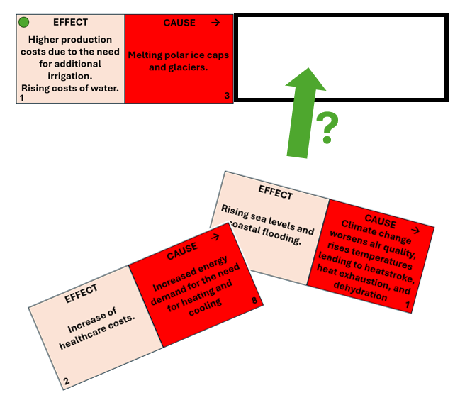

Q2. At the end, when the figure is complete, add up the numbers on the edges of two dominoes. The sum gives a number which must be transformed into a letter (A=1, B=2, C=3, etc.).
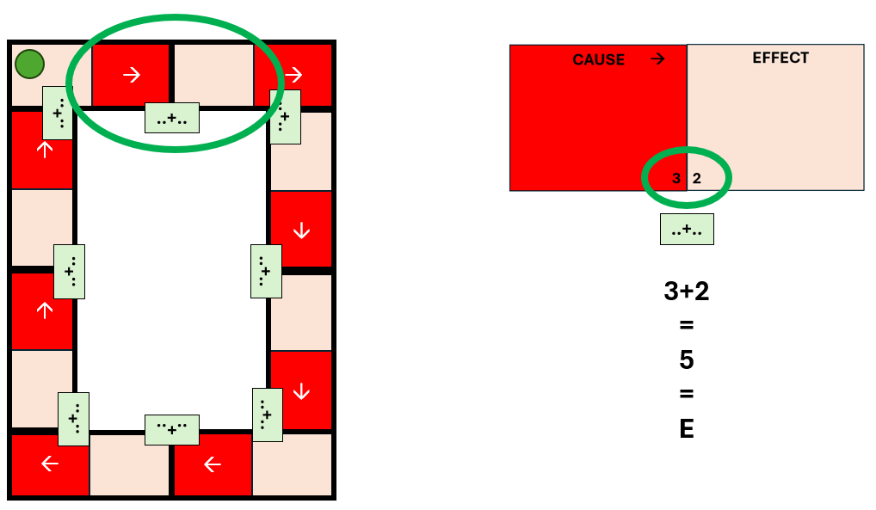

Finally, in order from the green circle, simply read the letters to obtain a word.
Result : the word is ECONOMIC

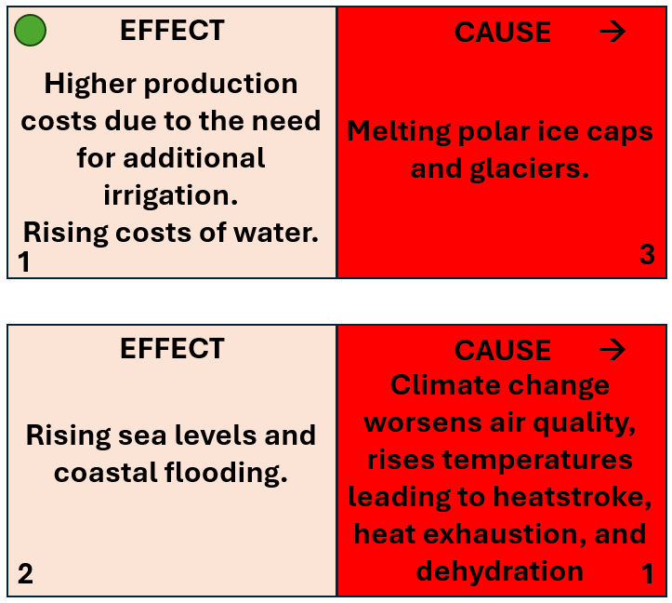

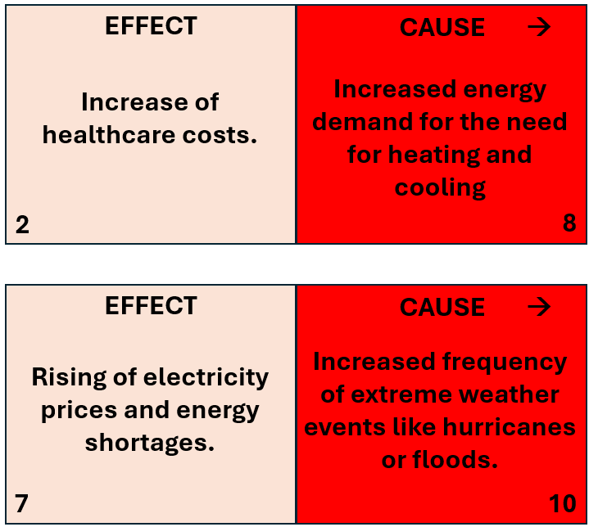

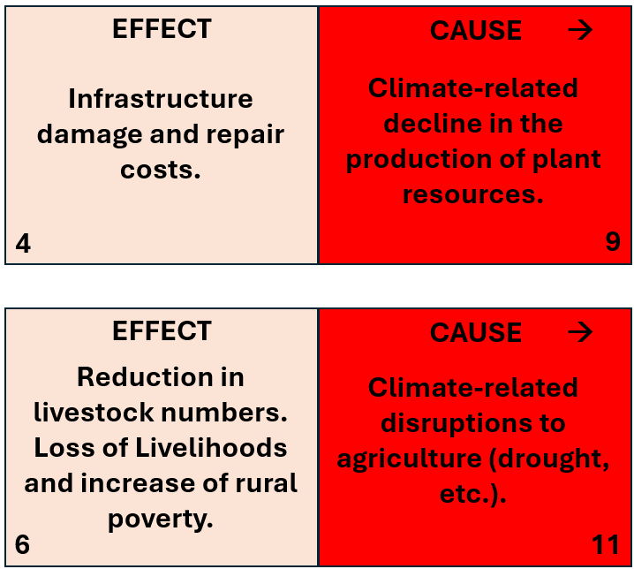

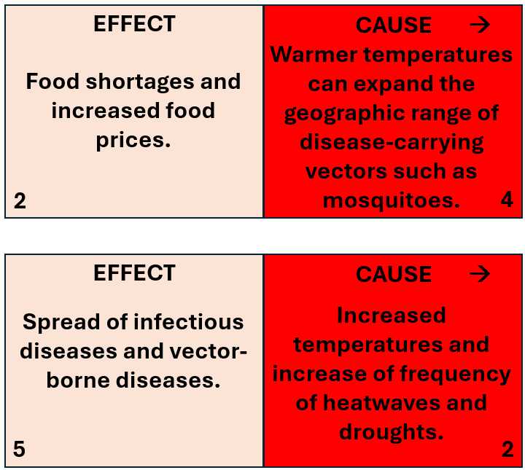

EXPLORE
Awareness-raising by the Climate action

Climate action
This department leads the European Commission's efforts to fight climate change at EU and international level.

Causes of climate change
Burning fossil fuels, cutting down forests and farming livestock are increasingly influencing the climate and the earth’s temperature.

Consequences of climate change
Climate change is a very serious threat, and its consequences impact many different aspects of our lives. Read our overview of climate change’s main consequences.

Q. Divide students into 4 groups. Give each group one of the following 4 texts (next page), written by Climate Change.
They have 20 minutes to transform this text into a poster on A3 paper.
At the end, fix the posters on the walls.
Source of documents: https://climate.ec.europa.eu/climate-change/consequences-climate-change_en

Document 1: consequences on health
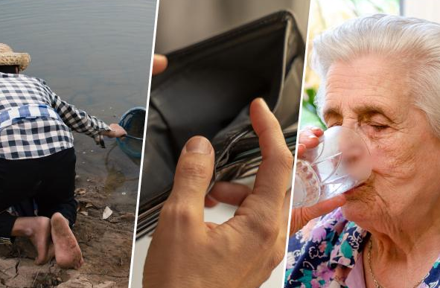
Climate change is a significant threat not only to human health but also to animal and plant health. While a changing climate might not create many new or unknown health threats, existing effects will be exacerbated and more pronounced than currently seen.
The most important health effects from future climate change are projected to include:
- Increases in summer heat-related mortality (deaths) and morbidity (illness);
- Decreases in winter cold-related mortality (deaths) and morbidity (illness);
- Increases in the risk of accidents and impacts on wider well-being from extreme weather events (floods, fires and storms);
- Changes in the impact of diseases e.g. from vector-, rodent-, water- or food-borne disease;
- Changes in the seasonal distribution of some allergenic pollen species, range of virus, pest and disease distribution;
- Emerging and re-emerging animal diseases increasing challenges to European animal and human health by viral zoonotic diseases and vector-borne diseases;
- Emerging and re-emerging plant pests (insect, pathogens and other pests) and diseases affecting forest and crop systems;
- Risks in relation to change in air quality and ozone.

Document 2: consequences for infrastructure and buildings
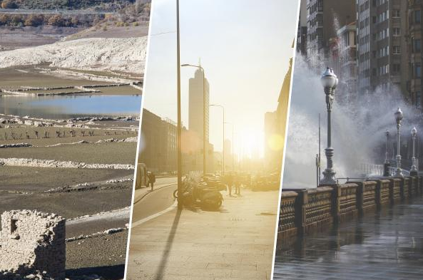
The impacts of climate change are particularly pertinent to infrastructure and buildings given their long lifespan and their high initial cost, as well as their essential role in the functioning of our societies and economies.
Buildings and infrastructure can be vulnerable to climate change because of their design (low resistance to storms) or location (e.g. in flood-prone areas, landslides, avalanches). Indeed they can be damaged or rendered unfit for use by any changing climatic condition or extreme weather event: rising sea level, extreme precipitation and floods, occurrences of extreme low or high temperatures, heavy snowfalls, strong winds…
Consequences of climate change for buildings and infrastructure will differ from region to region.

Document 3: consequences for energy
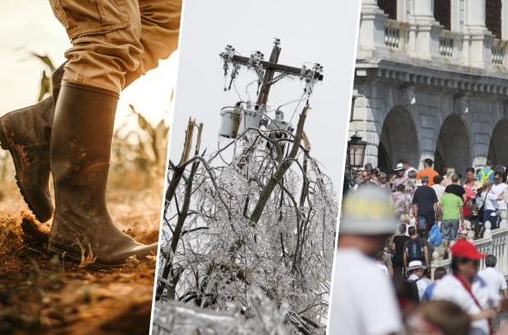
Climate threats for the European energy system already exist and are projected to increase. Climate change is expected to reduce demand for heating in northern and north-western Europe and to strongly increase energy demand for cooling in southern Europe, which may further exacerbate peaks in electricity demand in the summer.
More intense and frequent heatwaves will shift energy supply and demand patterns, often in opposite directions. Further increases in temperature and droughts may limit the availability of cooling water for thermal power generation in summer (lowering energy supply), whereas demand for air conditioning will increase.
Moreover, greater magnitude and frequency of extreme weather events will cause threats for physical energy infrastructure: overhead transmission and distribution, but also substations or transformers.
Climate change also brings increased uncertainty in weather patterns across Europe. This has a direct negative impact in the long term on the production of renewable energy. Some immediate examples would be less sun or wind in areas where there is usually more or heat and droughts affecting the crops intended for the production of energy from biomass.

Document 4: consequences for agriculture
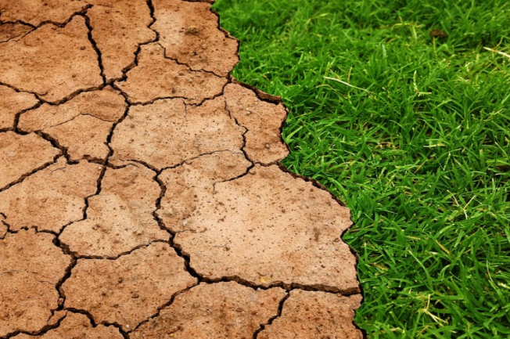
Climate change already has and will continue to have a significant negative impact on European agriculture throughout the 21st century due to increased heat, drought, floods, pests, diseases and the decreasing health of soils:
  - Substantial losses in agricultural production (lower crop yields)
  - Reduction in suitable areas for crop cultivation
Southern regions of Europe will be hit the hardest due to heat and water shortage. While in the North of Europe higher temperatures may open up new areas for warm-season crops, these gains won’t offset the losses in other regions.

EXPLAIN
Find a way in the puzzle

Q. Divide students into groups.
Provide the link to the mind map on the economic impact of climate change to each group.
Each group must then write explanatory sentences following a path from the center of the map to one end. A sentence must be written on an A4 sheet in landscape format.
Students must write at least 5 sentences per group, which they choose together.
At the end, each group must hang its sentences on the wall around the posters from the previous activity that correspond to their sentence.

Link to the mindmap

Source of the mindmap: https://www.mindomo.com/fr/mindmap/the-global-economic-impact-of-climate-change-8bbde81deffc448397920aa2347be3d7

EXTEND
Can you reach net zero by 2050?

Q. Play a game to see if you can save the planet from the worst effects of climate change.
https://ig.ft.com/climate-game/

Your goal
You need to keep global warming to 1.5C by cutting energy-related carbon dioxide emissions to net zero by 2050. In 2021, they reached a record 36bn tons a year. You must also deal with other greenhouse gases, and protect people and nature, for the planet to remain habitable.
This game is based on published scientific research and bespoke modelling by the International Energy Agency for the FT.

EVALUATE

Q1. Give students 5-10 minutes to walk around the posters with the explanatory sentences around them.

Q2. Then ask them to answer the following questions:
- what areas are affected by climate change?
- for each area, list at least one negative consequence and explain it.

