Project ID: 2021-1-CZ01-KA220-SCH-000034484
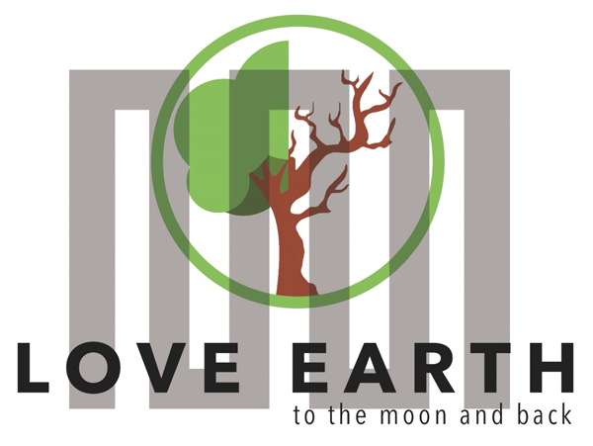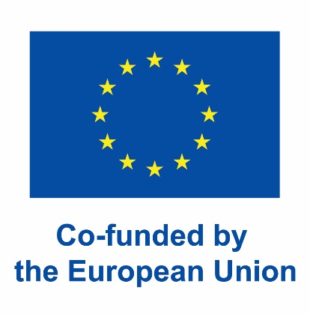

COURSE FOR ENVIRONMENTAL EDUCATION
e-Modules: Teaching Learning activities and their technology
enhanced material set to develop
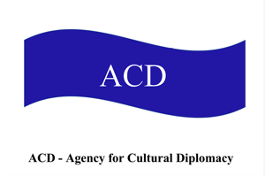

Thematic Units for Week-Long Workshop Sessions:
Inquiry-Based Integrated Learning Workshop Series
on the Intersection of Arts, Science, and Policy

M5: #Waterfootprint, Water Diplomacy, soft power art activism

COURSE AUTHOR:
©Tatjana Christelbauer MA (TC)
ACD Team, Austria

DISCLAIMER
Funded by the European Union. Views and opinions expressed are however those of the author(s) only and do not necessarily reflect those of the European Union or the European Education and Culture Executive Agency (EACEA). Neither the European Union nor EACEA can be held responsible for them.
COURSE SHARING LICENSE CC BY-NC-SA = 
Canonical URL: https://creativecommons.org/licenses/by-nc-nd/4.0/

MODULE:5
LESSON: #Waterfootprint, Water Diplomacy, Soft Power Art Activism
SUBJECTS: Ecology, Cultural Diplomacy, environmental Education, Policy learning, English, Ethics, Arts …

M5 Cultural practices
Workshops & lessons to the topic of Cultural Diplomacy for Sustainable development- CD2030 .. in the practice of CSOs and youth

Water diplomacy, oceans & rivers facts&acts; engaging with arts, WATCH-acts,
Water footprint

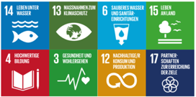

Subjects: Environmental Education, Biology, Political Science, Arts, English, …

Content:
- Introduction to Responsible consumption and Water Diplomacy
  - Water Diplomacy as a form of Cultural Diplomacy for Sustainable Development
  - Why Water protection matters? Facts and Emerging Issues: Global Ocean Facts
Rivers: key statistics and concern
  - Supporting Measures and Initiatives:
    - The Water Footprint
    - Supporting Initiatives: World Water Day, Save the Parrot Fish campaign
1.3.3 WATCH -Initiatives

- Supporting Water Diplomacy, engaging with Arts
  - Hundertwasser's Environmental Posters and the impact of Art in Environmental Protection
- Tasks for engaging: Civil Society Organizations & Youth for Environmental Protection
  - Good practices from ERASMUS+ project LeMOON team, from Austria and from the blind activists and celebrities

4.River Waters Protection lesson part
  - Danube birds and valse
  - Ecological initiative “Unski Smaragdi”
- References and Sources for Further Research

- Introduction to Responsible Consumption and Water Diplomacy
Responsible consumption and sustainable resource management are critical in addressing global challenges related to water diplomacy, environmental conservation, and public health.
Water diplomacy involves cooperative strategies for managing transboundary water resources to prevent conflicts and ensure equitable distribution. This approach not only preserves water ecosystems but also supports the health and wellbeing of communities dependent on these resources. By fostering responsible consumption habits and engaging in environmental guardianship, we can actively contribute to the protection of our rivers, oceans, and biodiversity while promoting global health and sustainable development.

  - Water Diplomacy as a form of Cultural Diplomacy for Sustainable Development
Water diplomacy, the cooperative management of shared water resources, is an essential form of cultural diplomacy that promotes sustainable development. It involves nations and communities working together to ensure equitable distribution, sustainable use, and protection of transboundary water resources. By integrating cultural diplomacy, water diplomacy not only addresses environmental challenges but also fosters mutual understanding and collaboration across cultures.
Cultural diplomacy in water diplomacy encourages the exchange of knowledge, traditions, and practices related to water management. It highlights the cultural significance of water in different societies, promoting respect for diverse approaches to conservation. This intercultural dialogue can lead to innovative and inclusive solutions that are sensitive to the needs and values of all stakeholders. Moreover, water diplomacy as a form of cultural diplomacy emphasizes the role of education and public awareness in achieving sustainable development goals (SDGs). It mobilizes civil society organizations (CSOs) and youth to participate in water conservation efforts, leveraging cultural events, art, and storytelling to engage and inspire communities.
Through collaborative projects and partnerships, water diplomacy can build resilient and sustainable communities, ensuring that clean and safe water remains accessible for future generations.
In essence, water diplomacy as a form of cultural diplomacy not only addresses the technical aspects of water management but also strengthens the social and cultural bonds that are crucial for long-term sustainability and peace.

  - Why water protection matters? Facts & emerging issues
Here are some facts about current emerging issues:
Global Ocean Facts:
Coverage: Oceans cover more than 70% of the Earth’s surface.
Biodiversity: They are home to over 200,000 identified species, with potentially millions more yet to be discovered.
Oxygen Production: Oceans produce over half of the world’s oxygen and absorb 50 times more carbon dioxide than our atmosphere.
Economic Value: The global ocean-based economy is valued at around $1.5 trillion annually.
Issues Affecting Oceans:
°Pollution: Around 8 million tons of plastic enter the oceans each year, causing harm to marine life and ecosystems.
°Overfishing: Nearly 90% of the world’s fish stocks are fully exploited, overexploited, or depleted.
°Climate Change: Rising ocean temperatures and acidification due to increased CO2 levels threaten coral reefs and marine life.

Rivers: Key Statistics and Concerns
European Rivers:
Length and Flow: The Danube River, Europe’s second-longest river, flows through 10 countries and provides water to millions of people.
Pollution Levels: Many European rivers, like the Seine and the Thames, have seen improvements in water quality due to stringent regulations, but pollution remains a concern in many areas.
Ecosystem Services: Rivers provide crucial ecosystem services, including water for drinking, agriculture, and industry, as well as habitats for countless species.
Global River Facts:
Freshwater Supply: Rivers provide about 60% of the world’s fresh water.
Biodiversity: Rivers and freshwater ecosystems host around 10% of all known species, despite covering less than 1% of the Earth’s surface.
Human Dependency: Approximately 2 billion people globally depend directly on rivers for their drinking water.
Issues Affecting Rivers:
°Pollution: Industrial discharge, agricultural runoff, and untreated sewage contaminate many rivers worldwide.
°Dams and Water Diversion: Over 50,000 large dams have altered river flows, impacting ecosystems and human communities.
°Climate Change: Altered precipitation patterns and increased evaporation rates due to global warming affect river flows and water availability.

Why Protecting Oceans and Rivers Matters
Health and Wellbeing:
°Clean Water: Access to clean water is essential for drinking, sanitation, and hygiene. Contaminated water sources can lead to diseases such as cholera and dysentery.
°Food Security: Oceans and rivers are critical sources of food. They provide fish and other seafood that are vital for nutrition and livelihoods.
Economic Impact:
°Jobs and Livelihoods: Many industries, including fishing, tourism, and transportation, depend on healthy oceans and rivers.
°Recreation and Tourism: Rivers and oceans support recreational activities and tourism, which are significant sources of income for many communities.
Environmental Sustainability:
°Biodiversity Conservation: Protecting aquatic ecosystems ensures the survival of diverse species and the health of the planet.
°Climate Regulation: Oceans play a key role in regulating the Earth’s climate by absorbing CO2 and heat. The Sustainable Development Goal (SDG) 14, “Life Below Water,” focuses on conserving and sustainably using the oceans, seas, and marine resources. It addresses various challenges facing marine ecosystems, including pollution, overfishing, habitat destruction, and climate change. Additionally, SDG 14 aims to promote sustainable marine resource management, protect marine biodiversity, and ensure the health and resilience of ocean ecosystems for present and future generations.

  - Supporting Measures and Initiatives:
    - The Water Footprint

In 2002, Arjen Hoekstra, created the water footprint as a metric to measure the amount of water consumed and polluted to produce goods and services along their full supply chain. The Water Footprint Organization defines the Water Footprint a ss a measure of humanity’s appropriation of fresh water in volumes of water consumed and/or polluted.
The water footprint concept offers detailed insights for adequate and equitable water resource management. It advocates for a balanced and sustainable water-use approach, aiming to tackle global challenges.
A water footprint measures the amount of water used to produce each of the goods and services we use, from the food we eat to the clothes we wear. It includes direct water use, such as drinking and bathing, as well as indirect use, such as the water required to grow crops and manufacture products. Understanding our water footprint is crucial for managing water resources sustainably, especially as global water demand increases and climate change affects water availability. By being aware of our water footprint, we can make more informed choices that reduce our impact on freshwater resources. Efforts to reduce water footprints can lead to significant conservation of water and contribute to more sustainable consumption patterns.

EUROPEs Water Footprint:
The average EU citizen’s daily energy consumption requires 1,301 litres of water, according to JRC scientists – enough to fill more than 6 large bathtubs.

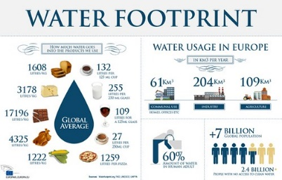
https://www.flickr.com/photos/european_parliament/8558534231

Calculate your Water Footprint to find out what in your daily life most affects your water footprint, then, take possible steps to reduce your water footprint or support activities that help others make water use more sustainable
https://www.waterfootprint.org/resources/interactive-tools/personal-water-footprint-calculator/

According to Water Footprint Organisation, ´making just a few changes can significantly reduce your water footprint, such as for example, the water footprint of 200 grammes of beef is the equivalent to 47 eight-minute showers and uses four times more water than the same amount of chicken meat. If a couple were to eat chicken instead of beef, they would reduce their water footprint by as much as 450 000 litres over a year.´

    - Supporting Initiatives:
World WaterDay is an annual United Nations observance day held on the 22nd of March that highlights the importance of fresh water. The day is used to advocate for the sustainable management of freshwater resources. Visit the UN Webpage, found out more about the World water Day and how you can engage. https://www.unwater.org/our-work/world-water-day

European Union Initiatives for promoting sustainable water management and conservation
The European Union (EU) has been at the forefront of promoting sustainable water management and conservation efforts:
Water Framework Directive (WFD): The WFD is a key piece of EU legislation aimed at protecting and enhancing the quality of water resources across Europe. It promotes sustainable water use and the reduction of water pollution. https://environment.ec.europa.eu/topics/water/water-framework-directive_en
Marine Strategy Framework Directive (MSFD): The MSFD aims to achieve Good Environmental Status (GES) of the EU’s marine waters and to protect the resource base upon which marine-related economic and social activities depend. https://research-and-innovation.ec.europa.eu/research-area/environment/oceans-and-seas/eu-marine-strategy-framework-directive_en
LIFE Program: The LIFE Program is the EU’s funding instrument for environmental and climate action. It supports projects that contribute to the implementation, updating, and development of EU environmental and climate policy and legislation. https://cinea.ec.europa.eu/programmes/life_en
European Environment Agency. Sustainable Water Management: European policies on water https://www.eea.europa.eu/themes/water/european-waters/water-management

Save the Parrotfish Campaign
Plastic pollution poses another significant threat to marine ecosystems, including coral reefs and the species that inhabit them. Millions of tons of plastic waste enter the oceans each year, contaminating waterways, entangling marine life, and disrupting marine ecosystems. Plastic debris can be ingested by fish and other marine animals, leading to internal injuries, starvation, and death.
Parrotfish are a prime example of a species affected by human activities and environmental changes. These colorful reef inhabitants play a crucial role in maintaining coral reef health by grazing on algae, which helps prevent coral smothering and promotes reef growth. However, parrotfish populations are threatened by overfishing, habitat degradation, and coral reef destruction.

Read more about parrotfish and it importance for oceans and the clean water here, sign the petition here if you would like to support its protection:
https://www.ipetitions.com/petition/save-the-parrotfish-save-our-islands
Watch the video on YouTube, listen to the song dedicated to “Parrotfish”.
https://youtu.be/ss46jfDiVCw?si=zmmlaw-m8AGlzeNp
https://www.youtube.com/watch?v=lVMV3StvLCs
Nature Is Speaking – Ian Somerhalder is Coral Reef | Conservation International (CI) Conservation International

How is youth engaged in European and global initiatives dedicated to promotion of sustainable water management and conservation?

Engage: connect with European Youth portals and engage in activities:
https://www.youthforum.org/news/open-letter-legislation-on-sustainable-resource-management
https://youth.europa.eu/solidarity/placement/39908_en

Get inspired by activities taken, connect and get supported for your initiative, publish, and share your activities on the relevant platforms, make your contribution visible and scalable for further implementations and dissemination of good practices. Use social media tools and platforms for good practices, invest your time in meaningful activities.

    - WATCH-initiatives: Connect&Act

River Watch Programs:
https://riverwatch.eu/

Field Trips: Organize trips to local rivers for water testing and biodiversity surveys. Use tactile models and audio guides to make the experience accessible for visually impaired students.
Data Collection: Train students in using accessible tools and apps to record and analyze data on river health.

Ocean Conservation Activities:
Whale Watching: Arrange virtual whale watching experiences or use 3D audio recordings to help visually impaired students experience marine life.
Campaigns: Involve students in local and global campaigns by creating educational materials and social media content.

Health and Wellbeing Projects:
Water Quality Testing: Set up school-based labs where students can test local water samples and learn about the impact of pollutants on health.
Healthy Living Workshops: Conduct workshops on the importance of clean water and a healthy environment for overall wellbeing.
Collaborative Projects: Partner with local environmental organizations to offer internships and volunteer opportunities for students.
Guest Speakers: Invite experts in water management, marine biology, and public health, policy makers and engaged artists to speak at schools and engage with students.

- Supporting Water Diplomacy, engaging with arts:
Hundertwasser's Environmental Posters and the impact of Art in Environmental Protection

Art can be a powerful tool for raising awareness about environmental issues. Posters, murals, and installations can convey messages about the importance of water conservation and responsible consumption in visually impactful ways.
Art can serve as a catalyst for advocacy, encouraging public and political support for water diplomacy initiatives. Art exhibitions, public displays, and social media campaigns can highlight the urgency of water-related issues and inspire action. By integrating art into environmental education and activism, we can foster a deeper connection to nature and inspire collective action to protect our planet's precious water resources.

Hundertwasser´s Environmental art and activism in the Austrian region
surrounding the Danube river and internationally

- National park Donau-Auen Stamp
Friedensreich Hundertwasser was actively involved as an artist in environmental protection around the Danube. One famous work in this context is the Nationalpark Donau-Auen stamp. The stamp was issued on the 20th anniversary of the disputes over the Hainburg power plant in the Stopfenreuth floodplain. It features the design of the poster that Hundertwasser created in 1984 for the campaign to protect the Danube wetlands in the east of Vienna, against the deforestation of floodplain areas for the construction of a power plant.

808 G NATIONALPARK DONAUAUEN Stamp
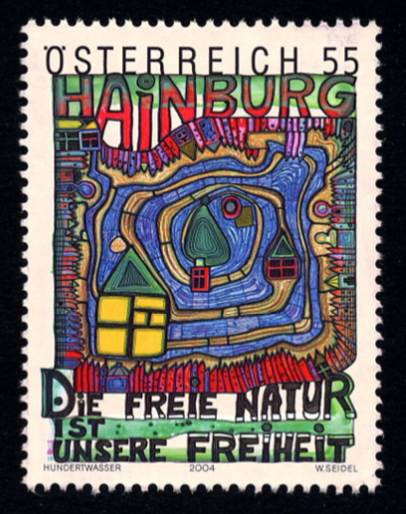

Source: https://hundertwasser.com/angewandte-kunst/808_g_apa175i_nationalpark-donauauen_2025

- Another significant work by Hundertwasser is the environmental poster from 1984 titled Naturfreikauf (Nature Buy-Back) featuring the Nature Donation Certificate, which he created for the campaign to prevent the clearing of forests for the construction of a power plant and to save the floodplain landscape near Hainburg, east of Vienna.

In 1990, with the label/wine label Sparkling Water, Hundertwasser supported an initiative by Bernd Lötsch, President of the National Park Planning for the Danube Wetlands, and Hubert Weinzierl, President of the BUND (German Federation for the Environment and Nature Conservation). Through his artwork, Hundertwasser helped finance the purchase of about five square meters of wetland in the planned Danube route area, thus enabling the Nature Buy-Back action to save the Danube wetlands between Straubing and Vilshofen, Bavaria. The goal of this initiative was to purchase unique biotope islands and eco-cells along the Danube as the first building blocks for a national park in Lower Austria, thereby preventing the construction of a hydroelectric power plant and saving the last natural river courses in Germany.

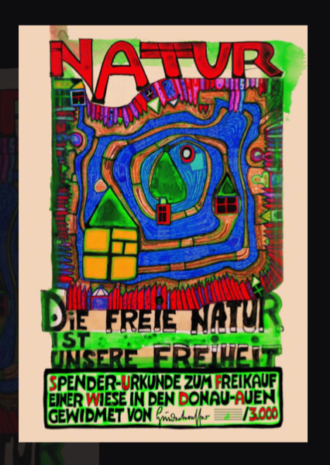

Source: https://hundertwasser.com/oekologie/808_e_apa178_natur_-_die_freie_natur_ist_unsere_freiheit_1804

Hundertwasser also persuaded the mineral water bottler Vöslauer GmbH to make a substantial donation to this initiative and, in gratitude, designed the Sparkling Water label. The mineral water bottle with the Hundertwasser label was so successful that it remained on the market for more than ten years. Starting in 1993, Hundertwasser donated his royalties to the Austrian WWF (World Wide Fund for Nature).
The Vöslauer spring was already known to the Romans and was documented in the year 50 AD as a healing spring. In the Middle Ages, it was mentioned in documents from 1136 as the Feselover Spring. This original spring now flows into the thermal baths of Bad Vöslau, with water for the baths coming from the same source.
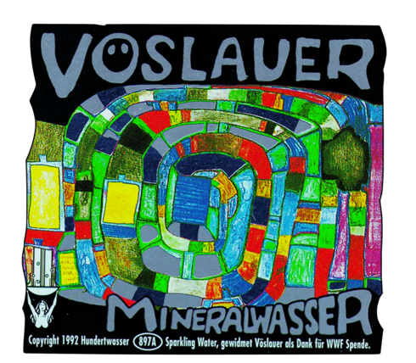

Details: https://hundertwasser.com/angewandte-kunst/897_a_apa272_sparkling_water_1882

- In 1982, on the occasion of his exhibition in San Francisco, Austrian artist Friedensreich Hundertwasser handed over the original posters he donated, "Save the Whales" to Greenpeace Pacific Southwest and "Save the Seas" to the Jacques Cousteau Society (Cousteau Society, Norfolk). The handover of Hundertwasser's environmental posters took place on December 11, 1982, at the West Plaza, Ghirardelli Square, in the presence of Leonard Post, President of Greenpeace Pacific Southwest, and Jean-Michel Cousteau, Vice President of the Cousteau Society. All proceeds from the sale of the posters went to environmental organizations. On the occasion of the handover, the HUNDERTWASSER WEEK was proclaimed in San Francisco from December 5 to 11, 1982, by Dianne Feinstein, Mayor of the City of San Francisco.

Hundertwasser's art can inspire and mobilize communities to engage in environmental activism across sectors, countries, and matters…
Upon invitation from the Austrian Federal Ministry for Environment, Youth, and Family under Federal Minister Dr. Marilies Flemming, Hundertwasser voluntarily designed the Austrian Ecolabel in 1990. He was also invited for support by other environmental organizations such as Greenpeace, the United Nations Environment Programme, and the Federation for Environment and Nature Conservation in Germany.

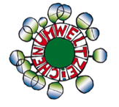
https://www.umweltzeichen.at/en/home/start

3. Tasks for engaging: Civil Society Organizations & Youth for Environmental Protection

Guiding intro
Civil Society Organisation (CSOs) and youth can leverage art and education to support water diplomacy and environmental protection.
Here are some ideas for actions led by Civil Society Organizations (CSOs) and Youth:
°Art Contests and Exhibitions: Organize art contests and exhibitions on themes related to water conservation and marine life. These events can showcase the creativity of young people and raise
°Public Awareness Campaigns: Use art to create compelling visuals for public awareness campaigns. Posters, social media graphics, and videos can communicate important messages about responsible consumption and water protection. Sign the petitions, create petitions for raising awareness about urgent concerns you find important to be communicated and the relevant actions must be taken.
°Workshops and Seminars: Conduct workshops and seminars that combine art with environmental education. These sessions can teach students about the importance of water resources while engaging them in creative activities.
°Collaborative Projects: Partner with local artists, environmental organizations, and schools to create community art projects that highlight water diplomacy and conservation efforts.

Supporting local, national but also global initiatives, we may reach more engaged supporters and achieve better results.

3.1. Good practices from ERASMUS+ project LeMOON team, from Austria and from the blind activists and celebrities

    - Here is an example of taking action together by ERASMUS+project LeMOON-team meeting in Iceland, while signing the petition "End Whaling in Iceland" launched by Change.org

Before that, the project team participated in the "Whale Watching" tour. Such tours are organized in the tourism industry as a "Responsible Whale Watching" measure to protect whales from increasing overfishing through encounters with these species. After all, whales are known climate protectors. Their bodies serve as massive CO2 storage units. A single whale can store approximately as much CO2 as 30,000 trees combined!
The collective action by signing the petition in a local initiative with a global impact strengthened the cohesion of the project team with one more experience of shared responsibility for improving relational cultures between humans and nature.
More about the "End Whaling in Iceland" campaign can be learned by following the web link, signing the petition, and supporting the campaign.
https://www.change.org/p/end-whaling-in-iceland-st%C3%B6%C3%B0va-hvalvei%C3%B0ar-%C3%A1-%C3%ADslandi?cs_tk=&utm_campaign=c314e80396db49ac870324b1aa4c01dc&utm_content=initial_v0_1_0&utm_medium=email&utm_source=petition_signer_confirmation_reminder_2&utm_term=cs

3.1.2. In Austria, good practices from Iceland in the field of climate protection measures have already been adopted. Based on Iceland’s strategic plan Urban Heat (UHI), the program "InKA – Infrastructure Adaptation to Climate Change" was launched in the city of Vienna in 2018.
Through interdisciplinary collaboration, foundations for measures against advancing climate change are being developed. Previously, in 2014, during the session on environment and agriculture, the Austrian National Council called for the protection of whales and dolphins. A resolution request for the government to clearly oppose the hunting of dolphins and whales in international bodies was unanimously adopted by the plenary.

3.1.3. More examples for engaging in: Get inspired
Blind Activists and Advocates
Haben Girma is a deafblind lawyer, advocate, and speaker who has been actively involved in advocating for disability rights and environmental sustainability. She has spoken about the importance of accessibility and inclusion in environmental initiatives, including water protection efforts.
Christy Smith is a blind environmental advocate and educator who has worked on various water conservation projects. She has been involved in raising awareness about water pollution, promoting sustainable water management practices, and advocating for accessible environmental education for individuals with disabilities.

Celebrities Supporting Water Protection:
Stevie Wonder, the legendary musician and singer, has been an outspoken advocate for environmental causes, including water conservation and pollution prevention. He has supported initiatives aimed at protecting water sources, raising awareness about water scarcity, and promoting sustainable water management practices.
Andrea Bocelli, the renowned Italian tenor, has been involved in various philanthropic efforts, including projects focused on environmental conservation. He has lent his voice and support to initiatives aimed at protecting water resources, preserving marine ecosystems, and promoting sustainable development.

These examples demonstrate how blind individuals and celebrities can contribute to water protection efforts through advocacy, education, and support for sustainable practices. By raising awareness and leveraging their platforms, they play a vital role in inspiring action and promoting positive change for the environment and future generations.

4.River Waters Protection lesson part
  - Danube birds and valse
  - Ecological initiative “Unski Smaragdi”

Guiding insights
In this lesson part on water protection, we will explore the importance of safeguarding our precious water resources, with a special focus on the iconic Danube River.
Whether you can see the beauty of its banks or feel its presence through other senses, the Danube River is a vital lifeline that connects communities, cultures, and ecosystems across Europe.

4.1. Danube River
Introduction to the Danube River: The Danube, often referred to as "Europe's River," is the second-longest river in Europe, stretching over 2,850 kilometers (1,770 miles) from its source in the Black Forest of Germany to its delta in the Black Sea. Flowing through ten countries and passing through four capital cities, the Danube connects diverse cultures and landscapes, creating a rich tapestry of biodiversity and heritage.

Water Quality of the Danube River: While the Danube is a vital resource for many, it faces significant challenges in terms of water quality. According to a report by the International Commission for the Protection of the Danube River (ICPDR), pollution from agricultural runoff, industrial discharge, and urban wastewater are among the primary threats to the health of the river. High levels of nutrients, such as phosphorus and nitrogen, contribute to eutrophication, while contaminants like heavy metals and microplastics pose risks to aquatic ecosystems and human health.

Green Technologies for Danube Protection in Austria: Austria, as one of the countries through which the Danube flows, has implemented various green technologies and sustainable practices to protect the river's ecosystem. These include:

Wastewater Treatment Plants: Austria has invested in advanced wastewater treatment plants equipped with state-of-the-art technologies to remove pollutants and improve water quality before it is discharged back into the Danube.
Renewable Energy Production: Hydropower plants along the Danube harness the river's energy to generate clean and renewable electricity, reducing the reliance on fossil fuels and minimizing environmental impacts.
Eco-Friendly Agriculture: Sustainable agricultural practices, such as organic farming and agroforestry, help reduce nutrient runoff and pesticide contamination, thereby mitigating the negative impacts of agriculture on the Danube's water quality.
River Restoration Projects: Austria actively participates in river restoration projects aimed at restoring natural habitats, improving water flow, and enhancing biodiversity along the Danube and its tributaries.

Artistic Inspiration from the Danube: The Danube River has long been a muse for artists, poets, and musicians, inspiring countless works of art that celebrate its beauty and significance. From paintings by the renowned artist Wassily Kandinsky to musical compositions like famous “The Blue Danube Walse”, composed by the Austrian composer J. Strauss II, the Donau river's allure has captivated creative minds throughout history.

Listen Danube Waltz on YouTube, Spotify, or visit some classical concert to get on-site impression: https://www.youtube.com/watch?v=_CTYymbbEL4
Watch the YouTube Video:
https://www.youtube.com/watch?v=cKkDMiGUbUw

Danube Swan Population: The Danube River is home to a diverse array of wildlife, including the elegant swan. Swan populations along the Danube are protected through various conservation efforts aimed at preserving their habitats and ensuring their survival. Measures such as habitat restoration, pollution control, and the establishment of protected areas help safeguard swans and other wildlife species that rely on the river for their livelihood. Additionally, educational initiatives and community engagement play a vital role in raising awareness about the importance of conserving the Danube's natural heritage for future generations.

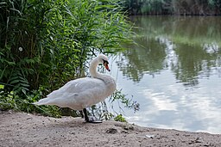
https://commons.wikimedia.org/wiki/File:Donaupark_Wien_2019-07-12_Irissee_10_Schwan.jpg

Are you living in a place along a river? Have you seen swans in your area? How are birds protected in your local community? Engage in research and explore BirdWatch.
Create a project dedicated to bird protection. Connect & act
In the European Union (EU), swans are protected under various laws and initiatives aimed at conserving their habitats and ensuring their well-being. For instance, the EU Birds Directive (Directive 2009/147/EC) mandates the protection of all wild bird species, including swans, by establishing a network of Special Protection Areas (SPAs) and setting conservation measures.
For more information on swan protection and conservation efforts in the EU, you can visit the BirdLife International website (https://www.birdlife.org/europe-and-central-asia/ ) or refer to the European Commission's page on the Birds Directive:
https://environment.ec.europa.eu/topics/nature-and-biodiversity/birds-directive_en

  - Unski Smaragdi
Ecological movement from Bosnia and Hercegovina

(Personal story)
As one of the first-generation pioneers who gratefully joined the launch program of the environmental association Unski Smaragdi, dedicated to actively promoting the protection of the Una River as a source of life, happiness and health, prosperity, and love with educational activities for “Green mindfulness” in the context of formal education in Bihac, BiH, I am sharing this story as an example of good practice which currently needs to be even more supported.
The Unski Smaragdi association was founded on the 17th of Mai in 1985 by the enthusiastic journalist Boško Marjanović whose love and dedication to the river Una and nature inspired him to create an initiative that was even granted by UNESCO with the Global 500! This impressive initiative survived war and destruction in the 1990s and is still active. Boško Marjanović was a dear friend and he personally appointed me in 1998 to act as an Ambassador of the river Una in the Western Europe.
Remembering the starting activities, such as cleaning its shore as a young scholar, but also creating artworks inspired by the river Una, writing poetry and songs about its beauty, I included this experiences in my art practice and profession in education, and it lasts until nowadays...
Also, a unique tradition has been created by Unski Smaragdi: all the newborns were welcomed with a friendship card from Unski Smaragdi, all students become ambassadors of the Una River and were appointed to act responsibly, protect the river and the surrounding nature, to invite friends and guests to visit the Una River and enjoy its unique beauty, mindfully…
According to local legends, the river Una was named by the Romans who, after seeing it for the first time, said "una" (Latin “one”, as a reference to its unique beauty) to describe it. Una is also a popular female name, even in the areas not close to the river. One explanation for this is that people who displaced during the Yugoslav Wars, continued to give this name to their children in a loving memory. The one&only river Una inspires local and international artists, scientists, writers, athletes, children, and adults.
As one of the ambassadors of the Una River, I created a memo card showing some of my works inspired by the Una River, with the origin message:
“Bistar um, bistra Una”!
(in English: “Clear (human) mind, Clear Una river”)

Keep the Europe Blue Heart and the smaragd-green eye as of the river Una!
Balance, reduce, prevent damages by fishery, hydropower, biodiversity, tourism, sports..

Watch river Una on YouTube video:
https://www.youtube.com/watch?si=fZk4g3rgeE1n7tHc&v=0GX9N-p3ePk&feature=youtu.be

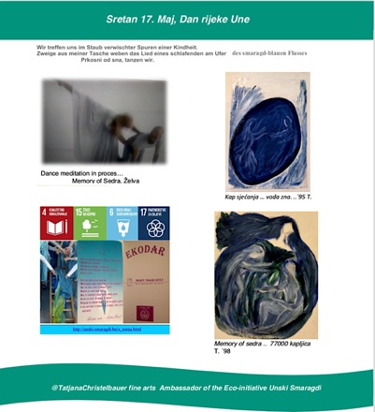

- References and Sources for Further Research:
International Commission for the Protection of the Danube River (ICPDR): https://www.icpdr.org/
European River Watch Network: https://www.rivernet.org/
European Environment Agency (EEA): https://www.eea.europa.eu/
United Nations Environment Programme (UNEP): https://www.unep.org/
"State of the Danube River Basin Report" by the ICPDR: https://www.icpdr.org/main/publications/state-danube-river-basin-report
"Danube Watch Magazine" by the ICPDR: https://www.icpdr.org/main/publications/danube-watch-magazine
Unski Smaragdi ecological movement:
http://unski-smaragdi.ba/
UNESCO Education SDGs
https://www.unesco.at/bildung/unesco-schulen/unterrichtsmaterialien-sdgs
WaterActionDecade:
https://wateractiondecade.org/take-action/
Global Water dances
https://globalwaterdances.org/
Art, Balkan Rivers:https://balkanrivers.net/de/artists
https://www.youtube.com/watch?v=lmzaAjcqgc0

Source: https://www.waterfootprint.org/water-footprint-2/what-is-a-water-footprint/
Source: https://joint-research-centre.ec.europa.eu/jrc-news-and-updates/water-footprint-eu-energy-consumption-2019-10-29_en
Read more about the EU Law for nature restoration: https://www.europarl.europa.eu/news/en/press-room/20240223IPR18078/nature-restoration-parliament-adopts-law-to-restore-20-of-eu-s-land-and-sea

