Project ID: 2021-1-CZ01-KA220-SCH-000034484
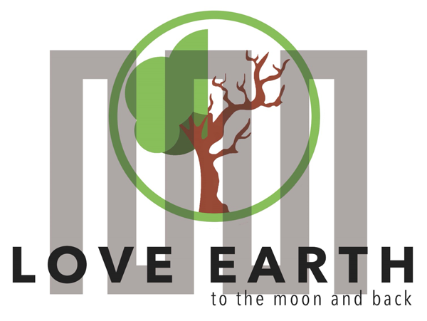

COURSE FOR ENVIRONMENTAL EDUCATION
e-Modules: Teaching Learning activities and their technology enhanced material set

DISCLAIMER
Funded by the European Union. Views and opinions expressed are however those of the author(s) only and do not necessarily reflect those of the European Union or the European Education and Culture Executive Agency (EACEA). Neither the European Union nor EACEA can be held responsible for them.

COURSE AUTHORS
Güray Karakaya

COURSE SHARING LICENCE

You are free to:
- Share — copy and redistribute the material in any medium or format for any purpose, even commercially.
- Adapt — remix, transform, and build upon the material for any purpose, even commercially.


MODULE 5 | THE IMPACTS OF THE ENVIRONMENTAL PROBLEMS AND CLIMATE CHANGE (PART 2 – CLIMATIC AND ENVIRONMENTAL CHALLENGES)
PART 4 | Global Implications
Lesson 1-2 | Global Implications = Disasters

SUMMARY

1. COURSE TIME, TARGET AND TOPIC 3
2. COURSE OBJECTIVES 3
Competences promoted in this lesson: 3
Objectives: 3
Lesson objectives: 3
3. LEARNING – TEACHING PROCESSES 3
4. EVALUATION 3
5. DOCUMENTS 4
ENGAGE 4
EXPLORE 5
EXPLAIN 5
EXTEND 6
EVALUATE 8

1. COURSE TIME, TARGET AND TOPIC
- Age of target students: 15+
- Teaching time: 2 hour
- Disciplines: Geography, Human Sciences, Maths, Science, Technology
- Title: Understanding Human Impact on Ecosystem Integrity

2. COURSE OBJECTIVES

Competences promoted in this lesson:
- 1.Communication in foreign languages competency - CLIL -
- 2.Mathematical competency and basic competencies in science/technology – STEAM -
- 3.Social and citizenship-related competencies

Objectives:
Developing students’ Systems–thinking competence; anticipatory ( future thinking)competence; interpersonal competence - collaboration competence- ; critical thinking competence; integrated problem solving competence

Lesson objectives:
- Students explain global implications of climate change and environmental problems.
- Students give examples of interconnected global implications and predict the future implications.
- Students develop projects for community resilience in the face of disasters

3. LEARNING – TEACHING PROCESSES
There is an ice-breaker and 4 activities in this lesson:
Ice Breaker: Turning the disaster into a dance show.
Instructions: Imagine that when you are preparing for a dance competition, an earthquake strikes. Instead of panicking, you should turn the disaster into a dance-off. Showcase your best moves and integrate drop, cover, and hold-on techniques into your performance ( song: you choose – performance duration 30-1.30 seconds – preparation duration 3 min)
- ENGAGE: Do the Puzzle. There are disasters hidden in the puzzle? How many of them can you find?
- EXPLORE: Timelines of major disasters - Answer the questions.
- EXPLAIN: Unscramble the text. Study it and define causes and effects of various disasters.
- EXTEND: How would you respond to the given disaster scenarios ? Create and present your response plan to the class.

4. EVALUATION
Considering Immediate Response, Local Knowledge and Connections, Capacity Building, Flexible and Adaptive, Psychosocial Support, Community Cohesion, sustainable recovery volunteers play the most crucial role.
Answer the Volunteerism Quiz
https://quizizz.com/admin/quiz/6615069851831a3e81fd6a05?source=quiz_share

5. DOCUMENTS

ENGAGE

ACTIVITY: Students are given a puzzle. They are asked to search for and find out the hidden disasters.
DIRECTIONS: Please look at the puzzle. There are many disasters some of which are hidden in the puzzle. How many can you find until the music stops?
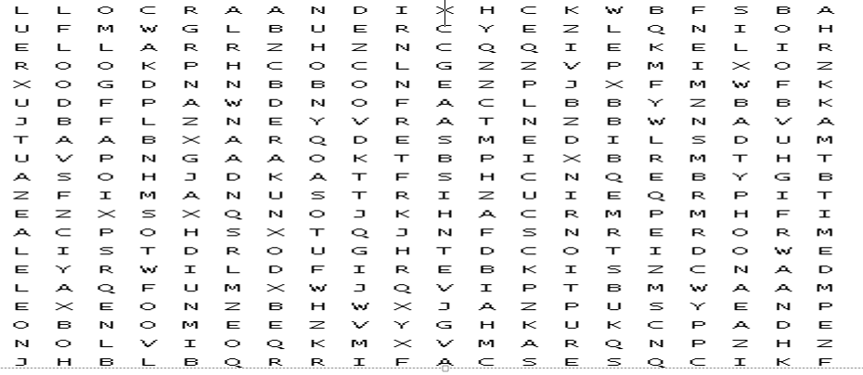
ANSWERS:
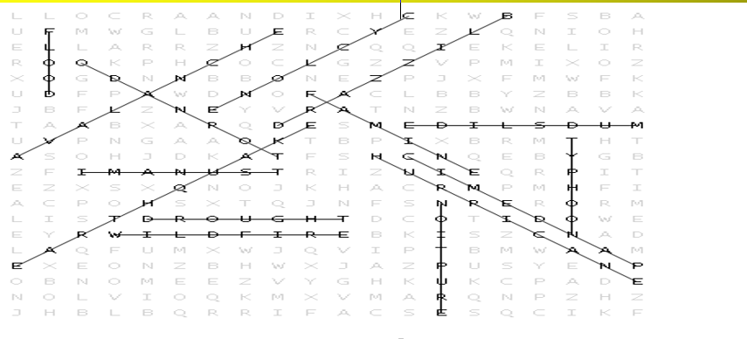

EXPLORE
ACTIVITY: Students are given some individual questions about their personal experiences in disasters so that they can create a disaster timeline.
INSTRUCTIONS: The global implications of climate change are mainly disasters. Can you create the timelines of major disasters ( natural or man-made) that you can recall?
To do that :
Think - Have you ever experienced a disaster or is there a disaster you can recall?
Explain the disaster - Please include the date, type of disaster, location, and significant impacts of the disaster.
You have 5 minutes to brainstorm and write down the disaster(s) you can remember.

EXPLAIN
ACTIVITY : Students are given a scrambled text. They are told to unscramble the text, study it and define causes and effects of various disasters.
INSTRUCTION : Unscramble the text. Study it and define causes and effects of various disasters. Read and compare and contrast your causes and effects with the ones given in the text.
The Global tionimplicas of ateclim Change – Diterssas-
Climate change is no longer a distant threat ; it is a reality that we are facing today. The Earth's climate is rapidly changing, primarily by uhnma a_t_v_t_es such as the burning of f_____ f_______, d_________, and i_________ processes.
As temperatures rise, weather atterpsn become more erratic, and treexme events become more frequent and tenines; the global implications of climate change are becoming apparent, particularly in the form of n________ d________.
One of the most tangible and devastating seconcesquen of climate change is the increase in the efrcyquen and severity of natural disasters. From h______ and h_________ to w__________ and f_______, communities around the world are experiencing the changing climate as in disasters.
1.Hurricanes and Tropical Storms:
Causes :
Effects :
2.Wildfires:
Causes :
Effects :

Hurricanes and Tropical Storms:
Warmer ocean temperatures lead to stronger winds, heavier rainfall, and more destructive storms. In recent years, we have witnessed hurricanes in coastal regions, causing widespread damage to infrastructure and displacing communities.
Wildfires:
Rising temperatures and prolonged drought create conditions for wildfires in many parts of the world. From the Amazon rainforest to the Australian bushlands, there happen wildfires, destroying ecosystems, releasing massive amounts of carbon dioxide into the atmosphere, and endangering lives.
3.Floods
Causes:
Effects:
4.Heatwaves
Causes:
Effects:
Floods:
Changing precipitation patterns and sea-level rise increase the risk of floods in coastal areas . Those flash floods damage houses, businesses, and agricultural land and cause economic losses.
Heatwaves:
Rising temperatures bring about more frequent and prolonged heatwaves, posing significant health risks to vulnerable populations, including the elderly and children. Heat -related illnesses and deaths increase during extreme heat events, highlighting the urgent need for adaptation measures.

EXTEND
ACTIVITY : Students are given disaster scenarios and asked how to respond those disaster scenarios . They are told to create and present their response plan to the class.
INSTRUCTION: The impacts of climate change as in disasters are not confined to national borders; they are felt on a global scale. Disasters disrupt ecosystems, compromise food and water security, displace populations, cause economic costs, and strain resources, increasing social inequalities and geopolitical tensions.
Addressing disasters requires action at all levels, from individual choices to international cooperation .
The time for action is now.
You will be given a disaster scenarios. Please discuss and brainstorm how you would respond to the given scenario, considering factors such as safety measures, evacuation procedures, communication strategies, and resource management.
You have 10 minutes to develop your response plans.
Please present your response plan to the class, highlighting your key decisions and rationale?
What are the challenges to mitigate with those disasters?

Scenario 1: Flooding in a Coastal City
Background:
The coastal city of Seaview is a metropolis known for its vibrant culture, thriving economy, and stunning ocean views. However, its location along the coast makes it susceptible to the impacts of severe weather events, including tropical storms and hurricanes and flooding.
Scenario Description:
It's mid-September, and meteorologists have been monitoring a powerful tropical storm developing in the Atlantic Ocean. As the storm approaches, it rapidly intensifies into a Category 3 hurricane, named Hurricane Delta, with winds of over 120 mph (193 km/h). Seaview, situated directly in the hurricane's path. As residents and authorities prepare for the worst.
Scenario 2: Wildfire Threatening a Mountain Community
Background:
The town of Pinecrest is renowned for its stunning natural beauty, pristine forests, and close-knit community. However, the setting also brings the risk of wildfires, especially during the dry season when vegetation becomes highly flammable.
Scenario Description:
It's late summer, and Pinecrest is experiencing a prolonged period of hot, dry weather. A combination of high temperatures, low humidity, and gusty winds creates ideal conditions for wildfires to start and spread rapidly. As residents enjoy outdoor activities and tourists explore the scenic trails, a small spark starts a fire in the forested hills above Pinecrest and the fire quickly turns into a dangerous wildfire.
Scenario 3: Urban Earthquake
Background:
The city of Metropolis is a centre of commerce, culture, and innovation. Situated along a major fault line, the city has long been aware of the risk of earthquakes, but its rapid growth and development have led to vulnerabilities in its infrastructure and buildings.
Scenario Description:
It's a typical weekday morning in Metropolis, with locals on the city streets and workers beginning their day in high-rise office buildings. Suddenly, without warning, the ground begins to shake violently as a powerful earthquake strikes the heart of the city.
SUGGESTION: Building more resilient communities is critical to minimize the impacts of climate-related disasters. Underline that a community need;
Emergency Responders; Community Leaders ; Volunteers in disaster preparedness, response, and recovery.

Make clear who those people are – and tell that ;
Emergency Responders are Firefighters, Police Officers, Emergency Medical Technicians and Paramedics, Search and Rescue Teams
Community Leaders are Local Government Officials, Community Organizations (ngo’s), School Administrators, Healthcare Workers, Hospital Staff, Public Health Officials, Emergency Medical Services
Volunteers are Community Volunteers, Medical volunteers, Technical and Specialized Volunteers

On the basis of that information students are suggested to be given a final disaster scenario and role play how they would respond to that disaster.
Setting: Plock City Hall - meeting room –
Characters : Emergency responders, community leaders and volunteers
Scenario 4: Alien Invasion
Background:
For centuries, people of Plock have gazed at the stars with curiosity and wondered about the possibility of extraterrestrial life. Maybe it is because of Copernicus who was more interested in the space rather than our Earth.
Scenario Description:
In the quiet town of Plock, the residents are going about their daily routines. Suddenly, the skies overhead are pierced by light and an unidentified spacecraft descend upon the town with alarming speed

EVALUATE
ACTIVITY : The lesson is concluded with two videos and some explanation about volunteering so that the students will comprehend it clearly that volunteers play the most crucial role considering Immediate Response, Local Knowledge and Connections, Capacity Building, Flexible and Adaptive, Psychosocial Support, Community Cohesion and sustainable recovery. They are given a quiz on volunteering.
INSTRUCTIONS: Considering Immediate Response, Local Knowledge and Connections, Capacity Building, Flexible and Adaptive, Psychosocial Support, Community Cohesion, sustainable recovery volunteers play the most crucial role. Watch the videos and read the explanation.
Answer the quiz on volunteering, then.

THE VIDEOS AND EXPLANATION
1.AFAD VOLUNTEERING PROJECT
AFAD (Disaster and Emergency Management Authority) founded in 2009 is a governmental institution responsible for coordinating disaster and emergency-related issues in Turkey. AFAD's volunteerism projects play an important role in providing fast and effective responses in the community's fight against disasters and emergencies.
Çünkü biz AFAD Gönüllüsüyüz! (youtube.com)
what is volunteering - Google'da Ara

THE QUIZ

Title: Volunteerism Quiz
https://quizizz.com/admin/quiz/6615069851831a3e81fd6a05?source=quiz_share

