Project ID: 2021-1-CZ01-KA220-SCH-000034484

COURSE FOR ENVIRONMENTAL EDUCATION
e-Modules: Teaching Learning activities and their technology enhanced material set to develop

DISCLAIMER
Funded by the European Union. Views and opinions expressed are however those of the author(s) only and do not necessarily reflect those of the European Union or the European Education and Culture Executive Agency (EACEA). Neither the European Union nor EACEA can be held responsible for them.

COURSE AUTHORS
Anne CHIAMA, Paul FERNANDEZ, Frédéric GUILLERAY

COURSE SHARING LICENSE
You are free to:
- Share — copy and redistribute the material in any medium or format for any purpose, even commercially.
- Adapt — remix, transform, and build upon the material for any purpose, even commercially.

MODULE 1 | HUMAN AND NATURE
PART 4 | The roles of producers and consumers on the natural balance
Lesson 1 | Nature has a delicate balance

SUMMARY

1. COURSE TIME, TARGET AND TOPIC 3

2. COURSE OBJECTIVES 3
Competences promoted in this lesson: 3
Lesson objectives: 3

3. LEARNING – TEACHING PROCESSES 3

4. EVALUATION 3

5. DOCUMENTS 4
ENGAGE 4
EXPLORE 5
EXPLAIN 6
EVALUATE 8

1. COURSE TIME, TARGET AND TOPIC
- Age of target students: 15+
- Teaching time: 1 hour
- Disciplines: Biology
- Title: Nature has a delicate balance

2. COURSE OBJECTIVES

Competences promoted in this lesson:
- Communication in foreign languages competency
- Digital competency
- Learning to learn competency
- Social and citizenship-related competencies

Lesson objectives:
- The students discover that the absence or reintroduction of a single species can impact an entire ecosystem and they draw the conclusion that nature has a delicate balance
- They use real data from scientific study conducted in Yellowstone National Park ecosystem

3. LEARNING – TEACHING PROCESSES
There are 3 activities in this lesson:
- ENGAGE: talk about world’s first national park and debate about reintroduction of species
- EXPLORE: When the Wolf is not here… (watch a video, male a concept map)
- EXPLAIN: And when the Wolf returns! (analyse scientific data)

4. EVALUATION
The evaluation is described in the last part of document.

5. DOCUMENTS
Engage, Explore and Explain part are adapted from Wolves of Yellowstone Teacher Guide, a free curriculum developed by PBS Learning Media and The Nature Conservancy.

ENGAGE
Initial representation and recall

This moment is useful
- to talk about the world’s first national park
- and discuss the positive or negative aspects of reintroducing a species that has disappeared from an ecosystem

1. THE WORLD’S FIRST NATIONAL PARK
Students read the document below:

In 1872, the world’s first national park, Yellowstone, was born. However, while it protected approximately 3,472 square miles of land (2,221,766 acres), it did not protect the gray wolves that lived inside its boundaries. In fact, in the early years of the park any visitor could hunt and kill any wild game or predator they encountered. Wolves were especially vulnerable because they were seen as an undesirable predatory species.
At least 136 wolves were killed in the park between 1914 and 1926. By the 1940’s wolf packs were seldom reported in the park. In fact, by the mid-1900’s wolves had been nearly eliminated not just from Yellowstone but from the lower 48 states entirely.
Fish and Wildlife Service to develop an environmental impact statement regarding wolf reintroduction and in 1995, the park moved forward with a plan to reintroduce wolves to the area.

2. DEBATE
Students debate around three questions:
- What do you think about the reintroduction of the wolf in an ecosystem?
- Is it positive or negative?
- What do you think the consequences will be?

EXPLORE
When the Wolf is not here…

Q. Watch the video below and stop at 2’36. As you watch the video, take note of the impacts of the absence of wolves in the form of a concept map by completing the beginning of the map below.

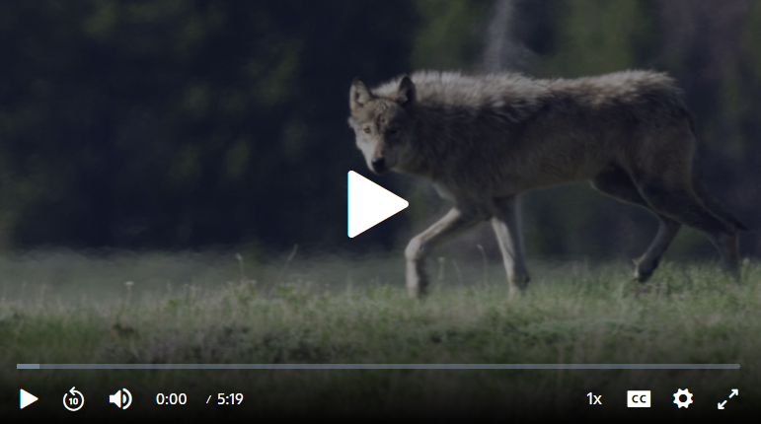
https://www.pbslearningmedia.org/resource/a58e3ca2-52ab-45f5-87ac-26ee0d681146/wolves-of-yellowstone-earth-a-new-wild
Licence : Permitted use Stream, Download and Share

CONSEQUENCES OF THE ABSENCE OF WOLVES

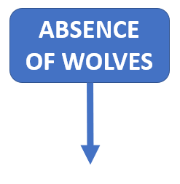

EXPLAIN
And when the Wolf returns !

The graphs below were taken from the 2012 study by William Ripple and Robert Beschta on trophic cascades in Yellowstone National Park.
Aspen, willow, and cottonwoods are common foods for browsers like elk.
Willows are also commonly eaten by beavers.
If scientists want to measure trees and shrubs to look for the impact that browsers are having on their growth, they might measure the following things:
- height: a measure of height can tell scientists how tall the trees are allowed to grow. If the mean tree height in one area is low compared to another area that could be an indication of heavy browsing by elk.
- recruitment: it is the growth of seedlings or sprouts above the level of browsers. In other words, the trees are able to grow taller than the level at which elk and other browsers can eat them.
- Tree rings: it indicates the age of a tree – the more rings a tree has, the older it is.
Increases in these three measurements can indicate an increase in the level of health of the woody plants. Decreases in these measurements could indicate a higher level of browsing pressure on the plants.

1. Relationship between wolves and elk
Q. Describe the general trend of the elk and wolf populations between 1993 and 2003.

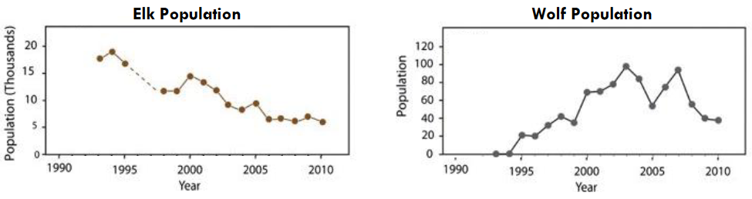

2. Relationship between elk and certain tree species
Q. Use information from the graphs to infer the relationship between elk population and tree growth.

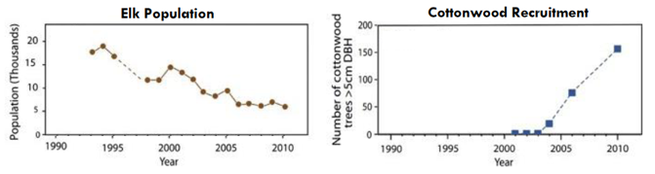

Q. In conclusion, explain why it is said that nature has a delicate balance

EVALUATE

CASE STUDY

Q. Study the case of the lynx and the Canadian hare to show that nature has a delicate balance

Snowshoe hare (Lepus americanus) are the primary food for the Canadian lynx (Lynx canadensis) in the Northern boreal forests of North America. When hare are abundant, Lynx will eat hare about two every three days almost to the complete exclusion of other foods.

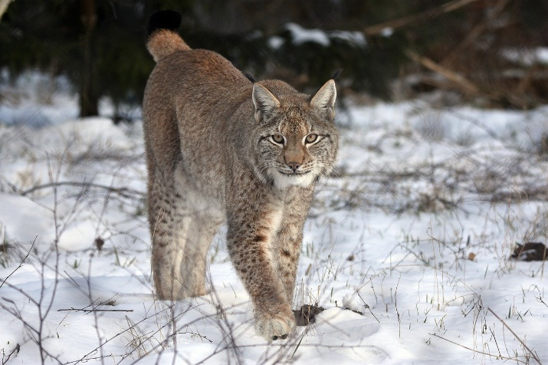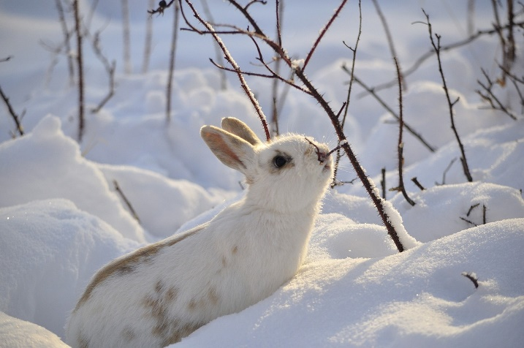
Source: Pixabay, no licence

Evolution of lynx and hare populations between 1930 and 1930

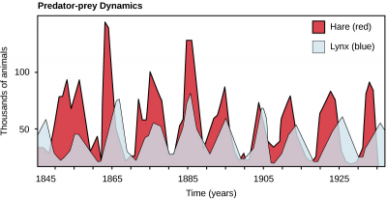

Source: bioprinciples.biosci.gatech.edu, under BY-SA-NC CC licence.
https://bioprinciples.biosci.gatech.edu/community-ecology-2

RIPPLE William, BESCHTA Robert, Trophic cascades in Yellowstone: The first 15 years after wolf reintroduction, in Biological Conservation 145 (2012) 205-213.

