Project ID: 2021-1-CZ01-KA220-SCH-000034484


COURSE FOR ENVIRONMENTAL EDUCATION
e-Modules: Teaching Learning activities and their technology enhanced material set

DISCLAIMER
Funded by the European Union. Views and opinions expressed are however those of the author(s) only and do not necessarily reflect those of the European Union or the European Education and Culture Executive Agency (EACEA). Neither the European Union nor EACEA can be held responsible for them.

COURSE AUTHORS
Güray Karakaya
Contributed by Murat Senger
COURSE SHARING LICENCE

You are free to:
- Share — copy and redistribute the material in any medium or format for any purpose, even commercially.
- Adapt — remix, transform, and build upon the material for any purpose, even commercially.


MODULE 4 | THE IMPACTS OF THE ENVIRONMENTAL PROBLEMS AND CLIMATE CHANGE (PART 1 – ECOSYSTEMS)
PART 6 | What are the effects of human activities on ecosystems?
Lesson 1-2 | Understanding Human Impact on Ecosystem Integrity

SUMMARY

1. COURSE TIME, TARGET AND TOPIC 3
2. COURSE OBJECTIVES 3
Competences promoted in this lesson: 3
Objectives: 3
Lesson objectives: 3
3. LEARNING – TEACHING PROCESSES 3
4. EVALUATION 3
5. DOCUMENTS 4
ENGAGE 4
EXPLORE 4
EXPLAIN 5
EXTEND 5
EVALUATE 6

1. COURSE TIME, TARGET AND TOPIC
- Age of target students: 15+
- Teaching time: 2 hour
- Disciplines: Geography, Human Sciences, Maths, Science, Technology
- Title: Understanding Human Impact on Ecosystem Integrity

2. COURSE OBJECTIVES

Competences promoted in this lesson:
- 1.Communication in foreign languages competency - CLIL -
- 2.Mathematical competency and basic competencies in science/technology – STEAM -
- 3.Social and citizenship-related competencies

Objectives:
Developing students’ Systems–thinking competence; anticipatory ( future thinking)competence; interpersonal competence - collaboration competence- ; critical thinking competence; integrated problem solving competence

Lesson objectives:
- Students study and make inferences about human actions and their impact on ecosystem integrity.
- Students analyze cause-and-effect relationships to understand the consequences of various human activities on ecosystems.

3. LEARNING – TEACHING PROCESSES
There is an ice-breaker and 4 activities in this lesson:
Ice Breaker: Visit the poetry website and choose a poem to read in front of the class.
Poems about Trees | Academy of American Poets
- ENGAGE: Where is that photo taken? What are the features of that location?
- EXPLORE: The photo is from the rainforests. Answer the questions for discussion.
- EXPLAIN: Visit the websites. Study the texts and define ecosystems and rainforests as an ecosystem.
- EXTEND: Study the materials delivered. Create a short presentation outlining the causes and effects of the chosen impact. Present your findings to the class.

4. EVALUATION
Share what you found most surprising or impactful during the lesson. Tell about the importance of human impacts on ecosystems and the need for responsible environmental stewardship.
Write a reflective assignment and explain how your own daily choices may contribute to or mitigate human impact on ecosystems in the context of human settlement and infrastructure.

5. DOCUMENTS

ENGAGE
ACTIVITY: Students are given a photo. They are asked where that photo is taken from and asked to tell what they know about that place ( its features, location, benefits…etc)
DIRECTIONS: Please look at the photo below. Where is that photo taken? Can you name its location? What are the features of that place? What are its benefits?
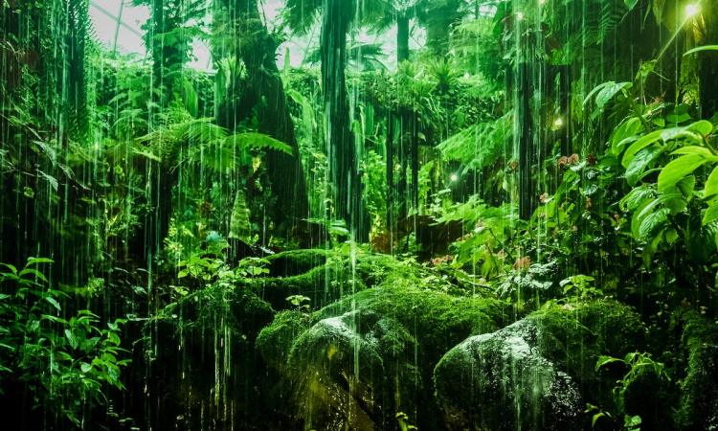

EXPLORE
ACTIVITY: Students are shown some more photos. They are given some discussion questions so that they can understand the rainforests as an ecosystem.
INSTRUCTIONS: The photo is from the rainforests. Will you answer the questions below, please?
Suggested Questions for Discussion:
1. Where are the rainforests located ?
2. What are the abiotic factors of rainforests?
3. What are the biotic components of the rainforests?
4. Can you give some examples of the interactions within that rainforests?
5. Do you think rainforests are an ecosystem?

ANSWERS :
1.Tropical rainforests are typically found near the equator in regions such as the Amazon Basin in South America, the Congo Basin in Central Africa, and parts of Southeast Asia.
2. Abiotic Factors are -Climate: Warm temperatures throughout the year with high humidity; -Precipitation: Heavy and consistent rainfall, often exceeding 100 inches annually; -Soil: Generally nutrient-poor soil due to rapid decomposition and leaching, with most nutrients stored in the biomass of living organisms.
3. Biotic Components are -Plants: A vast array of plant species, including towering trees such as mahogany and kapok, as well as a dense understory of shrubs, ferns, and epiphytes; -Animals: Diverse animal life, including mammals like jaguars, monkeys, and sloths, a multitude of bird species, amphibians, reptiles, and an incredible variety of insects; -Microorganisms: Abundant fungi and bacteria contribute to the decomposition of organic matter, recycling nutrients in the ecosystem.
4. Some examples of the interactions are : -Food Web: Complex interrelationships among species, forming intricate food webs where various organisms are connected through predator-prey relationships and symbiotic interactions; -Competition: Intense competition for resources such as sunlight, nutrients, and space, leading to unique adaptations and ecological niches for different species; -Mutualism: Examples of mutualistic relationships, such as the partnership between certain plants and ants, where the ants protect the plants in return for food and shelter.
5. Yes they are an ecosystem.

EXPLAIN
ACTIVITY : Students are asked to visit websites and given texts. They are told to study them and comprehend ecosystems and rainforests as an ecosystem.
Rainforest Ecosystem Definition – Characteristics, Types and Importance (earthreminder.com)
Rainforests 101 | National Geographic (youtube.com)
Suggestion : Students should refer to the websites and the texts to understand the ecosystems while studying rainforests.
INSTRUCTION :Visit the websites and given texts. Study them and define ecosystems and rainforests as an ecosystem.

EXTEND
ACTIVITY : Students are asked for a guided discussion. They are encouraged to share their findings from the texts and web sites and discuss the cause-and-effect relationships they identified. They are asked "What are the human actions involved?" and "How do these actions impact the ecosystem components?".
Each student or group are assigned a specific human impact on an ecosystem. They are instructed to conduct additional research and create a short presentation outlining the causes and effects of the chosen impact. They are allowed to present their findings to the class.
SUGGESTION: Students should create visual representations (diagrams, charts, or drawings) illustrating the cause-and-effect relationships they discussed. This could be done individually or in small groups.

INSTRUCTION: Discuss the human impact on ecosystems. Share your findings from the texts and web sites and discuss the cause-and-effect relationships you identified. Answer the questions: "What are the human actions involved?" and "How do these actions impact the ecosystem components?".
Choose one specific human impact delivered on the ecosystem. Conduct additional research and create a short presentation outlining the causes and effects of the chosen impact..Present your findings to the class.
SUGGESTION: Students may be assigned below mentioned human impact on ecosystems.
Deforestation: Extensive logging and clearing of land for agriculture pose significant threats to tropical rainforests.
Climate Change: Global climate change can impact rainfall patterns, temperature, and the overall stability of these ecosystems.
Biodiversity Loss: The destruction of habitats in tropical rainforests contributes to the loss of many plant and animal species, some of which may have medicinal or ecological importance.

EVALUATE
ACTIVITY : The lesson is concluded with a class reflection. Students are asked to share what they found most surprising or impactful during the lesson. It is emphasized the importance of understanding human impacts on ecosystems and the need for responsible environmental stewardship.
Students are assigned a reflective writing assignment, considering how their own daily choices may contribute to or mitigate human impact on ecosystems.
INSTRUCTIONS: Share what you found most surprising or impactful during the lesson. Tell about the importance of human impacts on ecosystems and the need for responsible environmental stewardship.
Write a reflective assignment and explain how your own daily choices may contribute to or mitigate human impact on ecosystems in the context of human settlement and infrastructure .

