|  |  |  |
| --- | --- | --- |
| Co-funded by the European Union logo in png for web usage | Erasmus Project: **Le MOON**  *2021-1-CZ01-KA220-SCH-000034484* |  |

**Module 4**

**THE IMPACTS OF THE ENVIRONMENTAL PROBLEMS AND CLIMATE CHANGE**

**Forests in Europe & in the world:**

2021: 160 million hectares of forests in the European Union, 39% of the EU land area [Forests, forestry and logging - Statistics Explained (europa.eu)](https://ec.europa.eu/eurostat/statistics-explained/index.php?title=Forests,_forestry_and_logging)

forests covered 4.06 billion hectares (10.0 billion acres; 40.6 million square kilometres; 15.7 million square miles), or approximately 31 percent of the world's land area in 2020. “the state of the world’s forests 2020” Food and Agriculture Organization of the United Nations [content (fao.org)](https://openknowledge.fao.org/server/api/core/bitstreams/5d85921a-6980-485a-be05-14d6b87a0ec9/content)

Total forests area from 1990 to 2021: [Global forest area 1990-2021 | Statista](https://www.statista.com/statistics/1292175/global-forest-area/)

1990-2018 - World forest land decreased by almost 4 percent over the period 1990 to 2018, with an average yearly reduction of 0.1 percent. Food and Agriculture Organization of the United Nations, land statistics.

The annual rate of deforestation was estimated at 10 million hectares between 2015-2020, compared with 12 million during 2010-2015. [Deforestation has slowed down but still remains a concern, new UN report reveals | UN News](https://news.un.org/en/story/2020/07/1068761)

[Visualizing the World’s Loss of Forests Since the Ice-Age (visualcapitalist.com)](https://www.visualcapitalist.com/visualizing-the-worlds-loss-of-forests-since-the-ice-age/) – a slide show

**Land use in agriculture in Europe and in the world:**

2020: Globally agricultural land area is approximately five billion hectares, or 38 percent of the global land surface. [Land use in agriculture by the numbers | Sustainable Food and Agriculture | Food and Agriculture Organization of the United Nations (fao.org)](https://www.fao.org/sustainability/news/detail/en/c/1274219/)

2020: 157 million hectares of land in the EU, 38% of total land area of the EU [Farms and farmland in the European Union - statistics - Statistics Explained (europa.eu)](https://ec.europa.eu/eurostat/statistics-explained/index.php?title=Farms_and_farmland_in_the_European_Union_-_statistics#Farms_in_2020)

**In 2021, some 38.9 % of the EU population was living in a city, with lower shares living in towns and suburbs (35.9 %) and in rural areas (25.2 %). Around 52 million hectares of land.** [Urban-rural Europe - introduction - Statistics Explained (europa.eu)](https://ec.europa.eu/eurostat/statistics-explained/index.php?title=Urban-rural_Europe_-_introduction)

1990-2018 - The total agricultural land grew on average by 0.1 percent per year since 1961, with a steady expansion up to the 1990s and a decrease in more recent decades. Food and Agriculture Organization of the United Nations, land statistics.

|  |  |  |
| --- | --- | --- |
| Co-funded by the European Union logo in png for web usage | Erasmus Project: **Le MOON**  *2021-1-CZ01-KA220-SCH-000034484* |  |

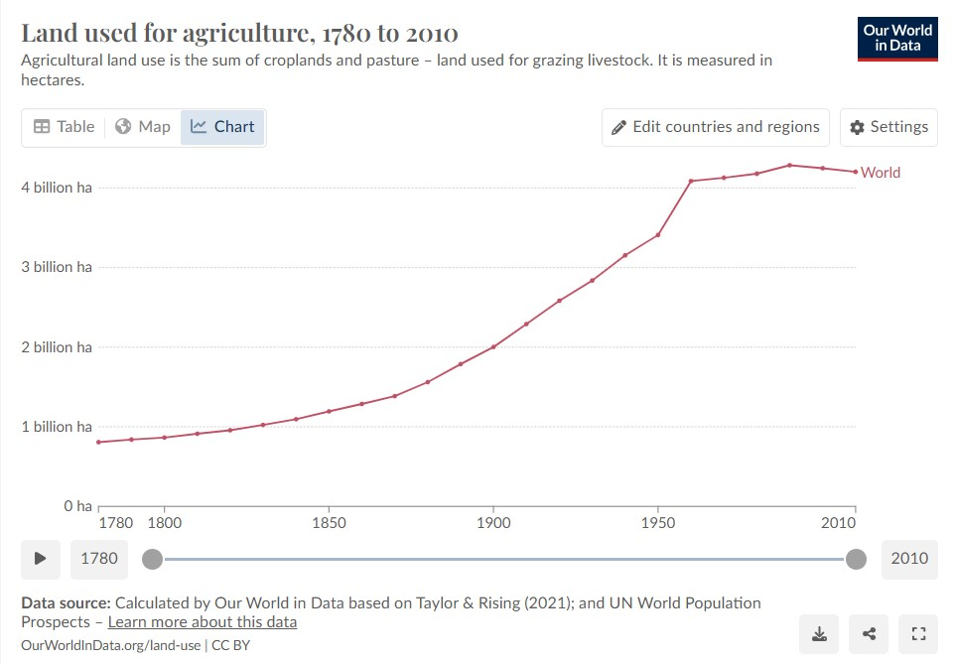

**Grassland in Europe & the world:**

2022: Permanent grasslands cover 34% of the European Union’s agricultural area [Permanent grasslands in Europe: Land use change and intensification decrease their multifunctionality - ScienceDirect](https://www.sciencedirect.com/science/article/pii/S0167880922000408)

2000: Grasslands are among the largest ecosystems in the world with their area estimated at 52.5 million square kilometres, or 40.5 percent of the terrestrial area excluding Greenland and Antarctica (World Resources Institute, 2000, based on IGBP data). In contrast, 13.8 percent of the global land area (excluding Greenland and Antarctica) is woody savannah and savannah; 12.7 percent is open and closed shrub; 8.3 percent is non-woody grassland; and 5.7 percent is tundra. [Grassland of the world (fao.org)](https://www.fao.org/4/y8344e/y8344e05.htm)

[Visualizing the World’s Loss of Forests Since the Ice-Age (visualcapitalist.com)](https://www.visualcapitalist.com/visualizing-the-worlds-loss-of-forests-since-the-ice-age/#google_vignette):

1800s – 36% of land in the world was covered by grasslands

1900s – 27% of land in the world was covered by grasslands

**Funded by the European Union. Views and opinions expressed are however those of the author(s) only and do not necessarily reflect those of the European Union or the European Education and Culture Executive Agency (EACEA). Neither the European Union nor EACEA can be held responsible for them.**