Project ID: 2021-1-CZ01-KA220-SCH-000034484


COURSE FOR ENVIRONMENTAL EDUCATION
e-Modules: Teaching Learning activities and their technology enhanced material set to develop

DISCLAIMER
Funded by the European Union. Views and opinions expressed are however those of the author(s) only and do not necessarily reflect those of the European Union or the European Education and Culture Executive Agency (EACEA). Neither the European Union nor EACEA can be held responsible for them.

COURSE AUTHORS
Céline CORNEILLE, Paul FERNANDEZ, Frédéric GUILLERAY, Marine ROBINI and Ervan ROUSSEL.

COURSE SHARING LICENSE
You are free to:
- Share — copy and redistribute the material in any medium or format for any purpose, even commercially.
- Adapt — remix, transform, and build upon the material for any purpose, even commercially.

MODULE 6 | SUSTAINABLE DEVELOPMENT AND SOLUTIONS TO ENVIRONMENTAL PROBLEMS AND CLIMATE CHANGE
PART 3 | Mitigation and Adaptation Strategies
Lesson 2 | All the ways to fight climate change

SUMMARY

1. COURSE TIME, TARGET AND TOPIC 3

2. COURSE OBJECTIVES 3
Competences promoted in this lesson: 3
Lesson objectives: 3

3. LEARNING – TEACHING PROCESSES 3

4. EVALUATION 3

5. DOCUMENTS 4
ENGAGE 4
EXPLORE 5
EXPLAIN 7
EXTEND 8
EVALUATE 10

1. COURSE TIME, TARGET AND TOPIC
- Age of target students: 15+
- Teaching time: 1-2 hours
- Disciplines: Biology
- Title: All the ways to fight climate change

2. COURSE OBJECTIVES

Competences promoted in this lesson:
- Communication in foreign languages competency
- Digital competency
- Learning to learn competency
- Social and citizenship-related competencies

Lesson objectives:
- Students experience and interpret the local environment and consider the changes over time.
- Students explain the changes in the local environment within the climate change

3. LEARNING – TEACHING PROCESSES
There are 4 activities in this lesson:
- ENGAGE: The ecological deficit of my country (use an online tool to identify the ecological deficit/reserve of my country)
- EXPLORE: Adaptation and/or mitigation? (web research to define and compare adaptation and mitigation)
- EXPLAIN: Find and share strategies! (design mindmap thanks to online resources)
- EXTEND: Make your voice heard as a citizen (write a charter for the political decision-makers)

4. EVALUATION
The evaluation is described in the last part of document.

5. DOCUMENTS

ENGAGE
The ecological deficit of my country

Q. Use the website of Global footprint network to determine the ecological deficit/reserve and other valuers for your country.
In order to do it, complete the table below.

https://data.footprintnetwork.org

VARIABLE | EXPLANATION / DEFINITION | VALUES FOR MY COUNTRY
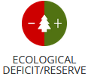 |  | Biocapacity < or > Footprint  Value for my country: ………..%
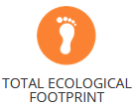 |  | Value for my country: ………..
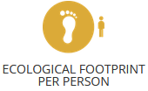 |  | Value for my country: ………..
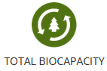 |  | Value for my country: ………..
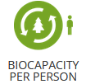 |  | Value for my country: ………..

EXPLORE
Adaptation and/or mitigation?

Because we are already committed to some level of climate change, responding to climate change involves a two-pronged approach:
- Mitigation strategies
- Adaptation strategies

Q. In order to be able to explain the difference between the two types of strategies, do some research on the web to complete the comparison table below.

 | ADAPTATION | MITIGATION
Definition
Examples
Short-term impact
Long-term impact
What I can do as an individual
What a city can do

Example of correction:
 | ADAPTATION | MITIGATION
Definition | The process of adjusting to current or expected climate conditions to reduce potential damages. | Actions aimed at reducing or preventing greenhouse gas emissions to limit climate change.
Examples | - Building dikes to prevent flooding.  - Adopting drought-resistant crops. | - Using renewable energy sources (solar, wind).  - Reforestation and forest conservation.
Short-term impact | Immediate reduction of risks and impacts from extreme weather events. | Reduction of greenhouse gas emissions with a longer-term effect on climate stabilization.
Long-term impact | Increased resilience of communities and ecosystems to ongoing climate changes. | Contribution to limiting global warming and its long-term effects.
What I can do as an individual | - Install rainwater harvesting systems.  - Plant local climate-resistant species. | - Reduce, reuse, recycle.  - Use public transportation or bike instead of driving.
What a city can do | - Develop urban green spaces to regulate temperatures.  - Implement early warning systems for extreme weather events. | - Implement efficient public transportation networks.  - Invest in renewable energy infrastructure.

EXPLAIN
Find and share strategies!

Q. Divide into groups of 2-3 students. Half of the groups will work on adaptation and the other half on mitigation.
Objective:
- Explore the provided resource website to identify adaptation or mitigation strategies.
- Each group completes an A3 mind map on its theme.
- At the end, each mindmap is presented to the other group.

MITIGATION strategies
Website: https://www.overshootday.org/100-days-of-possibility
Each group of 2-3 students chooses one different topic among:
Explore the strategies.
Each group must choose and be able to explain at least 3 strategies.
Then create a mindmap (example below).
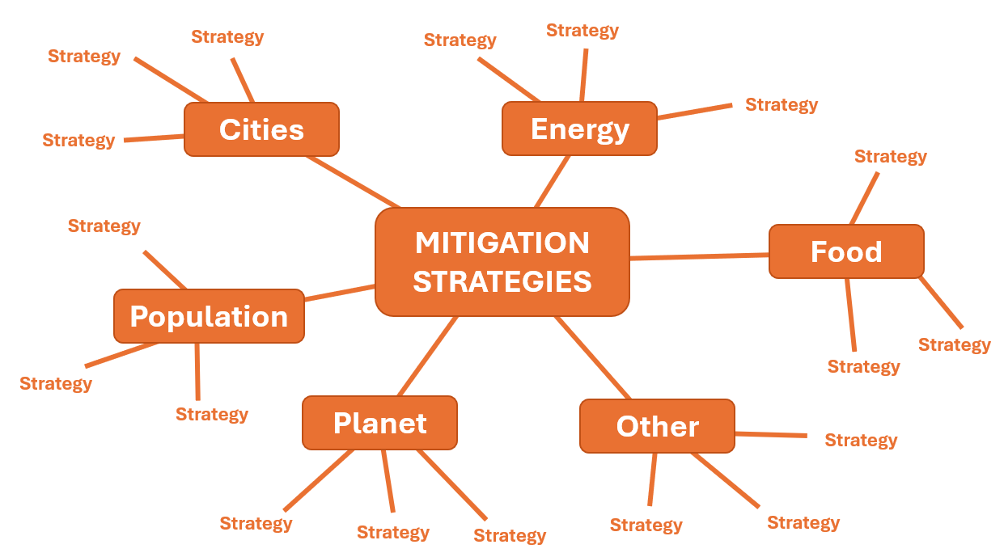

Adaptation strategies
Website: https://www.epa.gov/arc-x/strategies-climate-change-adaptation#all
Each group of 2-3 students chooses one of the following topics:
- Ecosysteme protection
- Smart Growth: Land Use and Building Codes and Policies
- Smart Growth: Land Use and Building Codes and Policies for Adapting to Drought
- Smart Growth: Land Use and Building Codes and Policies for Adapting to Extreme Heat
- Smart Growth: Land Use and Building Codes and Policies for Adapting to Flooding & Extreme Precipitation
- Smart Growth: Land Use and Building Codes and Policies for Adapting to Sea Level Rise
- Smart Growth: Land Use and Building Codes and Policies for Adapting to Wildfire
- Stormwater Management and Water Quality
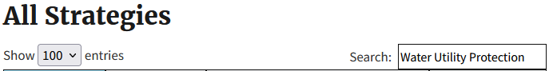
- Water Utility Protection
On the website, scroll to the search field and type in the keywords of your topic.
Explore the strategies. Each group must choose and be able to explain at least 2 strategies.
Then create a mindmap (example below).
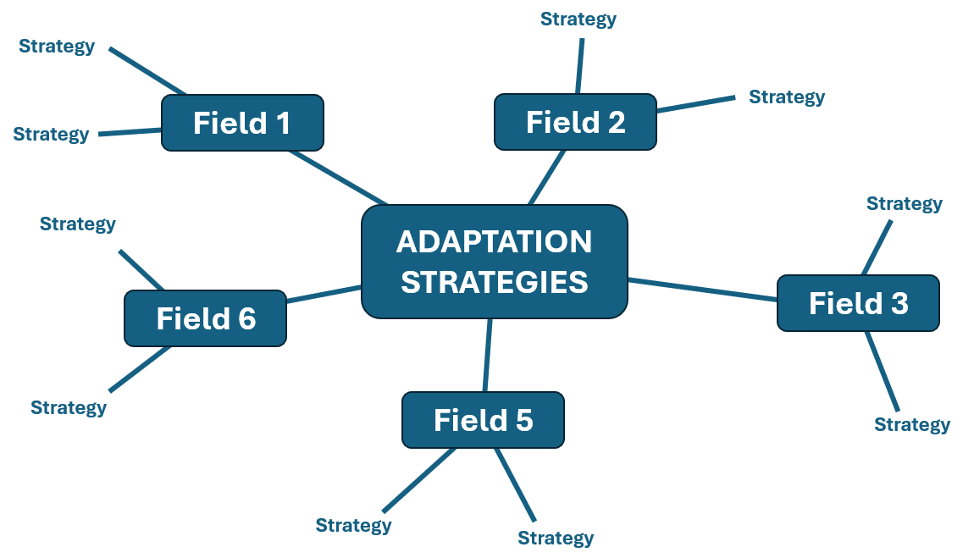

EXTEND
Make your voice heard as a citizen

Q. From the set of adaptation and mitigation strategies listed in the previous activity, choose 10.
Write a charter of actions to be taken on climate change in your local environment.
Send your charter to your city's political decision-makers.

Example of a charter template:

Charter of actions to combat climate change in [city name]

Preamble:
Aware of the urgency of meeting the challenges posed by climate change and of our collective responsibility to protect and preserve our environment for present and future generations, we, the undersigned students of [school name] and citizens of [city name], propose the following charter. This document presents ten concrete articles designed to guide our city's political decision-makers in implementing effective climate policies.

Article 1:
Article 2:
Article 3:
Article 4:
Article 5:
Article 6:
Article 7:
Article 8:
Article 9:
Article 10:

Signatories: This charter is endorsed by the undersigned students of [school name], who urge our political decision-makers to adopt and implement these actions as a matter of priority.
Signatures:

EVALUATE

The correct answers are in green.

Q1. What is the primary difference between adaptation and mitigation in the context of climate change?
a) Adaptation and mitigation are the same and interchangeable.
b) Adaptation is about preventing climate change, while mitigation is about dealing with its impacts.
c) Adaptation involves global actions, while mitigation involves local actions.
d) Adaptation focuses on adjusting to climate conditions, while mitigation aims at reducing greenhouse gas emissions.

Q2. Which of the following is an example of an adaptation measure?
a) Using renewable energy sources like solar and wind power.
b) Reforestation and forest conservation.
c) Building dikes to prevent flooding.
d) Adopting drought-resistant crops.

Q3. Which of the following is an example of a mitigation measure?
a) Reducing industrial emissions through regulations.
b) Installing rainwater harvesting systems.
c) Developing urban green spaces to regulate temperatures.
d) Implementing efficient public transportation networks.

Q4. As an individual, which action would be considered a mitigation effort?
a) Planting local climate-resistant species in your garden.
b) Installing rainwater harvesting systems.
c) Using public transportation or biking instead of driving.
d) Developing urban green spaces to regulate temperatures.

Q5. Which of the following actions can a city take to support mitigation?
a) Implementing early warning systems for extreme weather events.
b) Developing urban green spaces to regulate temperatures.
c) Relocation programs for vulnerable communities.
d) Investing in renewable energy infrastructure.

Q6. Which of the following actions can a city take to support adaptation?
a) Implementing early warning systems for extreme weather events.
b) Designing and implementing heat-resistant building codes.
c) Promoting energy-efficient appliances in households.
d) Providing subsidies for electric vehicles.

