I perhaps owe having become a painter to ____

**I . Listen and fill in the blanks with the correct words in the box. The words are in Turkish but do not worry, trust your EARS.**

**soğan- karanfil – domates – biber – patlıcan - karayemişa - çami - kınayı**

**1."___________, __________, ____________"**

**"___________, __________, ____________"**

**Bir anda bütün dünyam karardı, Bu sesle sokaklar yankılandı**

**"___________, __________, ____________"**

**2.Haberin var mı taş duvar? Demir kapı, kör pencere, Yastığım, ranzam, zincirim,**

**Uğruna ölümlere gidip geldiğim, Zulamdaki mahzun resim,**

**Görüşmecim, yeşil __________ göndermiş,**

**__________ kokuyor cıgaram**

**Dağlarına bahar gelmiş memleketimin...**

**3. İçim buruk biraz arkadaşlar, Ayrılıyorum sizden**

**Dolaşırken mekan mekan, Beni ararsınız evden**

**___________ yakmışlar geline, Hazırlanmış gidiyor evine**

**Başında al yazması var, Ağlıyor bakmayın yüzüne**

4. **Hayde gidelum hayde, Hayde gidelum hayde,Hayde gidelum hayde**

**Dağa ____________, Dağa ____________, Dağa ____________,**

**Elun nişanlısına, Elun nişanlısına,Elun nişanlisina**

**Ben nasil deyim hayde, Ben nasil deyim hayde,Ben nasil deyim hayde**

**Çiktum ______ budadum, Çiktum_______ budadum, Çiktum ______ budadum**

**Endurdum yarisina,Endurdum yarisina,Endurdum yarisina**

**Böyle sevdamu olur, Böyle sevdamu olur, Böyle sevdamu olur**

**Girsin yerin dibuna, Girsin yerin dibuna, Girsin yerin dibuna**

**II . Look at the photos and answer the questions.**

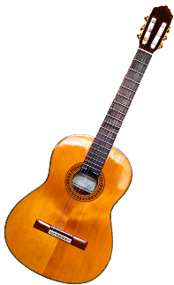 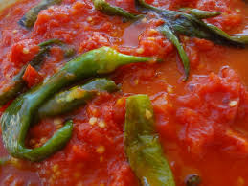 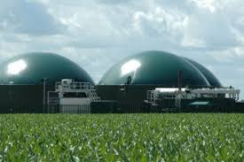 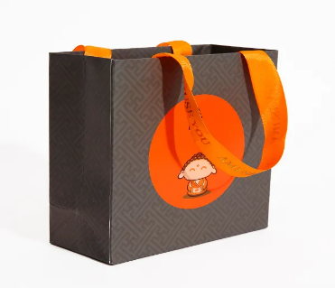

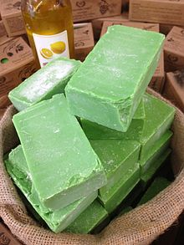 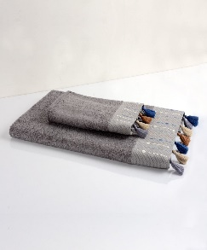 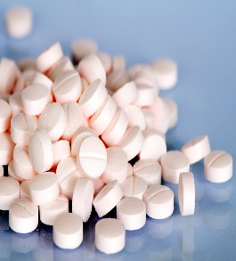 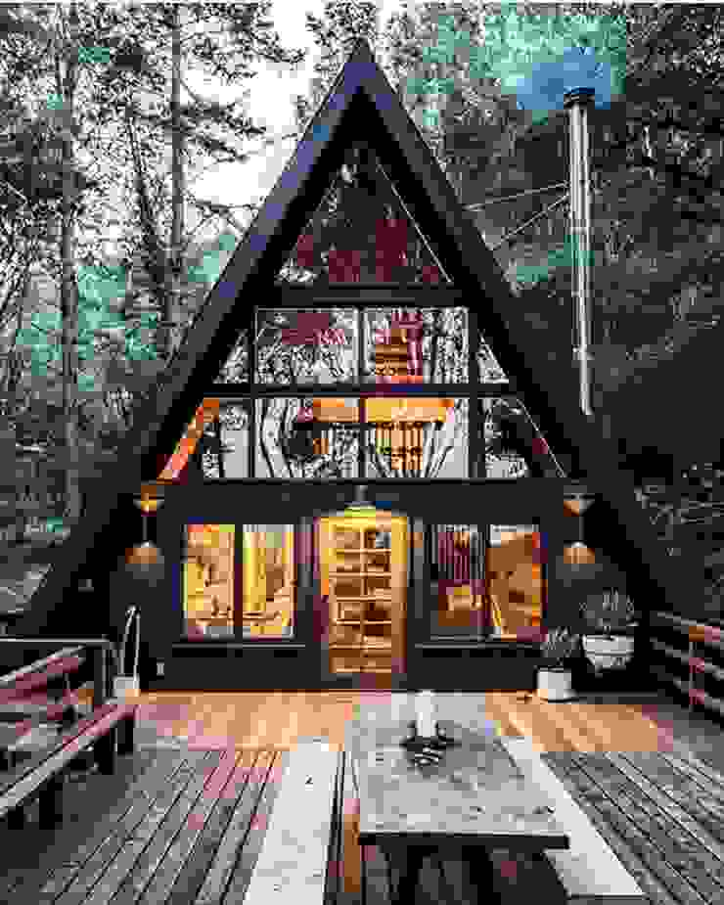

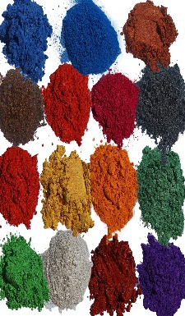 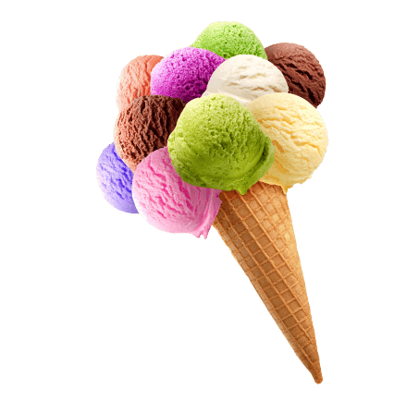 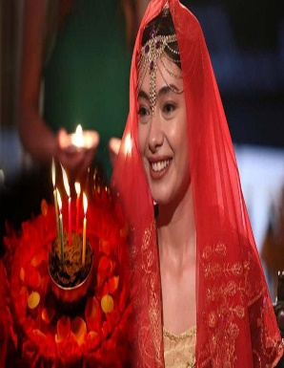 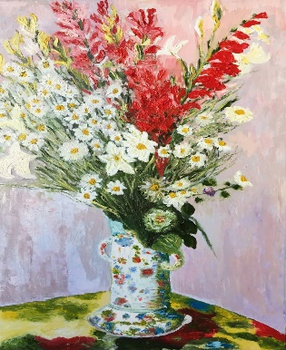

**Questions for Discussion:**

1.Look at the photos. What do you think they have in common ?

2. Can you connect those photos with the key words in Activity 1? How are they connected?

3. What is the natural resource we focus on? What are the different uses of that natural resource?

**The List of the Different Uses of the Natural Resource of ________**

1.

2.

3.

4.

5.

6.

7.

8.

**Funded by the European Union. Views and opinions expressed are however those of the author(s) only and do not necessarily reflect those of the European Union or the European Education and Culture Executive Agency (EACEA). Neither the European Union nor EACEA can be held responsible for them.**