Project ID: 2021-1-CZ01-KA220-SCH-000034484
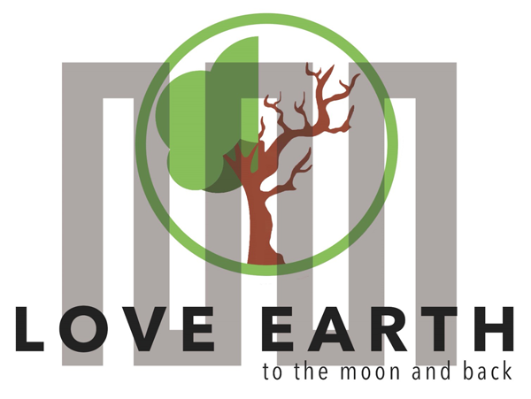

COURSE FOR ENVIRONMENTAL EDUCATION
e-Modules: Teaching Learning activities and their technology enhanced material set to develop

DISCLAIMER
Funded by the European Union. Views and opinions expressed are however those of the author(s) only and do not necessarily reflect those of the European Union or the European Education and Culture Executive Agency (EACEA). Neither the European Union nor EACEA can be held responsible for them.

COURSE AUTHORS
Lubomír Hájek, Petra Garay

COURSE SHARING LICENSE
You are free to:
- Share — copy and redistribute the material in any medium or format for any purpose, even commercially.
- Adapt — remix, transform, and build upon the material for any purpose, even commercially.

MODULE 1 | HUMAN AND NATURE
PART 3 | The positive and negative effects of nature on human being ; The natural and artificial environment
Lesson 2 | The natural and artificial environment – part 2 - Biosphere

SUMMARY

1. COURSE TIME, TARGET AND TOPIC 3

2. COURSE OBJECTIVES 3
Competences promoted in this lesson: 3
Lesson objectives: 3

3. LEARNING – TEACHING PROCESSES 3

4. EVALUATION 3

5. DOCUMENTS 4
ENGAGE 4
EXPLORE 5
EXPLAIN 5
EXTEND 6
EVALUATE 6

1. COURSE TIME, TARGET AND TOPIC
- Age of target students: 15+
- Teaching time: 1 hour
- Disciplines: Biology, Geography, Human sciences
- Title: Biosphere

2. COURSE OBJECTIVES

Competences promoted in this lesson:
- Communication in foreign languages competency
- Digital competency
- Mathematical competency
- Learning to learn competency
- Cultural awareness

Lesson objectives:
- The students learn about irrigation, its rules, and possibilities.
- The students explore the natural and artificial state of rivers and its impact on the environment.
- They apply the knowledge in practical activities.

3. LEARNING – TEACHING PROCESSES
There are 4 activities in this lesson:
Biosphere:
- ENGAGE: ZOO- and its purpose
- EXPLAIN: discuss the welfare of animals
- EXPLORE: Przewalski´s horse
- EXTEND: levels of biosphere

4. EVALUATION
Biosphere – online quiz- biosphere

5. DOCUMENTS

ENGAGE
Q: Read the information about ZOO, discuss its importance

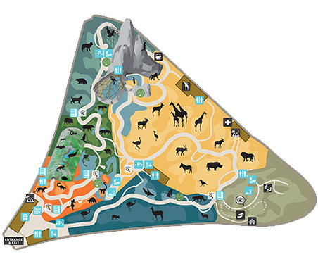We all have been there, Zoos. I think I can say everybody love this place. As children we went there with garden school, as teenagers we go there for a date or with a family and maybe in the future, we will bring our children here. It´s a beautiful and amazing place for all age categories. But have you ever thought about true meaning of zoos?

What is zoo?
The word “zoo” is short for “zoological park.” A zoo is a place where animals live in captivity. Zoos contain wide varieties of animals that are native to all parts of the Earth. Most people think that parks are mostly for entertainment, and they have from it a huge profit, but that´s not entirely true. Yes, they make lots of money in our eyes but in big corporation world it isn´t. In many times zoos don´t have money for their own function and they need help from state or European union. Why they need the money and where it all goes? For well-being of animals, we need to meet the conditions of WELFARE and we need to pay for professionals who will take care of them.
Zoos spend between five thousand to twenty million only for running the zoo. Extra money they spend for upgrading animal fields. For example. Zoo in Toronto says only feeding animals cost 1million dollars.

Task 1 for students:
Make a group of 3 – 5 members and try what it would be like to be a ZOO principal. Make a financial plan for zoo, try to figure out have many visitors you will have (make a price for tickets). What kind of animals do you have and try to find another tourist attractions without animals included. And you need to respect animals WELFARE (if you don’t know what that means, please see chapter below).
Information:
- You have a ZOO in size of 100 ha.
- You need to feed about 4 000 animals.
- You need to have some refreshment area where visitors can order meals.
- You need to have a pet zoo for kids.
- You need to have a safe playground for children.

EXPLAIN
Q: Try to answer the following questions related to the welfare of animals:
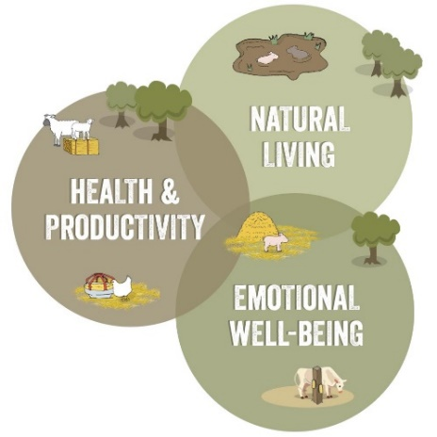
- What is WELFARE and why animals need it?
- In the Czech Republic animals’ rights are guaranteed by Act No. 246/1992 Coll. to protect animals against cruelty.
- Are there any similar laws in your country which insure welfare of animals?

Q: Watch the video:
“What is Animal Welfare”
Discuss this topic. Are these precautions sufficient or should we do more for animals?

EXPLORE
Q: Explore the satiation of the Przewalski ´s horse
PRZEWALSKI´S HORSE
Genetic programs and returning endangered species back to nature.
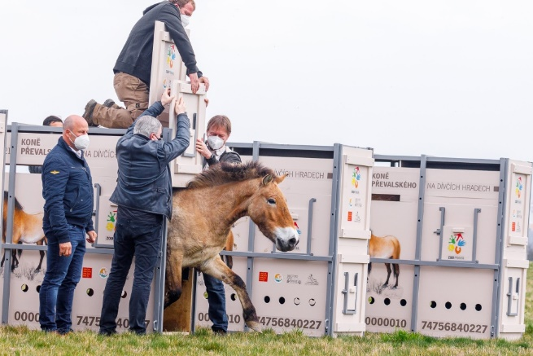
Many zoos have their own genetic program of returning endangered species back to nature. For example, Zoo Praha has been working on a program about returning Przewalski´s horse back to wildness of Mongolian plains. We need this kind of programs to save wild animals and our only hope are individuals which we are keeping in captivity.
You may be asking: „Why do we even need to rescue Przewalski´s horses?“ Great question! Przewalski´s horse is the last wild horse breed on the earth. This kind was discovered in 1881 by the Russian explorer N.M. Przewalski’s. And by then Przewalski´s horses were hunting to the moment they were gone in wildness.
However, Zoo Praha is one of the most important organizations in the process of returning Przewalski´s horse to nature. First transport was made in 1998 and 2000 when the Zoo donated four horses to another organozation. Partnering with the Czech Army, Zoo Praha transported three to four horses to Mongolia each year between 2011 and 2015 –which is in total:18 mares and one stallion. Thanks to this project they saved Przewalski´s horses and repopulated them in Mongolia. By now in Mongolia there are over 500 individuals running free. Amazing, isn´t it?
Task 1:
Make posters about some endangered animal of your choice and put them in your class or in the school hallway

Task 2:
Try to look for similar program in your country, perhaps share the information about Przewalski´s horse

EXTEND
Q: Extend your knowledge about the levels of the biosphere:
What is biosphere?
The biosphere is mainly described by the reference of the whole life and living organisms around the Earth. It consists of five levels of organizational structure:

(1) Biomes
The large biosphere is divided into large parts of biomes. Scientists classified biomes into five different types: tundra, grassland, forests, deserts, and aquatic biomes.

(2) Ecosystem
The ecosystem is made up of a biological community and the physical environment. And so it includes both the biotic and abiotic factors. The living things and their physical environment function together as a unit.

(3) The community of Species
A biological community, though, is defined as the assemblage of interacting organisms (either of the same or different species) coexisting in a particular area and time.

(4) Population
All the members of the particular species living in the single habitat are known as Population The population size can vary from a few to thousands of members.

(5) Organisms
The organisms are the living entities of the biosphere.

EVALUATE
Alternative: print out the attached worksheet and give to students – set a time limit.
Přidat worksheety

Sources:
- https://www.parczoologiquedeparis.fr/en/plan-your-visit/circuits/map-and-tours-2742
- https://www.globalanimalpartnership.org/5-step-animal-welfare-rating-program
- https://www.zoopraha.cz/en/animals/we-help-them-to-survive/projects/7678-return-of-the-przewalski-s-horse-to-mongolia
- https://www.zoopraha.cz/en/animals/we-help-them-to-survive/projects/7678-return-of-the-przewalski-s-horse-to-mongolia
- https://www.svscr.cz/zdravi-zvirat/ochrana-pohody-zvirat-welfare/
- https://torontolife.com/city/it-costs-1-million-a-year-to-feed-the-animals-how-the-toronto-zoo-is-functioning-without-revenue/
- https://www.insightsonindia.com/environment/basic-concepts-of-ecosystem/biosphere-habitat-biome/organizational-structure-of-biosphere/

