MODULE 1 – HUMAN AND NATURE
PART 5. Our responsibility for the development of attitudes and behaviours aimed at maintaining the natural balance
Lesson 1: How to maintain the natural balance?

1. THE LESSON CONTENT
Age of target students: 15+
Teaching time: 2 hours
Disciplines: English, art, ICT, biology, social studies, geography
Title: How to maintain the natural balance?

2. OBJECTIVES
Competences promoted in the lesson :

- Communication in foreign languages competence
- Digital competence
- Learning to learn competence
- Social and citizenship-related competencies
- Initiative and entrepreneurship competencies
- Cultural awareness and expression competences
The lesson objectives:
- The students recognize that they are responsible for the development of attitudes and behaviors aimed at maintaining the natural balance.
- They give examples of human actions destroying the natural balance
- They define the consequences of actions destroying the natural balance

3. LEARNING-TEACHING PROCESSES

ENGAGE:
‘balance’
- a state in which all your weight is evenly spread so that you do not fall
- a state in which opposite forces or influences exist in equal or the correct amounts, in a way that is good
- the amount of money that you have in your bank account

Think about its meaning for a while and share your ideas with us on

https://presenter.ahaslides.com/

EXPLORE:

- Then the teacher shows three pictures: one with a rural area, another one with a typical overpopulated paved urban area and the third one with scales .
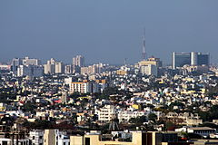
Kalkuta (https://www.bing.com/images)
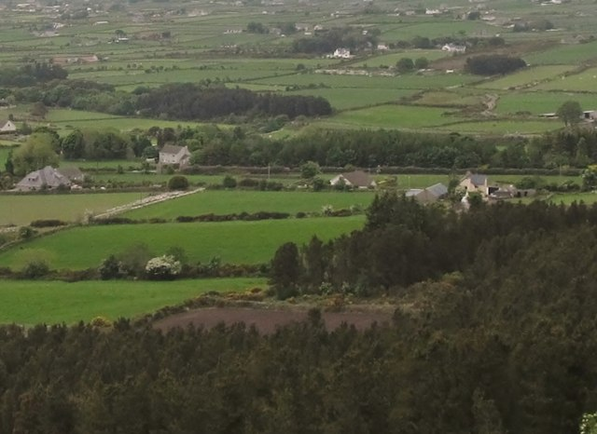

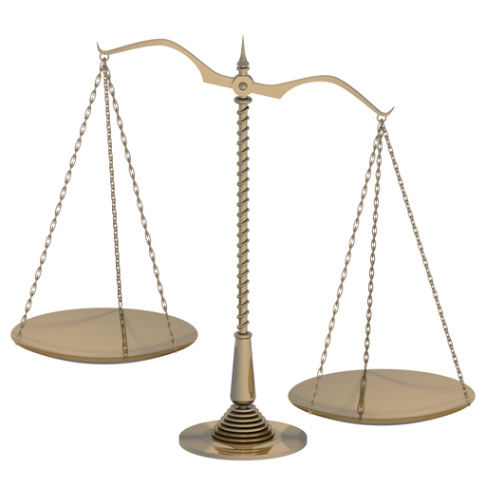
http://jorgesuberoisa.blogspot.com/2012/02/fragmentos-de-un-discurso-escrito-para_12.html

Rural settlement in the Rourke’s Park (©Eric Jones)

What are we going to discuss during our today’s class?

EXPLAIN:
Students listen to/read the lyrics of the song entitled ‘Big Yellow Taxi’ by Joni Mitchell and complete the gaps with: paved DDT gone tree museum spots
They paved paradise (3-4 minutes)
And put up a parking lot
With a pink hotel *, a boutique
And a swinging hot spot
Don't it always seem to go
That you don't know what you've got
Till it's gone
They 1. __________ paradise
And put up a parking lot
They took all the trees
Put 'em in a 2 ___________________ *
And they charged the people
A dollar and a half just to see 'em
Don't it always seem to go
That you don't know what you've got
Till it's gone
They paved paradise
And put up a parking lot
Hey farmer farmer
Put away that 3. _________________ * now
Give me 4. _______________ on my apples
But leave me the birds and the bees
Please!
Don't it always seem to go
That you don't know what you've got
Till it's 5. ______________
They paved paradise
And put up a parking lot
Late last night
I heard the screen door slam
And a big yellow taxi
Took away my old man
Don't it always seem to go
That you don't know what you've got
Till it's gone
They paved paradise
And put up a parking lot
They paved paradise
And put up a parking lot
© January 7, 1970; Siquomb Publishing Corp

ANSWERS:
- paved 2. tree museum 3.DDT 4.spots 5.gone

- The students answer the questions: (3-4 minutes)

What is this song about?
What has happened in the place described in the song?
Could you enumerate the activities?

DDT - a chemical formerly used to kill insects that harm crops (https://www.ldoceonline.com/dictionary/harm)

- The teacher asks students two questions about factors affecting or destroying the natural balance (10 minutes)

Students work individually/in pairs. They come up with their ideas and look for some in the article
entitled: Humans exploiting and destroying nature on unprecedented scale – report | Environment | The Guardian

(https://www.theguardian.com/environment/2020/sep/10/humans-exploiting-and-destroying-nature-on-unprecedented-scale-report-aoe)

Question 1: What human actions affect the natural balance?

(e.g. deforestation, overfishing, noise/water/air pollution, overpopulation , burning fossil fuels, etc.)

Question 2: What are the consequences of these actions?

( wildfires, soil erosion, global warming, melting of glaciers/polar caps, smog, air pollution, harm to the health of humans/animals/plants, damage to buildings etc. (5-6minutes)

- Students share their ideas on https://presenter.ahaslides.com/ (7 minutes)

EXTEND:

- Summary of the students’ answers: students get familiar with the results of the survey consisting of 2 questions. They read out the answers and comment on them. (5 minutes)

EVALUATE:

- Students name human actions affecting natural balance presented in the pictures. (5 minutes)

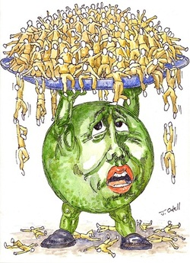
https://www.mrgscience.com/ess-topic-84-human-population-carrying-capacity.html

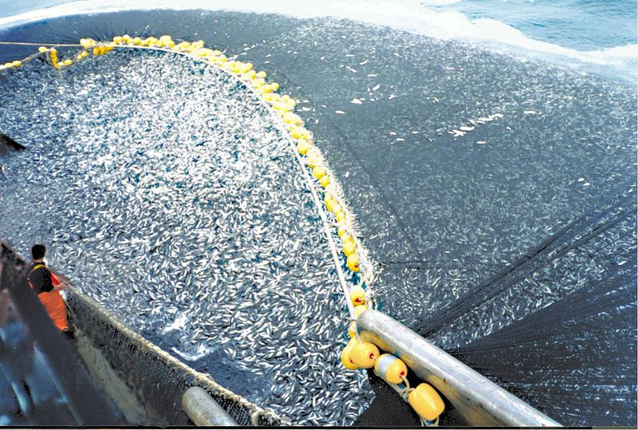
http://www.biologiamarina.eu/Saccheggio_pesce_in_Africa_p3.html

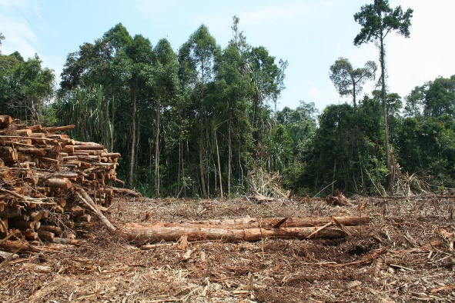

https://intercontinentalcry.org/new-evidence-shows-willful-destruction-of-the-brazilian-amazon/

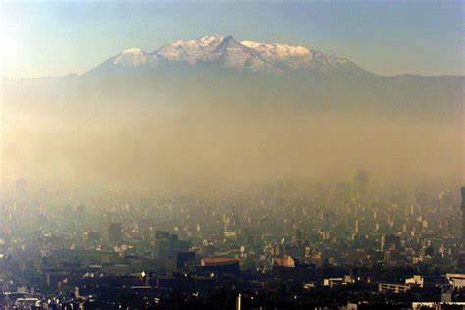

https://energycue.it/smog-citta-traffico-non-problema/17716/

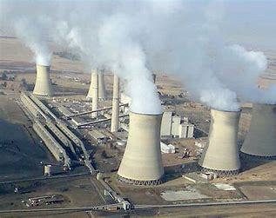

http://wagingnonviolence.org/feature/will-fossil-fuel-divestment-take-root-south-africa/

- Name other harmful human actions not shown in the pictures.

- Decide which problems seem to be urgent and should be immediately taken care of?

MODULE 1 – HUMAN AND NATURE
PART 5. Maintaining the natural balance
Lesson 2: Designing a social awareness for the natural balance project

1. THE LESSON CONTENT
Age of target students: 15+
Teaching time: 1 hour
Disciplines: English, art, ICT, biology, social studies, geography
Title: Social awareness and natural balance – designing a project.

2. OBJECTIVES
Competences promoted in this lesson:
- Communication in foreign languages competency
- Digital competency
- Learning to learn competency
- Social and citizenship-related competencies
- Initiative and entrepreneurship competencies
- (cultural awareness and expression competences)
Lesson objectives:
- They design a project that creates social awareness for the protection of the natural balance.

It is vital to understand that the students are encouraged and invited to come up with their own ideas of a project as it has to be something relating to their own culture best. Some groups might choose to organize a social campaign involving spreading leaflets, creating an online book whose superhero protects the nature and its sustainability and, in the end turns out to be a common, regular teenager whose everyday actions do wonders for the planet protection. However, in this lesson it is proposed that the students should design a project in the form of an Instagram or tik-tok account. The task is thought to be an engaging and highly developing activity for the students themselves and it is crucial to allow them to maintain independence in choosing certain solutions or ideas, e.g.
If the students decide to create an online book/comic book then they might use the following free tools in the process:
Free Comic Strip Maker - Create Comic Strips Online | Canva
Create Your Own Comic Strips Online with MakeBeliefsComix
https://www.pixton.com/create/comic-strip
https://www.canva.com/create/ebooks/
https://fliphtml5.com/
https://myebookmaker.com/

3. LEARNING – TEACHING PROCESSES
There are following stages in the lesson:
- ENGAGE: Introduction and warm-up activities
In this initial stage of the lesson students are asked to recall the conclusions drawn at the end of the previous lesson:
- they are the ones responsible for spreading awareness
- a change has to start now and locally
- people’s attitudes towards nature and themselves can be changed and shaped through education
- a project has to be designed
- EXPLORE:
1. In order to make sure the students know what environmental sustainability is, the teacher writes a number: 24% on the board and asks the students what it refers to. There might be some answers but if none of them is correct, the learners need to be informed that this is the number of avoidable deaths around the world that can be traced back to environmental factors (https://www.who.int/docs/default-source/documents/publications/quantification-of-the-disease-burden-attributable-to-environmental-risk-factors.pdf?sfvrsn=dbac7e7e_1).
2. The teacher asks what people need to live (clean air to breathe, fresh water to drink, safe, not affected by pollution places to leave)
3. The students are shown the U.S. Environmental Protection Agency’s (https://www.epa.gov/report-environment/sustainability-and-roe) definition of environmental sustainability: “meeting today’s needs without compromising the ability of future generations to meet their needs.” As a conclusion: the teacher asks what each of us can do everyday to lead a life in accordance with this definition. Students are supposed to number just 3 or 4 things to show their understending of the issue.

- EXPLORE:

- In this stage of the lesson, the learners are informed that as the main part of their project they will be setting up a tik-tok account in which they are going to provide and promote daily activities helping to sustain natural balance.

- Depending on the number of students, they will be divided into pairs or groups. The teacher gives out shapes that fit together and asks the students to find the people they can make a rectangle with. The rectangles or other shapes stand for a team.

3. Each team is asked to come up with 3 activities/actions that their peers might find engaging and ineteresting to do every day in order to start caring about their mental well-being and natural sustainability. They will have to be recorded and then uploaded to tik-tok. These might be such challenges as going to school or back home on foot once a week. It is also each team’s responsibility to suggest how the followers or tik-tok users might be rewarded for joining in. It would be of vital importance to invite school communities to join the project. Thanks to that the scope of the project would be widened and would contribute to creating a community of the teenagers involved and joined by the common purpose and bond. Not to mention the fact that the reward system could be introduced and linked with the school grading system.

- EXPLAIN:
Making a thorough plan of the project. The students need to decide about the deadlines, the way they will introduce the information about the project to the tik-tok users (the logos, the name, the leaders, the goals), how long each challenge or task will last, who will be responsible for managing the account and who this person will be assisted by.

- EXTEND:
Students start setting up the account and fulfilling the initial steps.
5. EVALUATE:
During this phase, the students will be carefully observed by the teachers. Their understanding of the concepts will be assessed through their involvement in the process of creating the project and its content, e.g. how applicable and realistic actions they propose, how reasonably they plan particular steps of the project. The quality of the final product will be assesed too.

