Project ID: 2021-1-CZ01-KA220-SCH-000034484
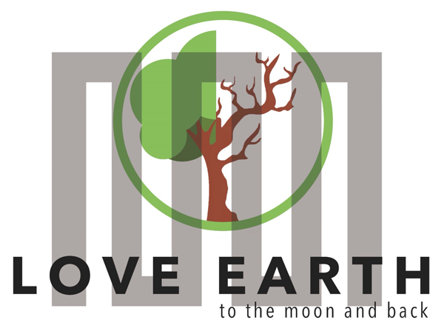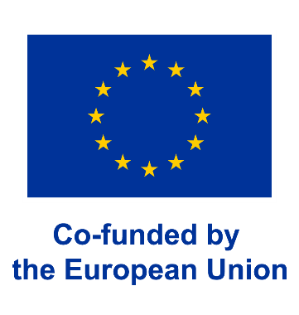

COURSE FOR ENVIRONMENTAL EDUCATION
e-Modules: Teaching Learning activities and their technology enhanced material set to develop

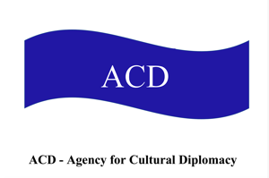

Guiding insights to theoretical framework, methodology and content provided by
ACD-Agency for Cultural Diplomacy Team
in the ERASMUS+ project LeMOON

COURSE AUTHOR
©Tatjana Christelbauer MA (TC)
ACD Team Austria

DISCLAIMER
Funded by the European Union. Views and opinions expressed are however those
of the author(s) only and do not necessarily reflect those of the European Union or the European Education and Culture Executive Agency (EACEA). Neither the European Union nor EACEA can be held responsible for them.
COURSE SHARING LICENSE CC BY-NC-SA = 
Canonical URL: https://creativecommons.org/licenses/by-nc-nd/4.0/

MODULE: ALL Modules

Guiding insights to theoretical framework, methodology and content provided by ACD-Agency for Cultural Diplomacy Team
In the ERASMUS+ project LeMOON

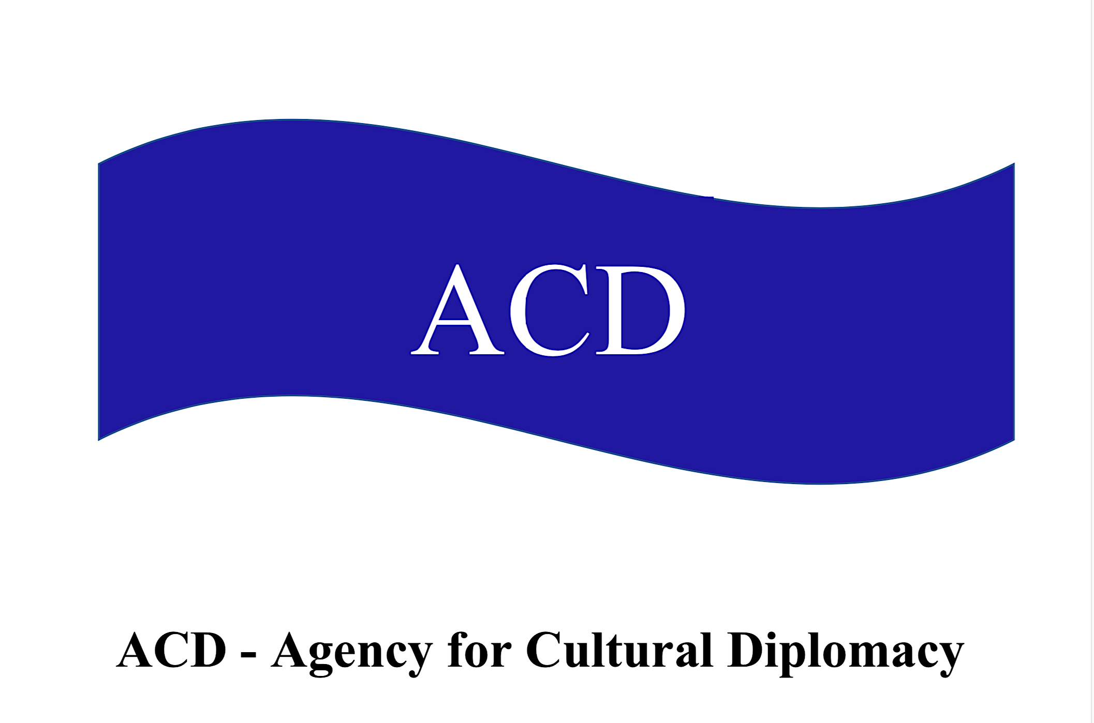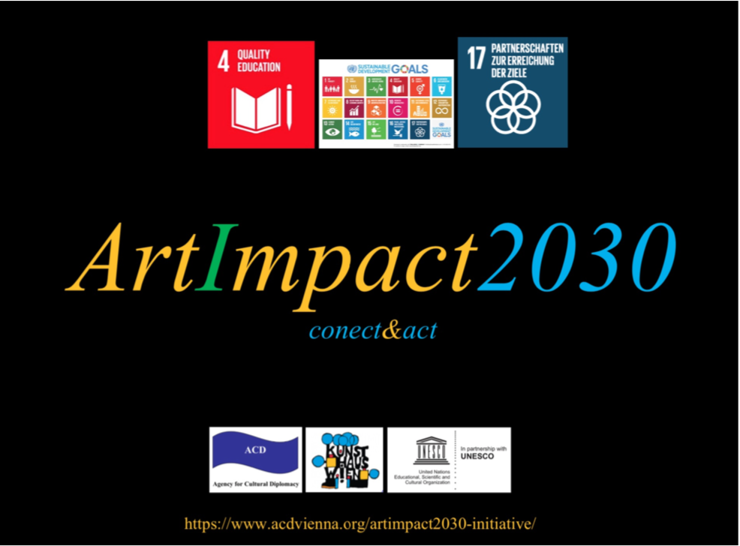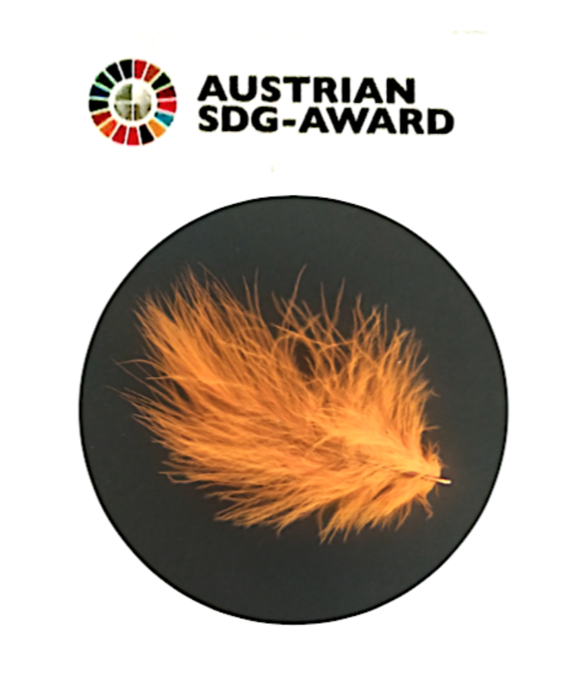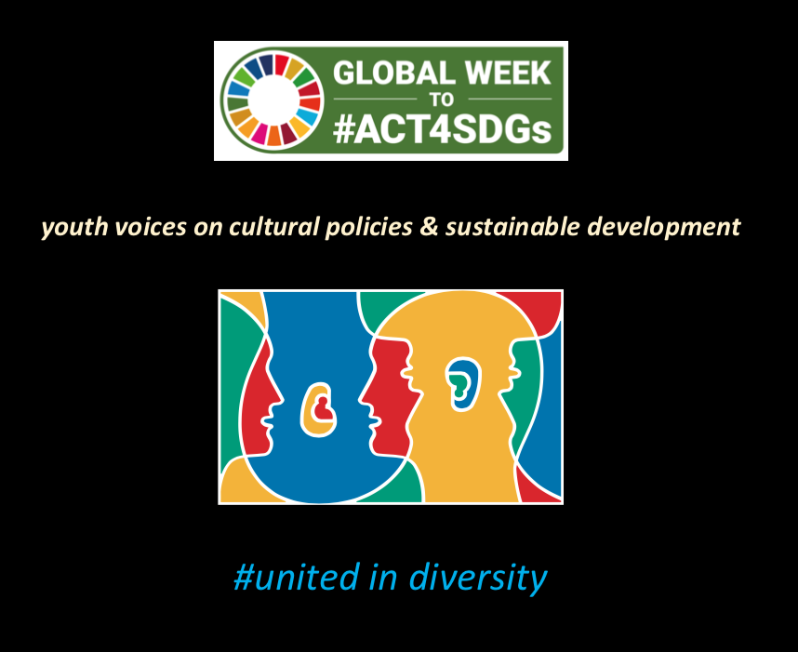

ACD-Agency for Cultural Diplomacy Team
Guiding insights to theoretical framework, methodology and content provided by ACD-Agency for Cultural Diplomacy Team
In the ERASMUS+ project LeMOON

Our methodology for lessons provided in the ERASMUS+ project LeMOON has been composed by ©Tatjana Christelbauer MA, ACD-Agency for Cultural diplomacy president, project partner, manager and trainer/researcher in the project. Contributions to Modules and lessons are provided by appointed ACD- team members, experts from fields of arts, science, policy, new media technologies, education, research, …

Format: Thematic Units for Week-Long Workshop Sessions:
Inquiry-Based Integrated Learning Workshop Series
on the Intersection of Arts, Science, and Policy"

Code of Conduct
The contents may inspire and guide for further encounters while following the laws of its nature as a guest, as the most insights are protected under diverse licenses. Therefore, is recommended to respectfully treat the copyrights of the intellectual property. For our content, we use the following licence:
COURSE SHARING LICENSE CC BY-NC-SA =
Canonical URL: https://creativecommons.org/licenses/by-nc-nd/4.0/

Images of Hundertwasser´s artworks have been exclusively provided for the use in this script by Hundertwasser Private Foundation Vienna and are under the copyright of the Hundertwasser

Table of Content
- Brief Introduction, ACD- project team members
  - Format
1.2 Methodological Concept
- Overall Aim
2.1 Relevance to the European Skills Agenda
- Overall Frame for the Creation of Learning Insights and Methodology Use
3.1 Cultural Diplomacy for Sustainable Development
- Theories and Concepts Used and Applied in the Content Provided by ACD
4.1 Theoretical Backdrop
4.2 Educational Concepts and Approaches
4.3 Methodology
4.4 Multiple Techniques for Inquiry-Based Learning
4.5 Learning Materials and Tools Used

- Brief introduction

ACD-Agency for Cultural Diplomacy Team brief introduction:
collaboration on the intersection of arts_science_cultural diplomacy for sustainable development

Tatjana Christelbauer MA: ACD- President&Founder, Project Manager, art_science_policy educator; Dr. Geraldine Fitoussi-Hoffmann: physician, Kari Film, ACD ParlaMint Spaces Academy member;
Lazar Bulatovic MA (ACD Ambassador for blind, Braille script & assistive technologies)
Mag. Tamara Tomasevic ACD Ambassador, expert for Ethics&Integrity, Intercultural education

Austrian Federal Institute for Blind BBI Wien- ACD-beneficiary partner in the project:
Mag. Erich Schmid: former teacher at the BBI institute Vienna, Expert in assistive technologies Carla Laszakovits: dipl. Pedagogue, English teacher
Focus group student participants BBI Vienna;

Members of the ACD- team for the temporary contribution:
Mag. Andrea Nagl: professional contemporary dance artist and dance teacher, craniosacral therapist, ACD Ambassador for dance arts in sustainable development
Elke Freytag: Austrian fashion designer, ACD Ambassador for fashion&lifestyles
Dr. Nathalie Tassotti: Mathematician, Ballet teacher

ACD-Agency for Cultural Diplomacy Team contribution, key terms:
#creative ecology, #planetary thinking #art&health, #resilience, #policylearning #culturaldiplomacy #dancearts #finearts #newmedia #europeandayoflanguages #sustainability, #FriedensreichHundertwasser, #spaceeducation, #steam, #AI, #UNESCOfuturesofeducation

Additional activities in the E+ LeMOON project:
AI -acts: "Truth, Trust & Hope: EU-AI-ethical guide" in collaboration with Deliberation Platform, Stanford University inTalk virtual sessions with students and teachers;
Workshops for the European Day of Languages with all ERASMUS+ LeMOON project teams

ACD-Agency for Cultural Diplomacy about
ACD-Agency for Cultural Diplomacy (Agentur für Kulturdiplomatie) was founded by Tatjana Christelbauer MA and Mag.iur Erhard Christelbauer MBA, LLM
and registered by the Federal Police Office in Vienna Austria on Mai 12th 2016 as a non-profit- cultural association, whose founding members are academic professionals engaged in intercultural education, arts, sciences, and diplomacy, legal & compliance.

ACD Mission Statement
Our mission is to contribute to sustainable development and the achievement of the 17 Sustainable Development Goals through art-based education within the framework of Cultural Diplomacy 2030. We integrate these initiatives into the practices of civil society organizations (CSOs) with an emphasis on the ACD concept of Cultural Diplomacy 2030, highlighting gender perspectives and cultural diversity as essential elements in promoting a more just and peaceful world.
The Austrian SDG Award was granted to the Orange Feather – Stille Post 25/11 x 365 educational initiative, which supports the UN Women global campaign, "16 Days of Activism for Ending Violence Against Women and Girls." This initiative combines media promotion, art projects, and educational workshops to foster assertive communication at cross-generational scale, for ending and preventing relational violence in all forms.

Green & transversal skills & future competencies are promoted through opportunities for engagement and experience-based learning
Memberships: European Pact for Skills, European Science Diplomacy Alliance, Anna Lindh International Network, Austrian IG Kultur
Bricks4futures initiatives, engaging with BVI youth and teachers by the new platform: https://www.acdvienna.org/aktuell/dots4futures/

  - Thematic Units for Week-Long Workshop Sessions:
Inquiry-Based Integrated Learning Workshop Series
on the Intersection of Arts, Science, and Policy"

The workshop series provides a comprehensive learning experience that goes beyond traditional disciplinary boundaries. It suggests that participants will engage deeply with the topic through a variety of lenses, by considering diverse viewpoints and methodologies from different fields enhancing their understanding and supporting transversal skills.
Proposing Project activities for assessment allows students to demonstrate comprehensive understanding by applying knowledge in a practical context, fostering collaboration, creativity, and critical thinking through hands-on implementation and problem-solving.
This format encourages deeper engagement as students navigate real-world challenges, promoting skills that are transferable beyond the classroom.

  - The methodological concept
Integrated variety of diverse situated theories, methods, and approaches is aimed to foster an inclusive and comprehensive creative learning environment on the nexus of arts_sciences_policy.
By emphasizing ethical education, inclusive-and diversity responsive thinking and reflective practices, we aim to develop responsible, ecologically aware individuals who are equipped with green skills
and future competences to navigate and contribute positively to their communities and the broader world. Including gender perspective into all subjects, and emphasizing the importance of equal rights, opportunities, and shared responsibilities for just societies and peaceful relational cultures without violence, we are ensuring that students are well-prepared to address the current global
challenges and engage in sustainable development process as active contributors, fellows, and leaders.
For each module, the ACD team members have composed a comprehensive set of lessons, complete with an introductory guide to the topics, guiding questions for inquiry-based study, and engaging exercises. Each lesson includes weblinks and references for further study and research, as well as a guide for deeper experience and understanding through week-long projects and workshops, to extend knowledge-to action, to increase competences and widen skills.
Each module is introduced with an overall description of the content and insights, highlighting the art-science-policy nexus. This section details the methods from the arts, the scientific subjects we focus on, and the relevant policies we reference to. Additionally, the module outlines the titles of individual parts and provides a list of supplementary materials, such as documents for further reading, posters, audio, and video materials.
All content is organized around three key aspects, applied to the three pillars of sustainability—ecology, economy, and social relations. This approach ensures an ethical framework, emphasizing the importance of understanding "the matters” and the impact of our actions in these various aspects.
By doing so, we aim to equip students and teachers with the knowledge and skills needed to address contemporary challenges in a sustainable and meaningful way.

An innovative approach
to art mediation is introduced by semantic meditation sessions on Austrian born international artist and environmental activist Friedensreich Hundertwasser artworks, created by Tatjana Christelbauer. Hundertwasser's artworks, often named in two or more languages are offering multiple symbolic interpretations and cultural perspectives. Each language represents a distinct cultural context, linguistic perspective, and interpretation of the artwork and its themes, enriching the artwork with layers of meaning and symbolism.
Through the pronouncement of the artwork's title and reflection in two, three or more languages, the exercise embodies the principles of symbolic interactionism by highlighting the role of language in meaning negotiation.
The shift between languages mirrors the dynamic process of symbolic interaction, wherein meanings are negotiated and shared through linguistic exchange.
By embodying Hundertwasser's artwork and engaging in multilingual reflection, participants negotiate meanings, challenge assumptions, experience how the same meaning translated in diverse languages can enact different states of matter and embodiment and cultivate transformative insights that contribute to a more holistic understanding of sustainability and environmental stewardship.

- Overall Aim:
Promoting green & transversal skills and future competences: green shift in the mindset 4 responsible action and interaction:
Our objective is to foster essential green and transversal skills and competencies, that are applicable across various fields and contexts, emphasizing social competences, particularly through soft skills and system thinking in communication and emotional cognition to build a foundation for responsible and reflective learners and teachers, who
are not only capable of thriving in their careers but also of making meaningful contributions to society and the environment.
Engaging blind and visually impaired students and their teachers into collaborative learning activities with non-blind students and teachers, our content has been co-developed with wider accessibility and include diverse perspectives, what makes added value to the insights and widens opportunities for diverse learners to engage.

  - Relevance to the European Skills Agenda: The European Skills Agenda aims to strengthen sustainable competitiveness, social fairness, and resilience by promoting lifelong learning and equipping individuals with the skills needed for the green and digital transitions.
Green skills and transversal competencies are integral to achieving these goals, as they:
- Enable individuals to contribute to a sustainable economy.
- Foster innovation and adaptability in a rapidly changing world.
- Promote social inclusion and equal opportunities.
Visit the webpage, learn more about the European Skill Agenda:
https://ec.europa.eu/social/main.jsp?langId=en&catId=1223&moreDocuments=yes and the European Pact for Skills: https://pact-for-skills.ec.europa.eu/index_en

- Overall frame for the creation of learning insights and methodology use:

  - Cultural Diplomacy for Sustainable Development:
At the Intersection of Arts, Sciences, and Policy Learning:
This approach enables youth and civilians to understand the importance of mutual engagement in the sustainable development process. It promotes sustainable development through arts and cultural practices situated within various fields of action and sectors, applying on scientific evidence for a comprehensive understanding of sustainable development in policy and practice of each and many individuals together.

Three Pillars of Sustainability: Economic, Ecological, and Social Aspects: These pillars serve as an ethical guide for posing questions in our lessons to reflect on the impacts of human actions and climate change. This reflection fosters awareness and responsible decision-making in all aspects of life.
Inclusive approach: Engaging with blind and visually impaired students and teachers in creative collaborations and inclusive initiatives is not only essential for fostering a supportive social climate but also for advancing the green transition and addressing climate change-related challenges.
According to UNESCO, fostering inclusive and equitable education is essential for promoting sustainable development and addressing climate change. Engaging individuals with diverse abilities, including blind and visually impaired individuals, in collaborative initiatives enhances creativity and innovation, leading to more effective solutions for environmental challenges (UNESCO, 2020).
Furthermore, the United Nations Sustainable Development Goals (SDGs) emphasize the importance of leaving no one behind in the pursuit of sustainable development. By actively involving blind and visually impaired individuals in environmental initiatives, we promote social inclusion and ensure that all members of society have the opportunity to contribute to the green transition (United Nations, 2015).
Art-based learning enables barrier-free accessibility which is one of the fundamental principles
of inclusive education and sustainable development. UNESCO highlights the importance of providing accessible learning environments and materials for individuals with disabilities to ensure their full participation in educational and environmental activities. By embracing alternative forms of communication and making environmental initiatives accessible to blind and visually impaired individuals, we promote inclusivity and equity (UNESCO, 2019).
Research has shown that representation matters in environmental decision-making and policy development. The United Nations Convention on the Rights of Persons with Disabilities recognizes the rights of individuals with disabilities to participate in all aspects of life, including environmental governance. By empowering blind and visually impaired individuals to actively participate in environmental initiatives, we promote democratic values and strengthen social cohesion
(United Nations, 2006).
Building Resilience: The Intergovernmental Panel on Climate Change (IPCC) highlights the importance of building social resilience to adapt to the impacts of climate change. Inclusive collaborations enhance social cohesion and mutual support within communities, leading to greater resilience in the face of environmental challenges. By involving blind and visually impaired individuals in green transition efforts, we strengthen the resilience of society as a whole (IPCC, 2014).
Promoting Environmental Justice: The concept of environmental justice emphasizes the fair distribution of environmental benefits and burdens across society. Research has shown that individuals with disabilities, including those who are blind or visually impaired, are often disproportionately affected by environmental hazards and climate change impacts. By promoting the inclusion of marginalized groups in environmental decision-making processes, we advance environmental justice and equity (United Nations, 2009).
In conclusion, evidence from organizations such as the United Nations and UNESCO underscores the importance of engaging blind and visually impaired individuals in environmental initiatives for promoting social climate, advancing the green transition, and achieving sustainable development goals. By embracing diversity, fostering inclusion, and empowering all members of society, we can create a more resilient, equitable, and sustainable future for generations to come.

- Theories and concepts used and applied in the content provided by ACD-Agency for Cultural Diplomacy team on the nexus of arts_sciences_sustainable development policy;
Overview of introduced methods and practices
  - Theoretical backdrop
Symbolic Interaction: based on theories provided by G.H. Mead, C.S. Pierce, P. Ricoeur, T. Hana. These theorists provide a foundational framework for understanding communication through symbolic interaction, where meanings are constructed through social interactions. This theory-bound aids in developing competences in communication through understanding of symbolic interaction, allowing students to understand metaphor and meaning through a three-fold approach to language and signs: somatic (body-related), semantic (meaning-related), and semiotic (sign-related), enabling a comprehensive understanding of language in context.
According to G. H. Mead, meaning arises through social interactions, where individuals interpret and respond to symbols based on shared understandings within a particular social context. These symbols can include words, gestures, signs, and other forms of communication. In the context of translation, symbolic interactionism offers insights into how meaning is negotiated and communicated across different linguistic and cultural contexts.
By highlighting the importance of ecological balance and sustainability in all aspects of human activity, translation can be explored as a practice of the green transition,
as outlined in the European Green Deal Strategy, by engaging artists to creatively explore and communicate environmental themes, promote sustainable behaviors, and inspire action towards a greener future. This involves harnessing the power of art to foster empathy, provoke reflection, and stimulate dialogue on pressing ecological issues, while translating environmental policies and initiatives into action by raising awareness, promoting eco-friendly behaviors, and advocating for sustainable practices within communities.

Ideokinesis is a concept that emphasizes the connection between imagination, movement, and perception in physical experience. Developed by Mabel Elsworth Todd, it revolves around the idea that mental imagery and the concept of movement can directly impact physical performance. In the context of the living metaphor of the rain rhythm, ideokinesis can be employed as a creative approach to enhance sensorimotor insights through a biomimetic source, which enables self-experience as a part of nature and the nature as a mentor for reinforcing, rather than damaging life sources, spaces for encounters, and relationships. According to P. Ricoeur, metaphors play a pivotal role in invoking moral imagination, as they provide vivid and symbolic images that guide ethical reflections when preceded in imagination. The use of metaphors is aimed at enacting multiple imaginative reflections through practical encounters with others, and re-orient toward shared understandings of broad terms such as sustainability and care.

Enacting Moral Imagination:
Philosophical insights provided and promoted by J.P. Lederach & L. Wittgenstein emphasizes the use of self-reflection and thought experiments to cultivate empathy and ethical understanding, while learning to imagine the potential impacts of their actions and prevent potential damages, learning to notice details and aspects in communication, and to engage in creative problem-solving.

Including Gender perspective: Integrating Standpoint Theory into our methodology, informed by scholars like G.C. Spivak and D. Haraway, allows us to understand societal dynamics through a gender lens, recognizing the unique perspectives shaped by factors such as gender, race, and social status. By applying this lens, we foster inclusivity, challenge binary frameworks, and address intersecting forms of discrimination, striving for equitable and just societies. Through centering gender perspectives and embracing a feminist approach, we work towards amplifying marginalized voices and dismantling systems of oppression.

  - Educational concepts and approaches
Humanistic Education and Relational Pedagogy: Rooted in the principles of humanistic education, reform pedagogy, and relational pedagogy as advocated by Margarete Schörl, John Dewey, and Bruno Latour, among other respective authors, our approach prioritizes ethical education and interactive learning experiences. Aligned with the UNESCO Education for Sustainable Development framework, we ensure inclusivity and ethical considerations in our teaching methods and curriculum design, fostering a holistic and sustainable approach to education. Bruno Latour's philosophy encourages us to reconsider our relationship with the natural and surrounding world and recognize the intricate networks of relationships that sustain life on Earth.
John Dewey's pedagogy advocates for a hands-on, inquiry-based approach to learning that encourages students to engage directly with environmental issues and challenges. By fostering critical thinking and problem-solving abilities, Dewey's approach empowers students to understand complex ecological systems and develop innovative solutions to environmental problems.
Furthermore, Dewey's emphasis on democracy and community engagement aligns with the principles of sustainable development, which prioritize inclusivity, social justice, and participatory decision-making. By promoting collaboration and collective action, Dewey's pedagogy enables students to work together towards common goals, including the preservation and restoration of the natural world.
The socio-educational approach based on humanistic value axioms such as human dignity, solidarity, the common good, subsidiarity, freedom, and responsibility, developed and promoted by the Austrian pioneer of modern early childhood education Margarete Schörl offers a wide range of thought and action tools for education for life in a multifaceted interwoven world, as
responsible individuals and members of diverse communities. “Love to our next” is the core principle of M. Schörl´s educational concept. Space-concept, fellow leadership concept, and methodology for learning has been developed under one key term by M. Schörl: fellowship guidance. #stayinlove motto in our lessons was inspired by M. Schörl´s note in “Erziehung zu Mitmenschlichkeit“: “bleibe in Liebe”, meant to avoid damage and harm in relational cultures.

Deliberative democracy, deliberative polling:
Deliberative democracy is a political theory and practice centered around the idea that legitimate decision-making should involve informed and inclusive discussion among citizens.
Stanford University professor James S. Fishkin further developed the concept of deliberative democracy with his work on deliberative polling. Deliberative polling involves gathering a representative sample of citizens, providing them with balanced information on a particular issue, and facilitating structured discussions to explore different perspectives. Prof. Fishkin's deliberative polling method has been used in various countries around the world to inform public policy decisions and enhance democratic practices. It emphasizes the importance of informed citizen deliberation and aims to bridge the gap between public opinion and policymaking by ensuring that the voices of ordinary citizens are heard in the political process.
In collaboration with Prof. Alice Siu Phd, a scholar of Prof. Fishkin, ACD team created virtual sessions with blind-and non-blind students to engage in discussions around AI ethics via deliberative democracy platform. Guiding insights for learning deliberative democracy approach are contained in the lessons to the topic of AI-ethics and Global citizenship in the Module 6.
Arts
Hundertwasser’s Art and Environmental Activism: with guiding insights form Hundertwasser’s
art and environmental activism, we emphasize social ecology and the development
of a green mindset through reflective, creative, and artistic practices.
This approach fosters attentive and respectful relational cultures, encouraging responsible
actions among humans and towards the environment, inspires for engaging in “soft power activism” through connecting with the national, European and international Youth initiatives dedicated to and aimed in supporting sustainable development through activities in education, drafting policy recommendations and attending & organizing virtual and on-site meeting son side of relevant events such as those initiated by the EU, UN and national and local governmental organizations, with contribution form the civil society and youth.

  - Methodology
Inquiry-Based Learning with moderated, facilitated and hands-on-guided Creative Methods:
Utilizing techniques from dance, fine arts, somatic practices, thought experiments, guided imagination, and storytelling, this method fosters creative freedom within a structured timeframe. The serious play method and inTalk sessions elicit empathy, active listening, reflexivity, and high levels of participation. Facilitated and moderated format allows students to explore and experiment, leading to deeper engagement and learning, within a structured process and timeframe.

STEAM Approach: Combining arts with science, technology, engineering, and mathematics, this approach facilitates creative entries into complex scientific theories, enhancing communication through artistic expression. In collaboration with blind and visually impaired students and the use of assistive technologies, teams expand their overall knowledge and competences, ensuring an inclusive learning environment.

Arts in science, science in arts: applied on Martin Wagenschein´s didactic and Ecological System Thinking (U. Bronfenbrenner): Integrating Wagenschein's pedagogical principles and Bronfenbrenner’s ecological systems theory, we apply system thinking to relational pedagogy.
This approach examines the interconnectedness of humans and their environments, providing a comprehensive backdrop for understanding the complexities of learning and development.

Learning Through Reflection, Engagement, and Collaboration: Incorporating diverse abilities, needs, experiences, and perceptions, this approach allows multiple entries to various topics. The deliberative approach enables the inclusion of diverse voices, teaching students to negotiate and prioritize for the greater good, aligning with the principles of deliberative democracy and cultural democracy.

Learning through Arts, deliberative approach:
Noticing aspects and developing a sense for detail, reasoning by the sense of responsiveness:
Incorporating the art practices and art-based learning methods such as dance, fine arts, storytelling, music, role play, in education enhances students' ability to observe details and respond thoughtfully, cultivating a deeper understanding and appreciation of their surroundings.

Dance arts, somatic practices: modern and contemporary dance, and ballet, somatic practices such as craniosacral, respiratory exercises, semantic movement-based dance mediation and instant improvisation, enable a multifold holistic experience of embodiment, including deep sensory awareness in a verbal and in nonverbal communication.

Fine arts and creative design: inquiry-based learning by drawings, painting, storytelling, role play, music composition and voice exercises in a multilingual setting with culinary art and fashion design supports individual reflective experience and collaborative engagement, while also deepening the sense for detail and developing skills for presentation.

AI art tools, assistive technologies, digital literacy: a bound of tools and practices for developing digital literacy skills and competences with a focus on ethics in communication and handling with diverse new media technologies, tools, apps, and devices. We promote and practice AI Dream by Wombo and Braille Art as simple for use, among other tools

  - Multiple techniques for inquiry-based learning and communication
Guiding Insights: By providing multiple form guiding insights with references for self-study, we enable students to elaborate on topics within week-long projects.
This method fosters adaptive and diverse situated learning, resulting in deeper understanding and personal and community-based engagement with the material.
Guiding questions and the use of key terms are valuable methods for inquiry-based and competences & skills-oriented learning because they provide a clear focus and direction for exploration. Guiding questions stimulate critical thinking, encouraging students to delve deeper into subjects and discover underlying principles.
Key terms serve as anchors, helping learners to grasp essential concepts and vocabulary, which are crucial for understanding complex topics. This approach fosters active engagement, as students must actively seek out information and construct knowledge rather than passively receiving it. Additionally, it helps in developing critical competencies such as problem-solving, analytical thinking, and effective communication. By centering learning around these methods, educators can better equip students with the skills needed to navigate and excel in an increasingly complex world.
Presentation techniques: moderation, art performance, project presentation, blog writing, sound recording. Moderation enhances communication, leadership, and conflict resolution abilities.
Art performance fosters creativity, public speaking, and emotional intelligence, while project presentation develops organizational, research, and collaborative skills. Blog writing and sound recording improve writing, digital literacy, technical skills, and storytelling+ …

Various Media Use and CLIL for Language Competence: Integrating Content and Language Integrated Learning (CLIL) with the use of various media, we focus on the semantic, somatic, and semiotic approaches to language and key terms in lesson topics. This approach enhances language competence and facilitates deeper engagement with the content.

Thought experiment, guided imagination, storytelling:
Thought Experiment involves imagining a hypothetical scenario to explore the consequences of different actions and decisions. This method encourages learners to think critically about potential outcomes and ethical implications, fostering a deeper understanding of sustainability issues.
Guided Imagination involves leading learners through a structured visualization exercise to envision a sustainable future or empathize with affected communities. This technique helps them develop emotional connections and ethical considerations, motivating active engagement in sustainable practices.
Storytelling method uses narratives in a multilingual setting to convey complex sustainability concepts and human experiences in an engaging and relatable way. By connecting with stories, learners can better understand the real-world impacts of environmental issues and feel inspired to take meaningful action towards sustainable development.

Ethical dilemmas: Incorporating ethical dilemmas as a method for ethical reasoning, especially for high school students, is essential in developing critical thinking and moral reasoning skills.
This method involves presenting students with complex, real-world situations that require them to consider various perspectives, weigh potential outcomes, and make reasoned decisions.
By engaging into moderated practice of ethical dilemmas, students learn to navigate moral ambiguities, develop empathy, and understand the implications of their choices on individuals, communities, and the environment. This practice not only enhances their ethical understanding but also prepares them to handle challenging decisions in their personal and professional lives.

Benefits: Self-reflection and ethical imagination guided by thought experiments are powerful tools for promoting this mindset shift. By envisioning different scenarios and considering the consequences of our actions, we can develop a greater awareness of the interconnectedness of environmental issues and the importance of sustainable practices. Thought experiments help us cultivate a sense of responsibility and empowering us to make informed choices that prioritize thinking with the next, while imagining consequences in advance and thus preventing harmful acts, toward human world and nature.
Consequence-related behavioral control refers to our ability to modify our actions based on the anticipated outcomes and their impact on the social and natural environment. Through experiential learning and self-reflection, we can develop this capacity to consciously choose behaviors that align with sustainability goals and contribute to a higher green ratio.

  - Learning materials and tools used:
Applied on professional practices of the ACD-team members and materials developed, provided references, weblinks, documents for further reading and weblinks are mainly deriving from trustful and relevant authors and organizations, such as UNESCO education & documents, United Nations information pages, media and documents, EU-legal documents, relevant scientific papers mainly provided by the European authors, including materials and media with examples form various countries worldwide, to increase diversity and variety of views and findings, encourage critical thinking and engage in international debates, movies and learning materials of the European Space Agency and NASA, for our insights for Space education, Hundertwasser-art and environmental activism related articles on the official webpage, dance arts, music, videos and movies from known artists and relevant for the curriculum, articles, documents and webpages with relevant informations, documents, and examples of good practice from Austria.

- References to works of authors relevant in methodology of ACD team

Pedagogy:
Multiple Persepctive approach Education for SD
IkuBi2030: https://www.tatjana-christelbauer.com/en/ikubi-ii
SDG-learning by ACD: https://www.acdvienna.org/sdg-learning/
ACD Space Academy: https://www.acdvienna.org/sdg-learning/parlamint-planetarythinking/
UNESCO Futures of Education by ACD: https://www.acdvienna.org/futures-of-education/intalk-sessions-unesco-futures-of-education/
^{UNESCO ducation:}
https://unesdoc.unesco.org/ark:/48223/pf0000124238
https://unesdoc.unesco.org/ark:/48223/pf0000190006
https://unesdoc.unesco.org/ark:/48223/pf0000215431
Some references related to moral imagination, ethical development, and responsible action:
^{John Paul Lederach:}
Lederach, J. P. (2005). The Moral Imagination: The Art and Soul of Building Peace. Oxford University Press
Lederach, J. P. (2010). When Blood and Bones Cry Out: Journeys through the Soundscape of Healing and Reconciliation. Oxford University Press.
^{Dignity Model:}
Hicks, D. L., & Stapley, J. C. (2012). Dignity: Its Essential Role in Resolving Conflict. Yale University Press.
Hicks, D. L., & Vaught, S. W. (2018). Dignity and Dialogue: Resolving Conflict and Building Community. Rowman & Littlefield.
Inner Development Goals (IDGs) Initiative: Institute for Global Ethics. (2002). Inner Development Goals for the Future.
https://www.globalethics.org/resources/files/Inner-Development-Goals-for-the-Future.pdf
Chappell, D. W. (2018). Inner Peace, Global Impact: Tibetan Buddhism, Leadership, and Work. Quest Books.

Art Education and Pedagogy, STEAM ACD-team:
Tatjana Christelbauer: IkuBi2030, Education 4 Futures: https://www.acdvienna.org/sdg-learning/ ; Dance arts_science_cultrualdiplomacya2030: https://www.acdvienna.org/acd-dance-arts/ , https://www.tatjana-christelbauer.com/en/galerie/dancearts , Fine arts: https://www.tatjana-christelbauer.com/en/Arts4Sciences , Museum education: https://www.tatjana-christelbauer.com/en/kunst-kulturvermittlung/Kulturdiplomatie , arts4health: https://www.tatjana-christelbauer.com/en/arts/health
KariFilm Dr. Geraldine Fitoussi-Hoffmann: https://www.karifilm.media/impressum/
Mag. Andrea Nagl: http://naglandrea.com/
Dr. Nathalie Tassotti, Mathematic learn book: https://www.hpt.at/verlagsprogramm/schulbuecher/mathematik-fuer-ahs-6-mit-e-book , Ballett: https://www.itboe.at/nathalie-tassotti
Mag. Tamara Tomasevic:
Psychology: Ethical Dilemmas: Ralf Potter Box model for ethical reasoning: https://www.sagepub.com/sites/default/files/upm-binaries/39590_Chapter7.pdf https://pars.rs/en/news/judicial-ethics-and-prevention-corruption-judiciary-0

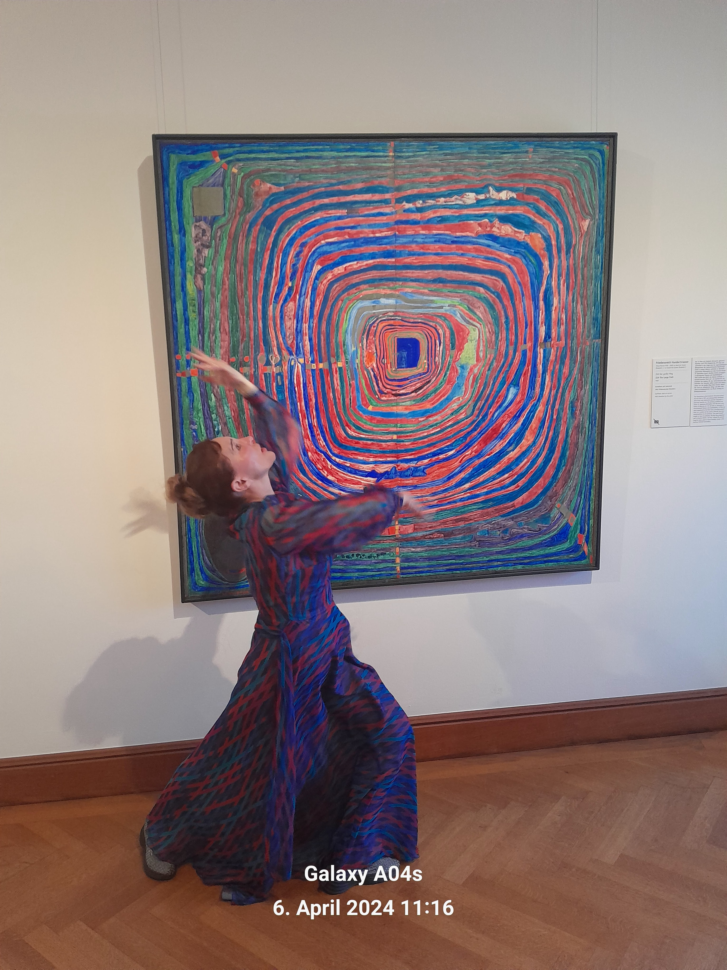

Image: ©TartjanaChristelbauer
Dance meditation to Hundertwasser´s artwork „ The Big Way“
Museum Obere Belvedere Vienna

Tatjana Christelbauer MA
Brief introductory to methodology

My lessons are rooted in diverse theories and incorporate "borrowed insights" from various authors, which have been placed into diverse contexts. While this approach may seem daunting at times, it reflects the complexity of life itself. I believe that diversity can be meaningfully connected, and it is crucial to understand the attachment and backdrop of the information we use.
In my teaching, I emphasize the importance of referencing my 3 decades long professional practice in education, arts and public relations with scientific evidence.
I draw upon resources from various scientific disciplines and approaches, even those that may be controversial. I believe that the challenge of connecting these diverse perspectives is motivated by a genuine interest and curiosity about how they can be brought together for the greater good.
We must not agree upon all the work of some author, but even only one aspect or a meaningful thought, can inspire and guide toward new horizons and frames, while situated within diverse contexts, interpreted form diverse perspectives, and welcomed as “good guests of nature” speaking with terms of Hundertwasser. When carefully treated, ´while knowing its backdrop and cradle, the borrowed seeds form a foreign garden will then grow within a new contextual frame, but with a same ethical aim: to inspire, provide guidance, and evidence for action in a favor of manyones together.´
Creativity plays a pivotal role in this process, as it allows us to shift boundaries and open up new possibilities for connection. By sharing common values within a contextual frame, such as sustainable development grounded in the idea of perpetual peace and responsible action, we can create innovative meanings and broaden perspectives. This approach not only fosters understanding but also promotes respectful treatment of everything we use and encourages responsible behavior.

Experiential learning through art and creative design, dialogues, individual activities, and collaborative sessions plays a crucial role in fostering the mindset shift required for the green transition. By engaging in hands-on activities, discussions, and collaborative projects, participants can explore environmental concepts in a tangible and immersive way, deepening their understanding of complex relational impacts among humans and nature. Learning with and from blind people enables perceptual shift from the visual toward multisensorial awareness.
Self-reflection and ethical imagination guided by thought experiments are powerful tools for promoting this mindset shift. By envisioning different scenarios and considering the consequences of our actions, we can develop a greater awareness of the interconnectedness of environmental issues and the importance of sustainable practices. Thought experiments help us cultivate a sense of responsibility and empowering us to make informed choices that prioritize thinking with the next, while imagining consequences in advance and thus preventing harmful acts, toward human world and nature.
Guiding questions and the use of key terms are valuable methods for inquiry-based and competences & skills-oriented learning because they provide a clear focus and direction for exploration. Guiding questions stimulate critical thinking, encouraging students to delve deeper into subjects and discover underlying principles.
Guiding questions related to my methodology:
How can creative learning methods contribute to barrier-free access to information and ensure that all individuals, can participate fully in the learning process?
Why is it essential for environmental education and sustainable development principles to be integrated into all learning subjects, and how does this contribute to a holistic understanding of our impact on the world around us?
Why is mastering relational cultures crucial for our collective prosperity and well-being, as advocated for by the UN Agenda 2030 and the Sustainable Development Goals (SDGs)?
How can environmental education be supported through arts and how arts_science_sustainable development policy nexus can serve for a comprehensive barrier-free learning methodology?

Vienna, 20th of June 2024
Tatjana Christelbauer MA

°Art_Science_Policy practitioner: engaged in research and practice on the interface of dance, fine arts, somatic practices with cognitive humanities and international relations https://www.tatjana-christelbauer.com/en/Arts4Sciences
° Dance arts: Martha Graham & Alvin Ailey Contemporary Dance School NYC, Member of the Modern Dance Company Smiljana Mandukic; lifelong practice, research, and performance in Vienna and international; conference speaker, performance lecturer, fine arts & multimedia installations https://www.tatjana-christelbauer.com/en/galerie
° Dance arts4health: mental health intalk & motion art projects with youth center Interface Vienna, migration &memory, poetry in motion choreographic compositions for Multikids Festivals, collaboration with embassies, researcher, multimedia artist in Vienna & internationally https://www.acdvienna.org/art-health-2030/
https://www.acdvienna.org/art-health-2030/art-exile/ , https://www.tatjana-christelbauer.com/en/arts4mental-health
° Master of arts in sociology: identity politics, cultural diplomacy; https://www.tatjana-christelbauer.com/kulturdiplomatie-cultural-diplomacy
° former employee as consultant for intercultural education and social integration at the Lower Austrian Government education department (1992-2020) as an Intercultural pedagogue, consultant and trainer in:IkuBi2030 learning model, Children Rights/ Human Rights in Education, Gender & Diversity; https://www.tatjana-christelbauer.com/en/ikubi-ii
° Dipl. Museum educator, cultural mediator: Hundertwasser ́s art in sustainable development, KPH Krems; Projects in collaboration with Austrian Cultural Forums (ACF) and Libraries abroad. https://www.tatjana-christelbauer.com/hundertwasser-artimpact2030-kunstvermittlung https://www.tatjana-christelbauer.com/kulturvermittlung-auslandskultu r
° Dipl. Public relations Manager, Cert. trainer for Wellness/Fitness/Nutrition; AMC Academy Wien ° Dipl. Corporate Health Manager, Harvard Health Academy CHWP https://www.tatjana-christelbauer.com/arts4mental-health
° ACD-Agency for Cultural Diplomacy association founder and president, project manager, trainer in ERASMUS+ projects; ICD Berlin conference speaker &manager; Program director for Young Leaders Forum (2009-2017) https://www.tatjana-christelbauer.com/en/kulturdiplomatie
° Performance and performing artist: multimedia dance projects dance arts diplomacy, artImpact2030 https://www.acdvienna.org/artimpact2030-initiative/
° Dance section with Pedagogues form Croatian Theater of Youth & Music school (5 years): piano by blind teacher Bahrija Krupic, vocal solo, choir, solfeggio /Bihac, Bosnia and Hercegovina;
° dance intalk & motion project leader and choreographer by Youth Center Interface Vienna, lecturer and workshop leader on dance arts as a form of cultural diplomacy;
Austrian SDG awarded for the Orange Feather Initiative in 2021 https://www.acdvienna.org/orange-feather-initiative/ ; Ambassador of ecological society “Unski Smaragdi”; Fini Dance Award

Contact: t.christelbauer@gmail-com
info@acdvienna.org
Weblinks: https://www.tatjana-christelbauer.com/en/portfolio , https://www.acdvienna.org/

Sources: Ricoeur, P. (1991). The creativity of language. In M. J. Valdes (Ed.), A Ricoeur reader: Reflection and imagination (pp. 433–482). University of Toronto Press; Ricoeur, P. (1978). Imagination in discourse and in action. In A. T. Tymieniecka (Ed.), The human being in action. Analecta Husserliana (7 vol., pp. 3–22). Springer. Searle, J. (2004). Mind: A brief introduction. Oxford University Press

