Project ID: 2021-1-CZ01-KA220-SCH-000034484
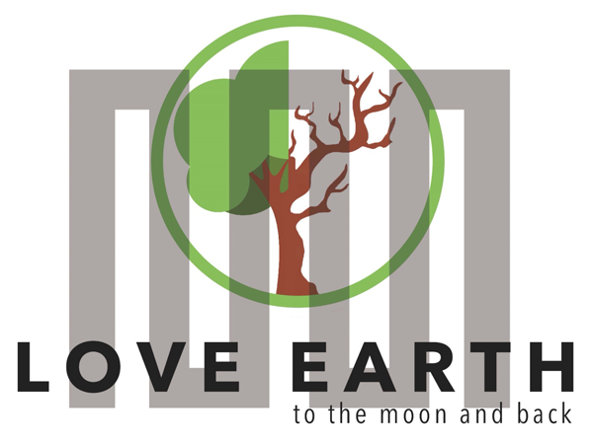

COURSE FOR ENVIRONMENTAL EDUCATION
e-Modules: Teaching Learning activities and their technology enhanced material set to develop

DISCLAIMER
Funded by the European Union. Views and opinions expressed are however those of the author(s) only and do not necessarily reflect those of the European Union or the European Education and Culture Executive Agency (EACEA). Neither the European Union nor EACEA can be held responsible for them.

COURSE AUTHORS
 | Justyna Pająk-Jaroszewska,  Martyna Florkowska-Kardasz

COURSE SHARING LICENSE
 | You are free to:  - Share — copy and redistribute the material in any medium or format for any purpose, even commercially.  - Adapt — remix, transform, and build upon the material for any purpose, even commercially.

MODULE 5 |  | THE IMPACTS OF THE ENVIRONMENTAL PROBLEMS AND CLIMATE CHANGE
PART 3 |  | Health Risks
Lesson 2 |  | Infectious diseases and disasters- cause and effect relationship

SUMMARY

1. COURSE TIME, TARGET AND TOPIC 3

2. COURSE OBJECTIVES 3
Competences promoted in this lesson: 3
Lesson objectives: 3

3. LEARNING – TEACHING PROCESSES 3

4. EVALUATION 3

5. DOCUMENTS 4
ENGAGE 4
EXPLORE 5
EXPLAIN 6
EXTEND 7
EVALUATE 7
A TEMPLATE............................................................................................................................................8

1. COURSE TIME, TARGET AND TOPIC
- Age of target students: 15+
- Teaching time: 2 hours
- Disciplines: Biology, Geography
- Title: Infectious diseases and disasters- cause and effect relationship.

2. COURSE OBJECTIVES

Competences promoted in this lesson:
- Communication in foreign languages competency
- Digital competency
- Learning to learn competency
- Social and citizenship-related competencies

Lesson objectives:
- Students learn about the relationship between natural disasters and the emergence of particular infectious diseases.
- Students understand the mechanisms through which natural disasters facilitate the spread of pathogens.
- Students become aware of preventive measures and public health interventions to mitigate the impact of infectious diseases post-disaster.

3. LEARNING – TEACHING PROCESSES
There are 4 activities in this lesson:
- ENGAGE: Introduction to the topic: students recall basic natural disasters’ names and their consequences
- EXPLORE: Natural disasters and potential infectious diseases (students do their research)
- EXPLAIN: Students present their findings
- EXTEND: Students prepare a quiz testing the knowledge from the lesson

4. EVALUATION
During the next class students take part in a quiz composed of the questions they prepared last time.

5. DOCUMENTS

ENGAGE

Natural disasters and their consequences
- Students are asked to give names of famous natural disasters in an open discussion.
Answers : floods, hurricanes/cyclones, eartquakes, wildfires, drought, volcano eruptions
- Students are then asked for examples of notable natural disasters. If they have no clue, they may browse the Internet resources for 2 minutes and find some.
Answers :
- The 2005 Hurricane Katrina
- The 2010 Haiti earthquake
- The 2004 Indian Ocean tsunami
- The 2023 Greece wildfires
- the 2010 Eyjafjallajökul volcanic eruptions

- Then students are asked about consequences of them in general. It’s up to the teacher how their students prepare the answers and share them (it could be a list as a result of pairwork/groupwork).

*If the students do not provide health-related answers, the teacher gives some hints to elicit this particular ones.
Answers :
- cause diseases
- displace populations
- damage infrastructure
- hinder economic growth
- cause death and injuries
- increase the risk of infectious disease outbreak
- lead to contamination of surface water
- disrupt essential services (healthcare, education, communication, and transportation)
- result in psychological and emoutional trauma
- lead to humanitarian crisis
- give rise to poverty, inequality, and marginalization
- affect the invironment (deforestation, soil erosion, water pollution, and loss of biodiversity), etc.

EXPLORE

Natural disasters and infectious diseases
- Students are asked to explain the meaning of the word ‘infectious’.
Answer : Infectious-(of a disease) able to be passed from one person, animal, or plant ...
- Students are paired or grouped. Each pair/group is given a card with a natural disaster. They are supposed to discover (using the teacher’s or the Internet resources) potential infectious diseases associated with it and find out what actually leads to diseases together with consequeces. After 15 minutes they present their findings to the class.
Advised source : WHO website (https://www.who.int/publications/i/item/communicable-diseases-following-natural-disasters) and the document entitled ‘Communicable diseases following natural disasters. Risk assessment and priority interventions’ available from the site.
- A template to use is included on the last page of this document.
Answer :
FLOODS
flood- waterborne diseases: Vibrio cholerae infection,
mosquito-borne diseases: malaria, dengue fever , Zika virus, West Nile virus)

WHAT LEADS TO DISEASES ? WHAT ARE THE CONSEQUENCES ? - potential students’ answers :
•Waterborne Diseases: Floodwaters can become contaminated with sewage, leading to the proliferation of waterborne pathogens such as bacteria (e.g., Escherichia coli, Vibrio cholerae), viruses (e.g., hepatitis A virus, norovirus), and parasites (e.g., Giardia, Cryptosporidium).
•Mosquito-borne Diseases: Standing water after floods creates breeding grounds for mosquitoes, increasing the risk of diseases like malaria, dengue fever, Zika virus, and West Nile virus.

Ideas for cards and suggested diseases:
- Hurricanes and Cyclones:
  - Vector-borne Diseases: Similar to floods, stagnant water post-hurricanes facilitates mosquito breeding, leading to diseases such as malaria, dengue fever, and chikungunya.
  - Respiratory Infections: Crowded evacuation centers with inadequate ventilation can promote the spread of respiratory viruses like influenza and coronaviruses.
  - Foodborne Illnesses: Disruption of food supplies and lack of refrigeration can lead to food contamination, causing outbreaks of diseases such as salmonellosis and E. coli infection.
- Earthquakes:
  - Trauma-related Infections: Injuries sustained during earthquakes can become infected if not properly treated, leading to wound infections, tetanus, and gangrene.
  - Water and Sanitation Issues: Damage to water and sanitation systems can result in the contamination of water sources, increasing the risk of waterborne diseases like cholera, typhoid fever, and dysentery.
- Wildfires:
  - Respiratory Issues: Smoke and air pollution from wildfires can exacerbate respiratory conditions and increase the risk of respiratory infections.
  - Vector-borne Diseases: Displacement of wildlife due to wildfires can bring disease-carrying vectors closer to human habitats, increasing the risk of diseases like Lyme disease and hantavirus pulmonary syndrome.
- Drought:
  - Water Scarcity-related Diseases: Limited access to clean water during droughts can lead to poor hygiene practices, increasing the risk of waterborne diseases such as diarrheal illnesses and parasitic infections.
  - Malnutrition: Drought-induced food scarcity and malnutrition weaken the immune system, making individuals more susceptible to infectious diseases.

EXPLAIN

Our findings
- Students responsible for particular natural disasters and infectious diseases related to them present their findindgs to the class.
The teacher decides which form of presentation works best with their students. It could be :
- a short individual presentation with some visuals displayed so that everyone can see it
- a shared online document which all the groups fill in with their information
- a piece of paper with a table that students complete and then exchange with other groups
But no matter which form of collecting information the teacher chooses students are supposed to read their findings aloud.
- All the students think of the list of preventive measures thanks to which it would be possible to avoid/reduce communicable diseases following natural disasters.

* Suggestions are presented in the very last part of the document that was used before, available from WHO website (https://www.who.int/publications/i/item/communicable-diseases-following-natural-disasters) entitled ‘Communicable diseases following natural disasters. Risk assessment and priority interventions’.

EXTEND

A quiz
- Students work in groups again ( this time each group consists of representatives of different groups from the previous activity) and prepare a quiz which is to test the knowledge from the lesson. The teacher supervises the activity and assists the students during their work.

EVALUATE
- During the next class students take part in a quiz composed of the questions they prepared last time. The teacher may choose the questions themselves.

FLOODS

Examples of waterborne diseases:  - …  - …  - … | What leads to waterborne diseases? | Consequences and preventive measures:
Examples of mosquito-borne diseases:  - …  - …  - …  - … | What leads to mosquito-borne diseases? | Consequences and preventive measures:

