Project ID: 2021-1-CZ01-KA220-SCH-000034484
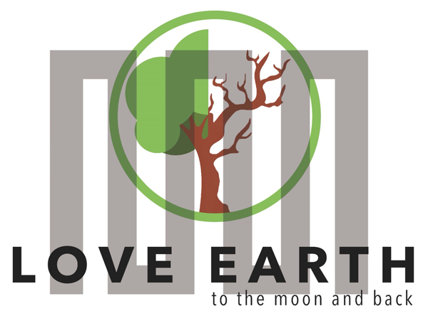

COURSE FOR ENVIRONMENTAL EDUCATION
e-Modules: Teaching Learning activities and their technology enhanced material set to develop

DISCLAIMER
Funded by the European Union. Views and opinions expressed are however those of the author(s) only and do not necessarily reflect those of the European Union or the European Education and Culture Executive Agency (EACEA). Neither the European Union nor EACEA can be held responsible for them.


COURSE AUTHORS
Lubomír Hájek, Petra Garay

COURSE SHARING LICENSE
 | You are free to:  - Share — copy and redistribute the material in any medium or format for any purpose, even commercially.  - Adapt — remix, transform, and build upon the material for any purpose, even commercially.

MODULE 5 |  | THE IMPACTS OF THE ENVIRONMENTAL PROBLEMS AND CLIMATE CHANGE PART 2 – CLIMATIC AND ENVIRONMENTAL CHALLENGES
PART 6 |  | ENVIRONMENTAL INJUSTICE
Lesson 2 |  | indigenous communities

SUMMARY

1. COURSE TIME, TARGET AND TOPIC 3
2. COURSE OBJECTIVES 3
Competences promoted in this lesson: 3
Lesson objectives: 3
3. LEARNING – TEACHING PROCESSES 3
4. EVALUATION 3
5. DOCUMENTS 4
EXPLORE 4
ENGAGE 5
EVALUATE 6

1. COURSE TIME, TARGET AND TOPIC
- Age of target students: 15+
- Teaching time: 1 hour
- Disciplines: Biology, Geography, Human science, Physics, Chemistry
- Title: Urban sprawl, Indigenous community

2. COURSE OBJECTIVES

Competences promoted in this lesson:
- Communication in foreign languages competency
- Anticipatory competency
- Learning to learn competency
- Social and citizenship-related competencies
- Cultural awareness
- Integrated problem-solving competency

Lesson objectives:
- The students enrich their knowledge regarding the topics of indigenous communities
- The students are going to deepen their awareness about indigenous communities
- The students are going assess the effect of urban sprawl on indigenous communities

3. LEARNING – TEACHING PROCESSES
There are 4 activities in this lesson:
- EXPLORE: Indigenous communities
- ENGAGE: Group discussion and research, searching for indigenous tribes on all continents
- EVALUATE: Revising various effect of urban sprawl on indigenous communities

4. EVALUATION
The evaluation is described in the last part of document.

5. DOCUMENTS

EXPLORE
Task: What does it mean to be Indigenous?
Indigenous Peoples can be identified according to certain characteristics:
- Most importantly, they self-identify as Indigenous Peoples.
- They share an ancestral link with those who inhabited a country or region before they were colonized or before other people became dominant.
- They have a strong link to particular territories and the surrounding natural resources.
- They have distance social, economic or political systems, which they are resolved to maintain and reproduce.
- They have a distinct language, culture and beliefs.
- They are politically and socially marginalized.

Task: Learn some other facts
Land rights in law, but not in reality:
  - They often do not control their own land, many of them come under the ultimate authority of central government which controls their land and resources.
New technologies force their resettlement.:
  - The promotion of new technologies such as improved seeds, chemical fertilizers and pesticides, large plantation schemes have caused environmental degradation and destroyed self-sustaining eco-systems, affecting many indigenous communities to the point of forcing them to resettle elsewhere.
Indigenous people speak the majority of the world’s languages:
  - It’s estimated that one Indigenous language dies every two weeks. At least 40 percent of the world’s 7,000 languages are at some level of endangerment.

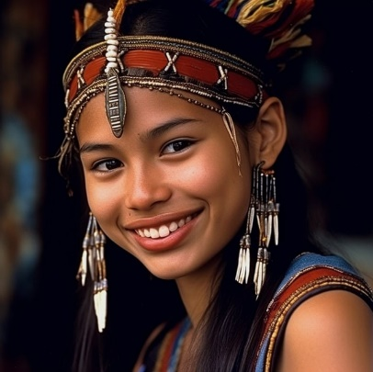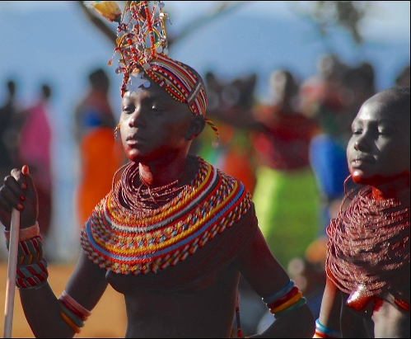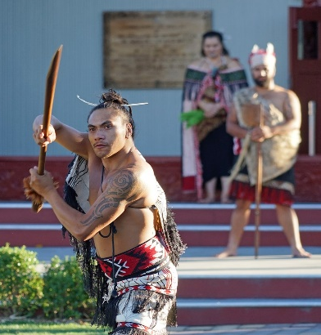

Task: In groups ask and answer the following questions and compare your findings with the other groups. Use online sources to find your answers.
- What are the most common health challenges faced by indigenous communities in your country or region?
- How does access to healthcare in indigenous communities compare to that of the general population?
- What historical events or policies have influenced the current social status of indigenous communities?
- How do indigenous communities maintain their cultural identity and traditions in modern society?
- Are there any specific gender roles in indigenous communities, and how do they impact gender equality?
- What challenges do indigenous women face in terms of access to education, healthcare, and economic opportunities?
- How does the education system in indigenous communities differ from the mainstream education system?
- What are the barriers to educational attainment for indigenous youth, and how are they being addressed?
- How does the economic status of indigenous communities compare to that of non-indigenous populations?
- What role do indigenous leaders and organizations play in advocating for the rights and well-being of their communities?

ENGAGE
Task:
- Find three indigenous tribes in every continent and write down one fact about them that you find interesting.
- Africa:

- Australia:

- Asia:

- Europe:

- South America:

- North America

- Discuss what injustice indigenous people face and what is the reason behind the threats they face.
- Find out when the international day of indigenous people is celebrated.

EVALUATE
Task : In groups, list the effects of urban sprawl into the table, include possible threats to indigenous communities of each effect.

Environmental effects: | Social effects:
Economic effects: | Political effects:

Sources:
pictures without a source-pixabay
https://en.wikipedia.org/wiki/Environmental_justice
https://a2larm.cz/2017/01/proc-je-umrzla-bezdomovkyne-environmentalni-tema/
https://plus.rozhlas.cz/zivotni-prostredi-na-ostravsku-se-zlepsilo-ale-dlouhodoba-zatez-se-na-lidech-8421812
https://www.biophiliccities.org/why-join
https://www.britannica.com/topic/urban-sprawl
https://academickids.com/encyclopedia/index.php/Urban_planning
https://www.clearpointstrategy.com/blog/types-of-urban-planning
https://www.un.org/esa/socdev/unpfii/documents/2016/Docs-updates/Statement_from_UN_Habitat_for%20IDWIP.pdf
https://www.abtglobal.com/insights/perspectives-blog/pathways-to-urban-resilience-for-indigenous-peoples
https://stories.undp.org/10-things-we-all-should-know-about-indigenous-people
https://www.britannica.com/topic/urban-sprawl
https://academickids.com/encyclopedia/index.php/Urban_planning
https://www.clearpointstrategy.com/blog/types-of-urban-planning
https://davidsuzuki.org/what-you-can-do/discourage-urban-sprawl/
https://www.amnesty.org/en/what-we-do/indigenous-peoples/

OpenAI. (2024). ChatGPT [Large language model]. https://chatgpt.com/c/8795eab5-2ce6-4413-9ac3-265f07175cda

