Project ID: 2021-1-CZ01-KA220-SCH-000034484


COURSE FOR ENVIRONMENTAL EDUCATION
e-Modules: Teaching Learning activities and their technology
enhanced material set to develop


Thematic Units for Week-Long Workshop Sessions:
Inquiry-Based Integrated Learning Workshop Series
on the Intersection of Arts, Science, and Policy"

M2: STEAM workshop Dance&Math. Respiratory Energy Flow, Spirals&Turns

COURSE AUTHOR:
©Tatjana Christelbauer MA (TC)
Contributor: Dr. Nathalie Tassotti /ACD Team, Austria

DISCLAIMER
Funded by the European Union. Views and opinions expressed are however those of the author(s) only and do not necessarily reflect those of the European Union or the European Education and Culture Executive Agency (EACEA). Neither the European Union nor EACEA can be held responsible for them.

COURSE SHARING LICENSE CC BY-NC-SA = 
Canonical URL: https://creativecommons.org/licenses/by-nc-nd/4.0/

MODULE: 2
STEAM workshop: Dance & Math, Respiratory Energy Flow, Lines & Curves
SUBJECTS: Dance Arts, applied Biology, Mathematics, Physics, English, …

Methodology for lessons provided in the ERASMUS+ project LeMOON has been composed by ©Tatjana Christelbauer MA, ACD-Agency for Cultural diplomacy president, project partner, manager and trainer/researcher in the project. Contributions to Modules and lessons are provided by appointed ACD- team members, experts from fields of arts, science, policy, new media technologies, education, research, …

Format: Thematic Units for Week-Long Workshop Sessions:
Inquiry-Based Integrated Learning Workshop Series
on the Intersection of Arts, Science, and Policy"

Code of Conduct
The contents may inspire and guide for further encounters while following the laws of its nature as a guest, as the most insights are protected under diverse licenses. Therefore, is recommended to respectfully treat the copyrights of the intellectual property. For our content, we use the following licence:
COURSE SHARING LICENSE CC BY-NC-SA = 
Canonical URL: https://creativecommons.org/licenses/by-nc-nd/4.0/

Images of Hundertwasser´s artworks have been exclusively provided for the use in this script by Hundertwasser Private Foundation Vienna and are under the copyright of the Hundertwasser private Foundation

WORKSHOP Sessions: Dance & Math, Respiratory Energy Flow, Spirals & Turns…

In this unit, it is aimed for students to classify natural resources and to notice the flow of matter and energy in nature through the cycles of matter and energy in their body by conscious breathing exercises and to comprehend the effect of this flow on natural life and living things. Exercises has been explored with Professional dancers and with high school students of the Vienna Institute for Blind BBI.

Topic/Concepts: natural resources, material cycles, energy flow, respiratory system, guided imagination, proprioception (awareness of the body in space)

Methodology:
art-based methodology including dance arts, storytelling, guided imagination, holistic approach to the science of energy flow experienced through respiratory flow and bodily movement-space awarenesss

Dance workshop including inTalk session with introductory insights to the topics, practical part and the reflection piloted with BVI-students and teachers at the Vienna Institute for blind BBI

Workshop Authors:

- Tatjana Christelbauer MA
ACD-Agency for Cultural Diplomacy president, E+ project Le_MOON manager, art-educator & mediator, dance arts professional

- Dr. Nathalie Tassotti
Mathematician, author of educational books for Mathematics, Ballet dancer and ballet teacher

Objectives:
to increase awareness of energy and focus on efficient use of energy in daily life through meditation and bodily movement;
to increase the spatial awareness, and proprioceptive self-imaging;
to learn connect the art-based (classical Ballet, modern dance) methods by engagement and learning in spatial, rhythmic, structural, and symbolic aspects of applied biology, mathematics and physics in arts.

Workshop content

- Introductory inTalk with participants (10 +min)
- Practical part containing exercises grounded in classical & modern ballet, mathematics each exercise 20+min
- choreographic compositions 20+ min
- Reflections 15+ min

- Workshop Session: Respiratory Flow, Spirals & Turns
created by Tatjana Christelbauer MA

Keyterms: #space, #relations, #energy #breathing #embodiment, #imagination

1.1. Warming up, preparatory activity:
Reflection on Energy Flow: Students reflect on their energy levels throughout the day, considering activities that leave them feeling tired, energized, or calm.

Expressing Activities Through Movement: Based on their reflections, students share one activity that energizes them, one that exhausts them, and one that brings calmness through bodily movement. This can include activities like prolonged sitting, walking, running, experiencing mental stress, listening to music, feeling rainfall, or reading a book. They articulate each activity aloud ("Long sitting makes me breathless", "Mental stress drains my energy", "Listening to music energizes me", "Reading a book calms me") and then embody it through a gesture, posture, or phrase.

Focus on Breath: During these movements, students focus on their breath, syncing their breathing with the movement and mentally connecting it to the specific activity they are expressing.

Challenge:
Combination of Activities: Students combine the three activities (one calming, one energizing, one tiring), practicing conscious breathing and integrating the respective bodily movements into a rhythm that feels natural to them.
Associative Practice: They repeat the movements, mentally associating the calming activity with both the energizing and tiring activities. The goal is to explore how self-regulation through conscious breathing can optimize energy management.

Imagery of Breath and Energy Flow: Students visualize the flow of air through their "lung wings," holding it momentarily before dispersing the energy throughout their body.

Awareness of Surroundings: They maintain awareness of the air in their environment, feel the ground beneath their feet, sense the temperature and light levels, and listen to any ambient sounds.

Repetition and Reflection: Each student performs their movements individually 3-4 times, signaling the next participant by calling their name. Afterward, the group discusses their experiences, focusing on the sensations felt through movement, the depth of their imaginative experience, the quality of their respiratory flow, and the effectiveness of the self-regulation techniques explored.

Grounding (cooling down):
Students reflect on the sensations they experienced and think about how they can use the energy more efficiently through respiratory exercises and self-guided imagination.

Observing their breath flow during bodily movements in space, and using vivid anatomy, students experience imaginative visualization of the inner body landscape. This visualization enables them to connect with the inner organs responsible for breathing, thereby strengthening their connection with the invisible parts of the body and fostering an overall sense of self within the surrounding environment."

  - EXERCISE1:
Note: Respiratory exercises introduced in this session are aimed to inspire for further practice and by interests, further research in neurosciences, for more comprehensive learning and understanding of the functioning of our breathing system. Somatic practicesintroduced in this workshop session are aimed at proposing exercises that will holistically support resilience, as the ability to cope with challenging life experiences mentally, emotionally, and physically, while reflecting on and being aware of our human vulnerability, as ability to sense, to response, to resonate ... to self-regulate
The integration of the somatic breathwork in performing dance arts professional training as well as in daily life of students who are not trained in dance, including the blind is aimed at supporting breathing regulation while emphasizing the connection between our physical sensations and emotional and mental states.

Guiding insights:
Breathing is a spontaneous act, but the practice of conscious breathing, can help regulate our stress levels, improve focus and concentration, and promote a sense of calm and relaxation. The practice includes external breathing, internal breathing, and regulating breathing through breath holding by guided imagination. It is essential to hold and stop the flow of breath between the sequences of inhalation and exhalation exercises (between 5-10 seconds) in order to activate internal breathing - ventilation - which increases attention and the ability to 'decelerate' from feelings of stress and tension. According to the teachings of Hatha Yoga, “If the breath is uneven, then the mind is restless, but if the breath is still, the mind is also still, and the yogi gets the power of stillness. That’s why you should hold your breath.” (Hatha Yoga Pradipika) According to the Tummo meditation method, which was practiced by Tibetan monks as early as the 11th century, the body temperature is increased using certain breathing techniques so that the 'bad thoughts and feelings 'burn away'.
With images of internal organs, such as: Lungenflügel ^ lungwings, the visualization of the internal body landscape is guided. Staying active mentally through guided imagination will prevent or reduce eventually occurring tensions in the body while holding the breath.

  - EXERCISE2: Heartbreth .. Lungwings ... airdrops guided imagination sequence
Imagine how air moves across the left and the right lung wing, while crossing the 150.000 000 alveoli while holding your breath. Imagine how alveoli start glomming in a color (by your choice). How is the air flowing across your body: polluting, ventilating, ...?
Now breathe out and exhale through your mouth on 8 counts. Listen to your heart rate – is it slowing down by exhaling? Open your arms slightly on-site and contract your palms while Imagining raindrops falling inside. Now inhale again on 4 counts, bend your knees, hold your breath for 4 seconds, and imagine the raindrops in your palms pulling your arms and palms together. Now close your arms and palms together, finish the exercise, open your palms, and let raindrops dance out ...

  - EXERCISE3: Featherflow act
Introductory guide, objectives:
Guided meditation and movement with an imaginary or real feather on the palm release creative energy but also conducts attention, encouraging participants to connect through sending and receiving the feather as a form of creative dialogue. Depending on the location, need, available time, purpose, etc., the playful exercise can last from a few seconds to a few hours.
Created in the 1990-es as a tool for the playful non-verbal communication among children from migrant families in Lower Austrian Kindergartens, later extended as a breathing ritual and starting exercise in dance workshops the Featherflow-exercise can be practiced as an individual exercise or in a group, all ages, and professions, including blind, to explore movement using the feather. It can be adapted as needed to accommodate different levels of mobility and ability.
Materials: a feather (down) light to be blown from a palm, real or imaginative one, used to visualize embodied breath and serve as a source for the self-guided motion, playful respiratory exercise for individual and group practice.
.

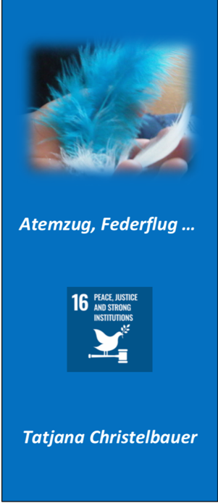
ENGAGE: Take a walk near a river and look for a feather on the shore or in the grass. Usually, in places where ducks and swans are regular habitants, feathers lost from their bodies are easy to find.
Start exercise in a sitting or in a standing position, close your arms in the front of your torso, keep both hands slightly cupped together (imagining) holding the feather among your palms (such as by praying hands); Breathe in through your nose and start blowing and following its path from one hand to other, up and down

Image: ©Tatjana Christelbauer

    - Moderated exercise:
°Begin by holding the feather in one hand, with your arm extended out to the side. Take a deep breath and focus on the feather in your hand, noticing its texture and weight.
°Slowly start to move your arm in a circular motion, allowing the feather to glide through the air. Imagine that you are painting a large circle in the space around you with the feather.
°As you move, sway your body gently from side to side, allowing the feather to guide your movements. Imagine that the feather is your embodied breath, and you are initiating and following its path.
°After a few minutes of circular motions, explore moving the feather in a figure-eight pattern. Imagine that you are weaving a beautiful tapestry with the feather, follow the image with your bodily movement. Embody the meaning. The change of the motional pattern may include the change in the tempo of the movement, while changing the volume of the breath by exhale movement.
°Finally, hold the feather in both hands and bring it close to your face. Take a deep breath and focus on the bright color and delicate texture of the feather.
Slowly blow the feather back and forth between your hands, feeling its weight and texture as you go.

    - Variation sequence: exploring the laws of nature in science with featherflow syllables:
Newton ́s Law of Motion
Featherflow exercise to explore the principle of the 1st Newton ́s Law of Motion.
Inertia – “An object at rest will remain at rest unless acted upon by a force; an object in motion continues in motion with a constant velocity unless acted upon by a force.”
This allows us to understand how breath as initial movement can be consciously used as a force to move an object, such as a feather.
The 2nd Newton ́s Law of Motion: Acceleration. “The Acceleration of an object as produced by a net force is directly proportional to the magnitude of the net force, inversely, proportional to the mass of the object, and occurs in the direction of the net force.” Je larger the force applied to an object, the faster it moves.
Now explore how the size and weight (of a feather) – by using the breath and it ́s rhythm pattern, to demonstrate the wind-when it blows strongly enough, the feather might change its original path. Use the fan to explore the force from outside .. If more feathers are enacted, it can be explored how varying masses (rhythmically) affect each other ́s speeds through the impact of the force (wind-breath-speech)

The 3rd Newton ́s Law of Motion: Action and reaction
“For every action, there is a equal and opposite reaction, the mutual actions of two bodies upon each other are always equal, and directed to contrary parts.”
Using the Third Newton ́s Law of Motion, we can illustrate how feathers create a ripple effect throughout its surroundings.
Stand in pairs, representing a pair of clouds, that interact with each other, while blowing a feather to each other, with a long pfffff sound ... Each time by a speech- sequence-act, a feather falls onto one of the engaged participants, they respond by creating ripples through their body and arms to signify the wave propagated by the falling feather.

Through this activity, students learn about how actions generate reactions in dynamic systems.
By combining these three principles through dance movements, students can gain insights into the natural world around them. It demonstrates how science and art co- relate in helping better understand the complex concepts.

References for further inquiry:
European Space Agency (ESA): Learning to live with the laws of motion
https://www.esa.int/Science_Exploration/Human_and_Robotic_Exploration/ Astronauts/Learni ng_to_live_with_the_laws_of_motion
NASA: Newton ́s Laws of Motion: https://www1.grc.nasa.gov/beginners-guide-to- aeronautics/newtons-laws-of-motion/
😊
https://www.generationgenius.com/videolessons/newtons-laws-of-motion-video-for-kids/

NOTE: Explore more about Respiratory System in the Lesson “Cyclical Nature” Module2

  - EXERCISE4: Breathing acts of Martha & Gertrud

Guiding quotes from the two Modern Dance pioneers: Gertrud Bodenwieser (1890-1959) and Martha Graham (1894-1991):

Breathing, the continuous rhythmical communication of our body with the outside world, is used as a means of expression, and each of our movements has to be carried by breath. It animates the life of the torso, in which the heart—age-old symbol of love and pain—is embedded.
(Bodenwieser & Cuckson, 1970, p. 81)

"Dance is breath made visible"
(...) “In the end, it all comes down to the art of breathing.” Martha Graham

Reflect on your experience with breathing, as described in the quotes of Bodenwieser and Graham: in Budweiser’s quote, breathing is described as the "continuous rhythmical communication of our body with the outside world" and is used as a means of expression.
How do you interpret the idea that´ each movement is carried by breath´? How does this view of breath as a communicator resonate with your experiences?

According to Martha Graham, "Dance is breath made visible," and she emphasizes that,"in the end, it all comes down to the art of breathing."
EXPLAIN: How does Graham's perspective influence your understanding of the intimate connection between dance as a bodily movement and breath? In what ways do you believe breath becomes visible in dance?

According to Gertrud Bodenwieser, “The breath animates the life of the torso, where the heart, a symbol of love and pain, is embedded.”

EXPLAIN: How does this imagery resonate with your understanding of the torso, hearth, and breath?
Considering Martha Graham’s emphasis on the “art of breathing,” how do you view the breath as an artistic element in your dance practice? How does conscious attention to your breath contribute to the artistic quality and expression of your movements?

Both quotes highlight the essential role of breath in dance.
How do you integrate the concept of breath into your practice?

Exchange experiences and good practices with respiratory exercises and create some projects on the topic of respiration, inspired by quotes from Martha Graham and Gertrud Bodenwieser. Name your work in relation to breath and respiration.

  - EXERCISE5:
Exploring the Butterfly effect through bodily movements: port de bras & spirals

The Butterfly Effect is a mathematical concept deriving from the Chaos theory that states that small changes in initial conditions can have a significant impact on the outcome of a system. In dance, we can see this concept in action through the exploration of port de bras.
Port de bras refers to the movement of the arms and upper body in dance, and small changes in the placement, timing, or quality of these movements can drastically impact the overall performance.
The Butterfly Effect is significant because it emphasizes the interconnectedness and sensitivity of systems to initial conditions. Understanding this concept encourages students to appreciate the ripple effects of their decisions and behaviors on themselves, others, and the environment. It promotes mindfulness and responsibility in their interactions, fostering a deeper awareness of how seemingly minor details can influence relationships and environments. By grasping the Butterfly Effect, students can cultivate a more thoughtful approach to life, aiming for positive impacts and harmonious relations in diverse social, virtual, and natural settings.

The port de bras exercise and respiratory practices introduced in this workshop exemplify the Butterfly Effect by demonstrating how small changes can lead to significant outcomes. In dance, a slight misalignment or "crooked position" in port de bras, or being "out of breath," can disrupt balance and fluidity, much like how minor actions can have widespread effects. These exercises highlight the importance of awareness and self-regulation. Their simplicity and precise structure encourage patience and attention to detail, helping dancers cultivate a mindful connection between their movements and breath. This practice not only enhances performance but also reinforces the interconnectedness of small actions and their broader impacts, fostering better self-awareness and control.

EXPLORE:
Port de bras exercise: the arms moving from the first position to third position in a circular motion, while making small changes such as by altering the speed of the motion, the alignment of the arms, or the shift of the torso.

° Begin in a standing position with heels together and feet slightly opened in a natural 1st position. Legs should be straight, and arms are in a preparatory position rounded next to the hips. Start with slow, synchronized movements of both arms, rounding them up to the center-front of the body, resembling holding a large bunch of flowers. Inhale as you open the arms to the sides and return to 1st position. Repeat this twice.

°° Next, move the arms up to 3rd position above the head, rounding them up and opening into 2nd position—both arms open to the sides with slightly bent elbows. Repeat this synchronized movement with both arms 3-4 times. Then, explore a sequence where one arm remains open while the other moves up, using rhythmic music to guide the timing of the sequence.

Note: A feather boa can soften the line of the arms during port de bras practice. Wrap both arms gently with a feather boa centered on the neck and along the back of the body, rounding it at the elbows and extending the line to the palms. Blind students have experienced the feather boa as useful and pleasant guide for softening arms. The use of geometric forms, such as triangles, can support enhancing spatial orientation, particularly for individuals who are blind or visually impaired.
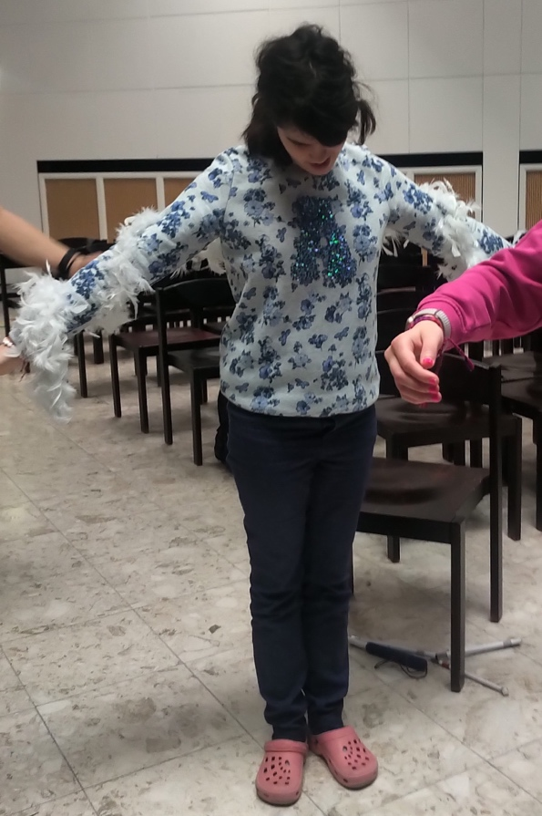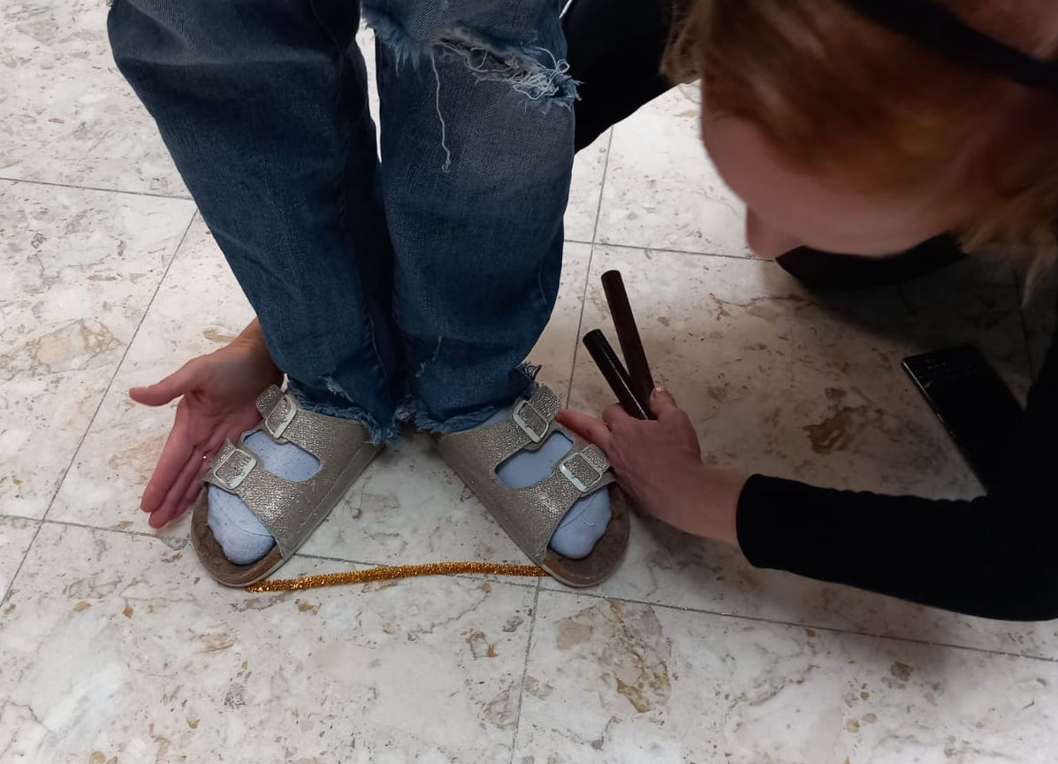

Images: ©Tatjana Christelbauer: Dance Workshop with Vienna Institute for Blind BBI students

Challenge: Change the flow and slightly bow your torso to the front, or extend – shift to the back, shift the weight to one leg and lean on while extending the other leg slightly in the air, only one foot high. Repeat the port de bras exercise twice. Explore changes in your balance, your bodily relation to space and your feeling of confidence, your breath flow.
EXPLAIN your experiences and reflect on your bodily awareness, apply on useful experiences when “feeling out of breath” or “out of balance”, maintain the shift of weights while regulating your breathing flow.
EXTEND experiences, explore the shapes and lines of port de bras by walking, by running, by walking with bend knees, almost in a squad,… create more opportunities, practice conscious breathing and the shift of weights with your whole body, hands, which helps them understand the geometry of the movement, practice more …

The "shift of weight" (in dance) involves transferring the body's balance by moving the weight from one supporting base, such as a foot or hand, to another. This technique allows (dancers) to change directions, initiate movements, and maintain stability while performing various steps and choreographies. By redistributing the body's weight, (dancers) students can create fluid transitions between movements, enhancing the overall grace and agility of their performance. Mastery of this fundamental skill not only improves movement quality but also enables (dancers) students to convey emotion and narrative through precise and expressive gestures. Conscious breathing supports the shift of weight by enhancing body awareness, engaging core muscles, managing energy effectively, strengthening the mind-body connection, and promoting emotional regulation. Integrating breath awareness into dance practice not only improves technical proficiency but also enriches the expressive and dynamic qualities of movement performances.

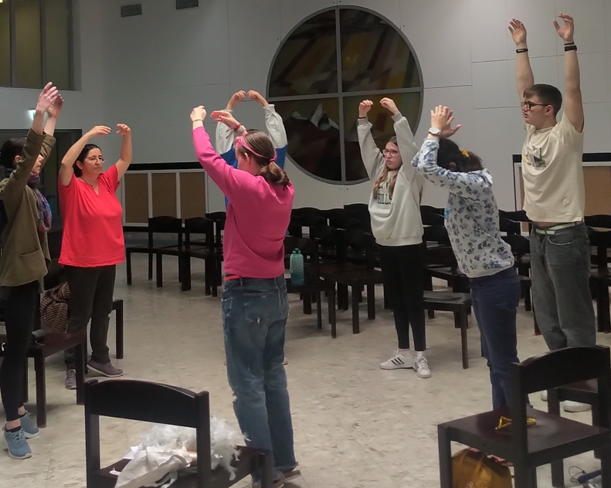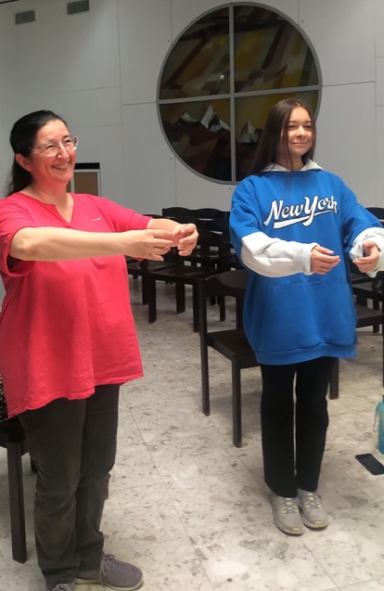
Images: ©Tatjana Christelbauer: Dance Workshop with Vienna Institute for Blind BBI students

    - Spirals (curve)
How is a spiral form situated in dance arts?
The spiral form represents a natural, organic form that can be found in many living organisms, such as seashells and plant growth patterns It is often seen as a symbol of growth and renewal.
The spiral motive in nature is characterized by a specific mathematical proportion (approximately 1.618, so, not “round”) and is often associated with the golden ratio, a mathematical ratio commonly found in nature such as by raindrops and snowflakes. Raindrops can take on a teardrop shape, which is a type of spiral form. The spiral form in dance is aligned with organic movements, initiated by breath, between inhale and exhale sequences which can be practiced and associated with other movements, such as in dance syllables created by Martha Graham.

Imagine: Imagine your arms moving like clouds or wide, silky scarves, shifting and changing shape as you move. Focus on the sensation of weightlessness and freedom, as if floating in the sky.
Explore the spiral form by changing the line of your arms, starting in the 2nd position (such as by port de bras exercise in classical ballet) arms extended on sites, elbows slightly bent, then while rotating your left shoulder to the front, your underarm is turning to down and at the same time while rotating your right shoulder to the back, your right underarm is turning up, your torso is slightly shifted to the right. Adding the plie (softening the knees), while moving the torso and hips, spinning up the tempo, observe how your breath flow and energy changes.

EXPLAIN the changes in terms of following:
Dynamic: Describe whether your movement is more vigorous, forceful, or intense.
Rhythm: Note if your breathing and movement patterns are steady, erratic, syncopated, or irregular.
Volume: Specify if your breaths are deeper, louder, quieter, or more shallow.
Controlled: Determine if you feel out of control of your breath and movement or if it feels managed.
Out of Breath: Indicate if you feel breathless, struggling for air, or unable to maintain a steady breath.
Balance: Assess if you maintain stability and poise or if you feel unsteady or off-balance.
Efficiency: Consider how effectively are you using energy and whether their movements are economical.
Endurance: Evaluate your ability to sustain the pace without tiring or losing steam.
Intensity: Reflect on the level of effort and exertion involved in your movements and breathing.

These terms should help students articulate the changes they experience in their breathing and energy flow as they increase their movement speed and intensity.

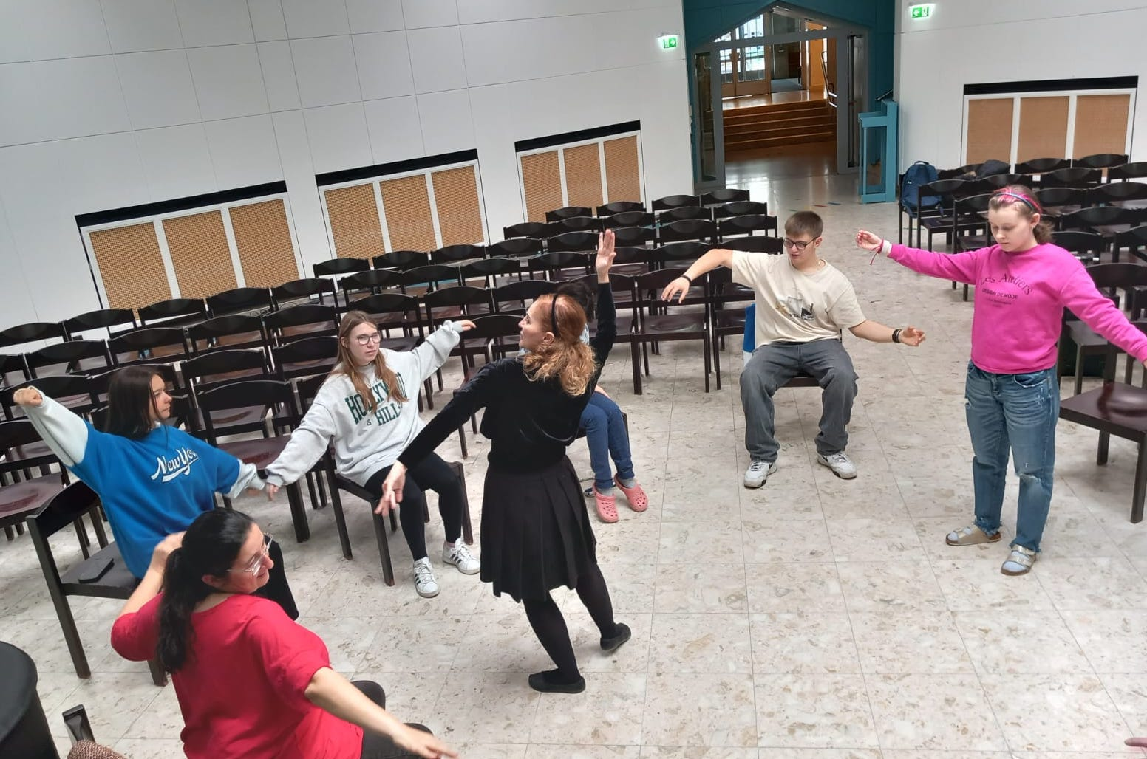
Images: ©Tatjana Christelbauer: Dance Workshop with Vienna Institute for Blind BBI students

Extend: The basic "spiraling" position consists of rotating the spine approximately 45° around its vertical axis, so that a dancer facing the front of the stage would have
their shoulders aligned with the "Via Triumphalis", an imaginary line parallel to a corner-to-corner diagonal of the stage.

Watch the YouTube videos on “Spiral” syllables created by Martha Graham in which “the first spiral exercise uses opposition of the upper torso against the lower torso to maintain the center of the spiral for deep contractions into and up from the floor. In the second exercise: spirals move around the axis of the spine. The weight centers between the legs. The base of the throat centered over the pelvic center maintains a perpendicular through the core of the body throughout the exercise.“ https://www.youtube.com/watch?v=wX0jkc4wMI8 (in English)
https://www.youtube.com/watch?v=9sfUx6YceKI (in French, another example)

EXPLAIN and describe the spiral movement as for the blind. Explore, practice, observe your breathing flow. Make notes, become aware of qualities and keep your awareness on your breathing flow, for better efficiency by your energy use.

  - Turns around yourself:
EXPLORE: Feet together, standing position, arms in the first position (rounded together in the front of your body); right foot opens on site (heels keeping together), left arm opens on site; left foot follows the right foot while left arm makes a little force (effort) to close with your right arm in the first position, repeat 4 times, each time you make a “quarter turn; change the working leg and site. spin up.
NOTE: When practicing turns, maintaining awareness of your breathing flow is essential. Smooth and controlled breaths not only support balance and coordination but also enhance focus and stamina. Align your breath with each movement to optimize stability and fluidity, allowing you to perform turns with confidence and grace.

EXPLAIN: How was the experience while spinning around yourself?
What makes such movement challenging or comfortable?
How is your energy, does such movement stresses you?

CONNECT: Form a circle with other participants, holding hands. Take 4 steps to the right, then 4 steps to the left, then move towards the center, and return to your original positions. Release hands and place them gently on each other's waists. Bow towards the center and extend one leg behind you, holding for 2 counts before returning. Move towards the center again as a group, turn around, and stand back-to-back, moving together in a circle without holding hands, shoulder to shoulder. Explore additional movement sequences.
Increase the tempo and observe your energy and breath flow. Compare this with your individual turning sequences and note the effects of slow and fast movements on your breath and energy.

Reflection Questions:
How did you feel about moving together in the circle?
Did holding each other in a circle feel supportive when lifting your leg and balancing?
This exercise encourages participants to explore connected movement, observe the impact of tempo on breath and energy, and reflect on the supportive aspects of group dynamics in movement.
Blind and visually impaired high school students have experienced their circle exercise as supportive by stretching the leg and moving faster.
“Breathing was not always under “control”, but it was fun and they wanted more dance.
Here are reflections from our workshop, document yours and keep practicing

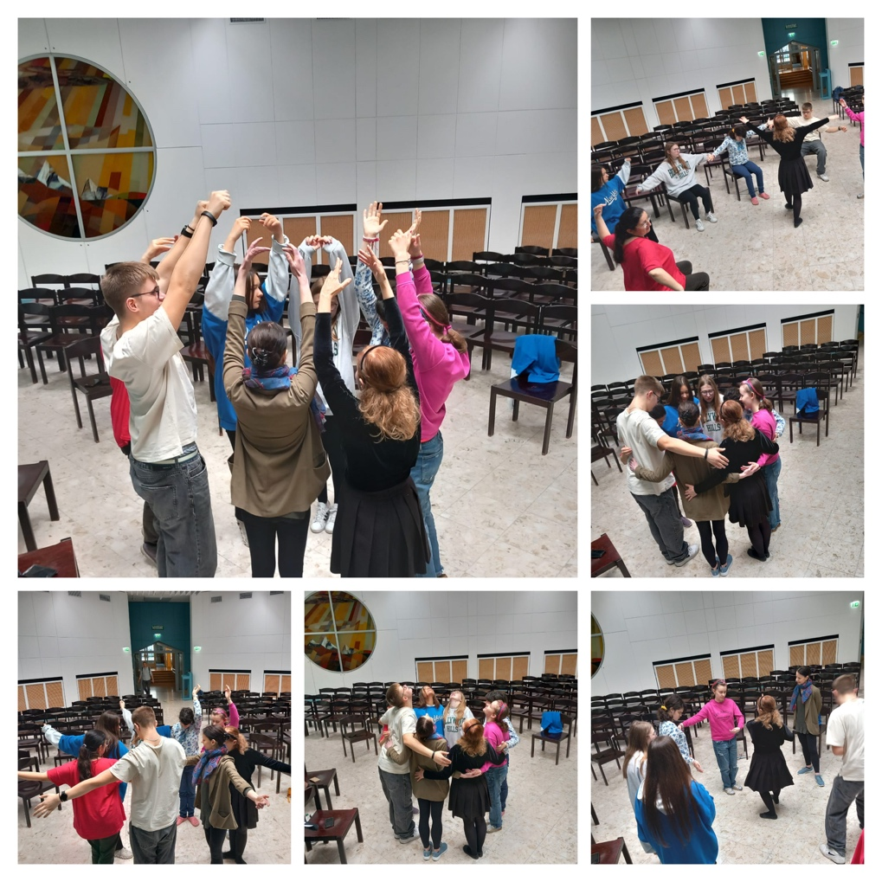
Images: ©Tatjana Christelbauer: Dance Workshop with Vienna Institute for Blind BBI students

- WORKSHOP created by Dr. Nathalie Tassotti

Intro:
Ballet is one of, if not the most structured styles of dance. This structure is as well made by a defined order of exercises that ballet dancers do on a daily base as it is by its almost mathematically structured use of music. Within each exercise in a ballet class precise counting is necessary to perform it correctly.
Dancers (not only in ballet but in a lot of dance styles) usually use 8 counts as a musical phrase. During this 8 counts a certain pattern of movement is executed. In the (for the dancer) best of all cases, these patterns are clearly visible.
For the exercise planned, we use a very important movement in ballet, namely a tendu. In a tendu one leg (the ‘working leg’) brushes along the floor to either the front, side or back, while both legs remain straight. Then a pattern will be picked and performed with the leg brushing to the front (i.e. a tendu devant) within 8 counts, eg.:

- Out (1) -close (2)- out (3) -close (4)- out (5) -close (6)- out (7) -close (8)
- Out (1) – close (2) and close (3) and close (4)- out (5) – close (6) and close (7) and close (8)
- And close (1)- And close (2) And close (3) and close (4)…

So as we can already observe, the variety of these patterns is huge.
In the next step this pattern is repeated with the leg brushing to the side, to the back and again to the side. Whenever an exercise is performed in these four directions, we say it’s done en croix.
This is one of the most commonly used overall pattern in ballet class.

Connection with mathematics:
Mathematics connects the human perception and action, therefore embodiment is especially helpful in order to understand its abstract and complex nature. In this case the (mathematical) notion of a sequence can be depicted. In mathematics, a sequence is an enumerated collection of objects in which repetitions are allowed and order matters. It contains members (also called elements, or terms) , the objects follow a particular pattern. Here our ‘objects’ are the movements of the tendus. A Sequence usually has a rule, which is a way to find the value of each term. Here in our example it is the rhythm in which the tendus are performed.
"Tondue" is a ballet term that refers to the movement of the working foot as it brushes along the floor to either the front, side, or back, while both legs remain straight. The movement involves stretching the foot or flexing the foot, which creates different shapes or lines with the leg.
When stretching the foot, the leg line extends in a straight line, which can be compared to a line segment in geometry. A line segment is a part of a line with two endpoints.
When flexing the foot, the leg line forms a curve, which can be compared to a circular arc in geometry. A circular arc is a segment of a circle's circumference.

Therefore, when performing the tondue movement, the working foot can be compared to a point that moves along a line segment or circular arc, creating different shapes and lines with the leg.
To optimize the exercise for blind students, we incorporate tactile and auditory cues, such as using a triaangle textured floor mats to indicate the direction of the tendu and using rhythmic music to establish the timing of the sequence. You can also encourage students to explore the shapes and lines with their hands, which can help them understand the geometry of the movement. Finally, we will provide verbal feedback and guidance to help students refine their technique and improve their understanding of the exercise.

Some suggestions for rhythmic music that can be used to establish the timing of the tondue sequence:
"Waltz of the Flowers" by Pyotr Ilyich Tchaikovsky
"The Nutcracker Suite" by Pyotr Ilyich Tchaikovsky
These classical ballet pieces have clear and consistent rhythms that can help students establish the timing of their tendu sequences. You can choose a piece that fits the tempo and mood of your class and use it as a guide for the tendu exercise. It is important to select music that is appropriate and engaging for students.
Description of the exercise:
Group size: 3-4 people
Step 1: The group chooses a tendu pattern within 8 counts. It’ performed en croix (top the front- to the side- to the back- to the side)
Step 2: The pattern will be reversed (ie if it is out-close- in- in- out- close- in-in, it’s going to be in- in- out- close- in- in- out- close etc)
Step 3: The pattern will reverse the en croix (start to the back, the side, then front, then side)
(Step 4: Reverse pattern and en croix)
Step 5: one person for each step, doing it together at the same time.
Step 5 will then be presented and the variety of patterns will become visible. We observe the larger picture of a sequence that is formed.

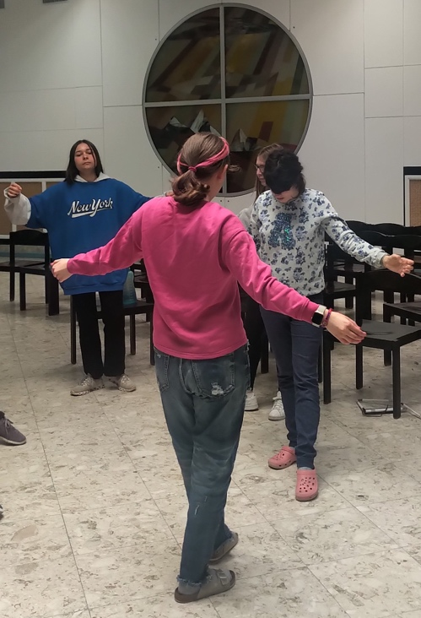
Image: ©Tatjana Christelbauer: Dance Workshop with Vienna Institute for Blind BBI students, tendu exercise

Dr. Nathalie Tassotti:
While doing her PhD in Mathematics, at the same time she started her study of dance, in particular ballet. After finishing university, she gained teaching experience in mathematics and started co-authoring educational books for mathematics students. She went to New York to continue her dance studies and also to do the ballet teacher training by the American Ballet Theater. After returning to Austria, she is now teaching in several dance studios in Vienna.

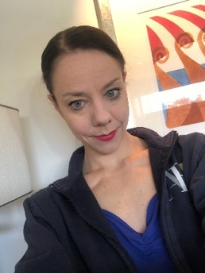

Method of Eric Franklin. Swiss dancer, pedagogue and founder of the Franklin method https://franklin-methode.ch/
The term “somatics” was coined by professor and theorist Thomas Hanna in 1976 to represent a field of movement studies and bodywork that foregrounds the internal physical sensations, perceptions, and experiences of the body. https://somatics.org/training/about/hanna Somatic practices, ecosomatic approach to resilience, read more about: http://wellnesscke.net/downloadables/AbriefhistoryofSomaticanddance.pdf , https://iadms.org/media/3599/iadms-resource-paper-somatic-studies-and-dance.pdf , https://pubmed.ncbi.nlm.nih.gov/28936167/
Source: https://news.harvard.edu/gazette/story/2002/04/meditation-changes- temperatures/
Wordplay created for Featherflow meditative respiratory practice: https://www.meinbezirk.at/landstrasse/c-regionauten-community/federfuehrung-perovodjstvo- koerpersprache_a4924141
Read more about the Featherflow exercise following the weblink: https://www.tatjana-christelbauer.com/en/featherflight
Source: webpage https://ausdance.org.au/articles/details/improvisation-a-continuum
Source: Martha Graham “Blood Memory” (1991). An Autobiographie: https://archive.org/details/bloodmemory00grah
Watch the video, explore more about the Butterfly Effect, research more by your interests: https://www.youtube.com/watch?v=hAUK03_hp_c

