Project ID: 2021-1-CZ01-KA220-SCH-000034484
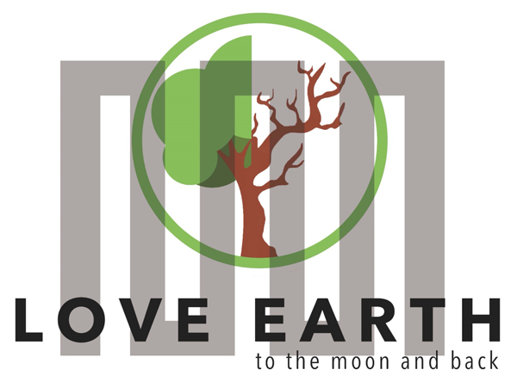

COURSE FOR ENVIRONMENTAL EDUCATION
e-Modules: Teaching Learning activities and their technology enhanced material set to develop

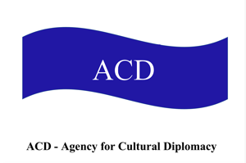
Thematic Units for Week-Long Workshop Sessions:
Inquiry-Based Integrated Learning Workshop Series
on the Intersection of Arts, Science, and Policy"
M2: Cyclical nature, Circadian Rhythm, Dreams …

COURSE AUTHOR:
©Tatjana Christelbauer MA (TC),
Contributor: dipl.ped. Carla Laszakovits, BBI Vienna
ACD Team, Austria

DISCLAIMER
Funded by the European Union. Views and opinions expressed are however those of the author(s) only and do not necessarily reflect those of the European Union or the European Education and Culture Executive Agency (EACEA). Neither the European Union nor EACEA can be held responsible for them.
COURSE SHARING LICENSE CC BY-NC-SA = 
Canonical URL: https://creativecommons.org/licenses/by-nc-nd/4.0/

MODULE: 2

LESSON bound: Sleep°awake Cycle, Breathing Cycle, Night&daydreams

1. TIME, TARGET AND TOPIC
- Age of target students: 15+
- Teaching time: week-long workshops
- Disciplines: Psychology, Biology, Fine Arts, Social Studies, English, Policy learning, …
- Title: Cyclical Nature in Humans and environments: Circadian Rhythm, Sleep-Awake cycle, Night & Daydreams

2. OBJECTIVES

Green Future Competences promoted in this lesson:
- Communication in foreign languages competency
- Digital competency
- STEAM
- Social and Global citizenship-related competencies
- Creative thinking
- Awareness and sensitivity to the cyclical nature.
- Knowledge and understanding of the circadian rhythm by example of the sleep-awake cycle
- Gender & diversity competence

Objectives:
- explore the biological human-nature correlation by example of the circadian rhythm;
- understanding the rhythmical meaning and applying it by reflecting on;
- understanding the function of the breathing cycle;
- learn with and from BVI-students about the cyclical nature of humans and environments;
- shape sensorial awareness of the environmental impact on the human sleep-awake cycle;
- with a spot on gender-specific differences;
- explore the impact of dreams, daydreaming and micro-breaks on daily life in a sleep-awake cycle;
- learning from experiences shared and introduced by blind students;
- understanding the potential of dreams to reveal aspirations, fears, and innermost longings as well as reflecting on daydreaming practices;
Creative approach to science, inquiry- based learning with arts & media
Intercultural and multilingual experiences of sleep-cultures, lullabies

3. LEARNING – TEACHING PROCESSES
ENGAGE: Guiding insights with online media use, entry to the topic through reflection by the use of surveys and guiding questions for inquiry
EXPLORE: Tasks for self-reflection, hands-on activities
EXPLAIN: individual presentations, small-size group activity, interviews, multimedia formats with tools from art, presentations
EXTEND: Guide for creating art projects, policy recommendations, public presentations

4. EVALUATION
The evaluation form is to be used by free choice, some guiding insights are provided by each workshop.

Workshop1

Cyclical Nature in Humans and Environments:

Introduction to Circadian Rhythm

Guiding questions:
What is meant by cyclical nature?
What is circadian rhythm?
How is the rhythm performed by nature?
Share examples

“Circadian rhythms are 24-hour cycles that are part of the body’s internal clock, running in the background to carry out essential functions and processes. One of the most important and well-known circadian rhythms is the sleep-wake cycle

Learn more about the circadian rhythm:
Watch the TED-talk video to discover more about circadian rhythm:
https://www.youtube.com/watch?v=Y8ZXOfWUbms

  - Understanding circadian rhythm through our sleep-wake cycle: CT24, Bio-clock
Imagine your bio-clock is made up of about 20,000 neurons in the hypothalamus. This area near the centre of the brain coordinates your body’s unconscious functions, such as breathing and blood pressure.

Engaging task: Watch the videos, reflect on what makes you “tick” and fall asleep or wake up?
What makes you tick? By OxfordSparks https://www.youtube.com/watch?v=2BoLqqNuqwA&t=5s
2. Lesson by Marco A. Sotomayor, animation by TOGETHER. https://www.youtube.com/watch?v=Y8ZXOfWUbms

REFLECT on your experiences and make notes: What does it mean for you to sleep well?
How many hours do you need to „sleep well“?
What Supplies are effective for “sleeping well? (mattress, pillow, cover blanket, …)
Environmental conditions: how do light, temperature and sound in space matter for sleeping well?
More ideas by your choice:

  - Multilingual/intercultural experience:
Did you sleep well?
In which languages can you ask this question?
Use a digital /voice translator,
explore the question in various languages, and learn about how sleep matters in diverse cultures.
Try Icelandic: Hvernig hefurðu það, svafstu vel? (Icelandic: How are you? Did you sleep well?)

  - Why does sleep matter?
Tasks:
- Watch the video by Economist about the four stages of sleep that the body experiences in cycles throughout the night: Source: https://www.youtube.com/watch?v=eTgNgGO_bLs
- Watch the video on good sleep strategies from the Perkins School of blind with examples shared by blind people; Source: https://www.youtube.com/watch?v=q0e2E__9F-I
- Reflect on your sleep quality, following the sleep stages. What stage do you find most interesting, and why?
How does your experience differ from the blind?
- Exchange experiences with your schoolmates, and ask blind students in your local community about their sleep strategies.

„sleepover“: I will sleep over that … How would you interpret this saying? Have you heard it before? How do you interpret this?

    - Sleeping Disorders
According to the World Health Organization WHO report, „emotional disorders are common among adolescents. Anxiety disorders (which may involve panic or excessive worry) are the most prevalent in this age group and are more common among older than younger adolescents. It is estimated that 3.6% of 10–14-year-olds and 4.6% of 15–19-year-olds experience an anxiety disorder. Depression is estimated to occur among 1.1% of adolescents aged 10–14 years and 2.8% of 15–19-year-olds. Depression and anxiety share some of the same symptoms, including rapid and unexpected changes in mood.“

Source: WHO https://www.who.int/news-room/fact-sheets/detail/adolescent-mental-health - :~:text=It is estimated that 3.6,and unexpected changes in mood.

Task:
Are you experiencing anxiety, depression, or other emotional disorders?
Can you talk about with someone close to you?

Listen to the podcast and/or read more about how sleep patterns by adolescents and what can be done to improve sleep, by Sleep Foundation: https://www.sleepfoundation.org/teens-and-sleep
Reflect on your experiences, make „true“- or „false“ by statistic information in the tables.

Engage in dialogues with your fellow schoolmates and teachers to the topic, look for help and advice, create a „silent message box“ and a peer-group for sharing notes on emotional state and challenges to be maintained together, ask for support, also try to help yourself if possible, with your known effective tools for the recovery.

Art practices and meditations cannot solve real problems but can help strengthen the emotional state to go through difficulties, maintain challenges, help find the form to express and to communicate the problem.

  - Sleep habits and the environment
How you sleep best way, what is the most important for you to sleep well?

Reflect on your sleep-environment, while describing the following:
Pillow (feathers, micro phaser, cotton, …):
Bed (large size, small size):
Temperature (your preferences: warm or cold in the room where you sleep)?
Mattress: soft, or hard?
Light (preferring a lamp or total dark room)?
What do you like to do before asleep? Share some examples on what is good for you, to get asleep easy, such as listening music, reading, … What kind of music or readings is relaxing?

Take a quiz on mattress, reflect on your findings:
Mattress quiz: https://www.sleepfoundation.org/mattress-quiz

Art & design task: make a pillow for sleeping, sitting or for leaning on, make design with some inspiring quote, lullaby, … Create together with your schoolmates some break-out spots and supplies, use your imagination and creativity to optimize environment with cost-efficient and sustainable resources, whole re-designing, re-using, re-creating existing materials & supplies. benches, swings, … Adapt existing infrastructure with creative ideas

Workshop 2
- Breathing cycle
A continuous cycle and connective path among humans and environments
Understanding cyclical nature from the human perspective through the lens of the sleep-awake cycle, while reflecting on breathing as unintended,
subconscious cyclical set of rhythmical movements.

  - Respiratory system, gas exchange
The air we breathe is the continuous connective path among humans and nature, a relationship element in communication, which connects the inner, with outer spaces through breath, and is an essential source for life. The air quality is closely linked to the earth’s climate and ecosystems globally. Producing and burning fossil fuels such as coal, oil, and natural gas creates air pollution that harms our health and generates toxic greenhouse gas emissions that drive climate change. Greenhouse gases are part of Earth's atmosphere. The greenhouse effect is the process through which heat is trapped near Earth's surface by substances known as 'greenhouse gases.'

Imagine these gases as a cozy blanket enveloping our planet, helping to maintain a warmer temperature than it would have otherwise. Greenhouse gases consist of carbon dioxide, methane, ozone, nitrous oxide, chlorofluorocarbons, and water vapor. Water vapor, which reacts to temperature changes, is referred to as a 'feedback', because it amplifies the effect of forces
that initially caused the warming.

The respiratory system is made of trachea, bronchi, alveoli, and the lungs. The system is responsible for gas exchange between the environment and the body (delivery of oxygen from the lungs to the bloodstream and elimination of carbon dioxide from the bloodstream to the lungs
A typical pair of human lungs contain about 300 million alveoli, providing a total surface area for gas exchange of between 70 and 80 square meters
Humans breathe in and out 15-25 times approx. 250 ml of oxygen and 200 ml of carbon dioxide) per minute.

Task: take a deep breath, hold it for some seconds, imagine the movement of your breath carried by 300 million alveoli across your lung wings.
Calculate: how many square meters does it take for the gas exchange in 6 hours?

The breathing rhythm is measured through a Respiratory rate (RR) of 12-20 breaths per minute.
The resting heart rate ranges from 60 to 100 beats per minute. A normal heart rhythm is called a sinus rhythm. The name “sinus” rhythm comes from the fact that the normal heart rhythm arises from the sinus node – the heart's natural pacemaker.
Explore your respiratory rate:
How many breaths (in and exhales) can you count in a minute? Can you hear your heartbeat?
How is your breathing rhythm patterned?

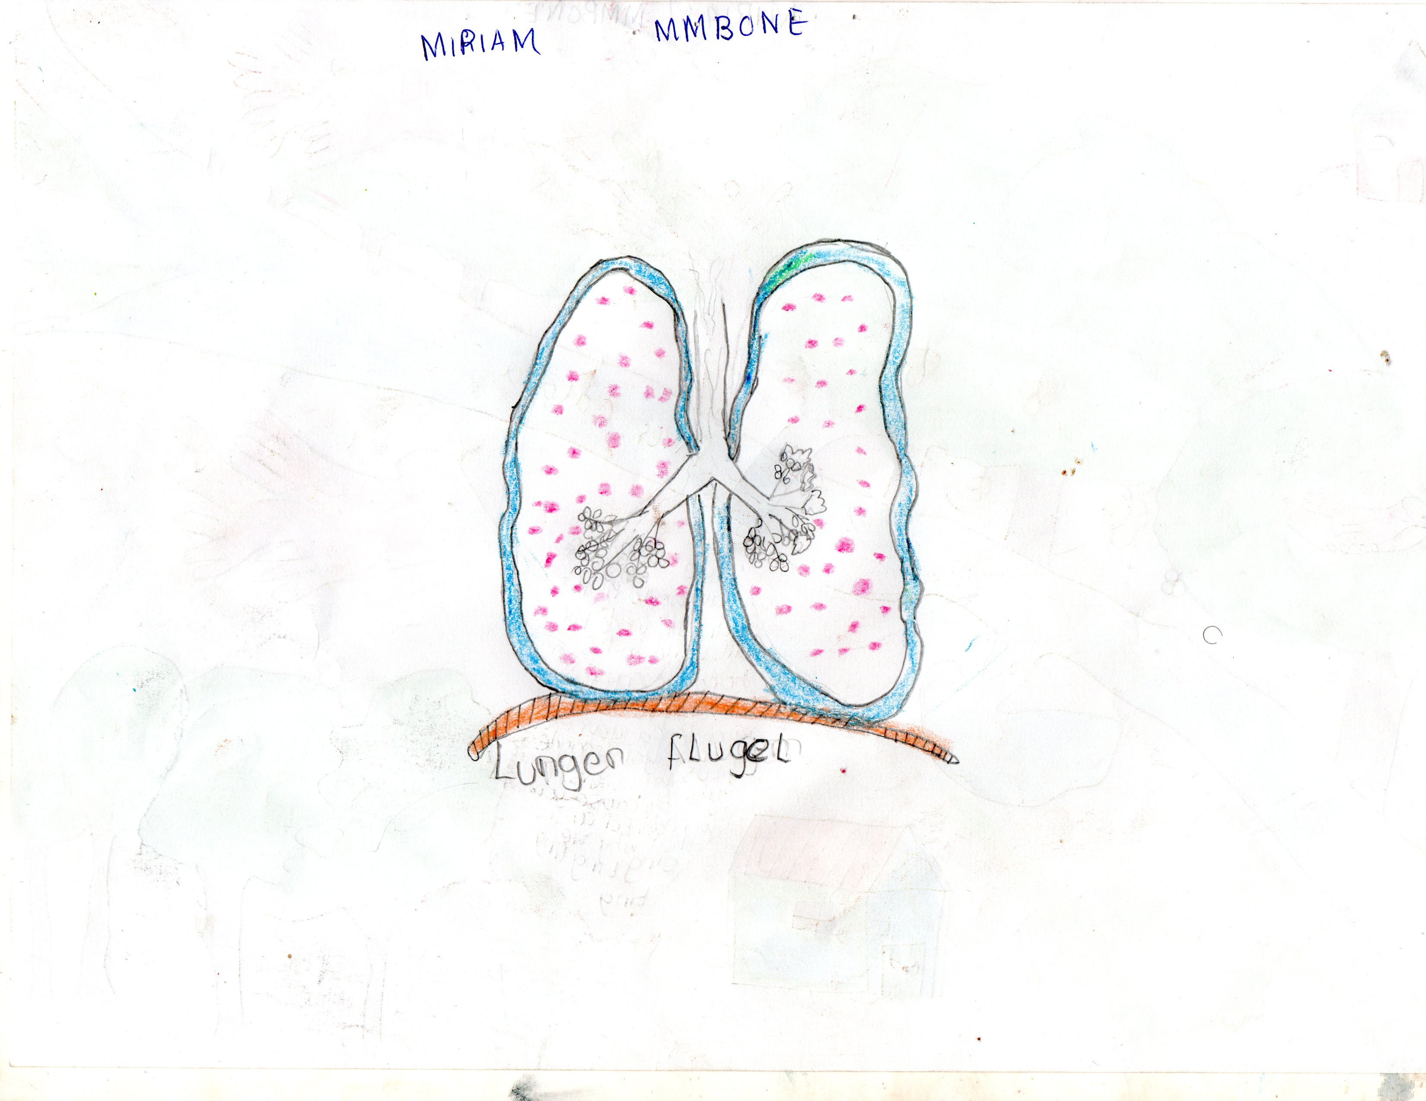
Lungwings“ artwork ©Miriam Mmbone, Noah´s Ark Academy Maragoli, Kenya 2020

Feather flow exercise
What does it take to hold on before saying something that can cause harm or anger?
Have you experienced „Being out of breath“? What was the cause? How can you regulate your breathing?
Try respiratory exercises with a feather; use an imaginative feather for a short meditation.

A conscious breathing exercise with a feather by playing alone and with a partner or with a group of people: blowing the feather from palm to palm, sending and receiving it, blowing away and following its path can help regulate breathing, inspire bodily movement in flow, enable playful moments with an impact on wellbeing.

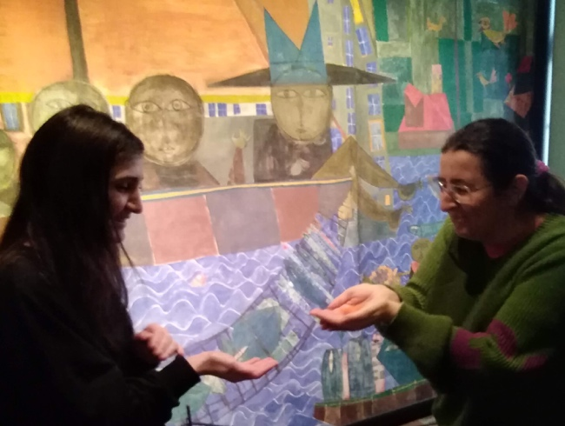
Featherflow acts ©Tatjana Christelbauer

  - How is breathing functioning while sleeping?
Let us first gain some insights into how the breathing cycle works from the scientific-anatomic perspective and then do some experiments.

1. Step: Watch the video/ listen to Mr A´r´s song for teaching respiratory system
Source: https://www.youtube.com/watch?v=LWWzXYWvn84&t=74s
2. Step: create your own song, draw breathing organs, reflect on your breathing capacities, and research more about the respiratory system by your interests.

Task:
To measure the respiratory rate, count the number of breaths for an entire minute or count for 30 seconds and multiply that number by two.
What is the result?
Share & compare with your schoolmates
Are you mostly breathing through your mouth or through your nose? Are you snoring while sleeping?
What are the causes of snoring? What do you do if someone is snoring in your room?
Read more about by sleep foundation: https://www.sleepfoundation.org/snoring

Talk about other breathing disorders.
Think about the Pandemic and the wearing of masks: how was your experience with breathing through?
Read more about the importance of nasal breathing, and try some exercises with nasal breathing.
Try to practice it daily before going to sleep for a week or two and observe if the practice of nasal breathing has effects on the quality of your sleep flow. Source: https://somnomed.com/en/the-importance-of-nasal-breathing/

EXTEND Experience:
Can you see your breath?
Do some experiments, take pictures, share your „breath“ image with your schoolmates, and create an exhibition connecting scientific insights with your artistic creations on the breathing system.
See some examples: Breath Made Visible is the first feature-length film about the life and career of Anna Halprin, the American dance pioneer who has helped redefine our notion of modern art with her belief in dance's power to teach, heal, and transform at all ages of life.
Source: https://www.youtube.com/watch?v=2KQnWkdgvsU&t=9s

Workshop 3:
- Diving deeper into the science & art of the sleep-wake cycle
Night & Daydreaming

Objective: Understanding the difference between rituals & routine, exploring the sleep-awake cycle with art & creative methods, exploring the effects of light on our sleep-awake cycle


Source: Wiki Commons

- Light effects on sleep-awake cycle
What impact may light have on your sleep quality and mood when you awaken?
Compare the effects of electric and artificial light with the effects of natural light provided by the awakening and mood during the day.
Research more about the effects of moonlight and sunlight on the human sleep-wake cycle and moods:
Effects of light on human circadian rhythms, sleep, and mood (Web article)
https://www.ncbi.nlm.nih.gov/pmc/articles/PMC6751071/
NASA: Moon: https://www.nasa.gov/mission_pages/moon/main/index.html
NASA: The Moon and Human Health: https://www.nasa.gov/feature/the-moon-and-human-health
NASA: Lunar Reconnaissance Orbiter: https://www.nasa.gov/mission_pages/LRO/main/index.html
ESA: Lunar Resources: https://www.esa.int/Science_Exploration/Human_and_Robotic_Exploration/Lunar_resources
ESA: Lunar Gateway: https://www.esa.int/Science_Exploration/Human_and_Robotic_Exploration/Exploration/Lunar_Gateway

Compose a presentation with your findings, engage in a project, or start a project on the topic of light and its impact and effects on human circadian rhythm, sleep, and mood.

Task: Watch the Aurora Borealis: Northern Light, Iceland, and research about northern lights and how they appear. There are many videos with Northern Lights that are relaxing. How do you find this phenomenon? What is the cause of this phenomenon? Find out, do research.
How do you describe Northern Light to blind people? Make a trial, compose a text, share it together with the image/video, and add #screenreading #imagetotext – hashtag.
Use the NVDA program to convert images to text for screen readers, or just think creatively and describe the Aurora Borealis. Such a trial can help you improve your storytelling skills and widen your visual perception when looking for details.
Source for NVDA: https://www.youtube.com/watch?v=49EYkrVRgzw
Sources for research: reading, watching, listening, reflecting on your own experiences.
Listen to the article by Sleep Foundation:
https://www.sleepfoundation.org/bedroom-environment/light-and-sleep

  - Moonlight & Sunlight
According to US National Aeronautic Space Agency, without the Sun, there would be no moonlight, no full or crescent moons, no lunar eclipses. What effects would it have on our life?
Tasks: Learn more about moonlight and sunlight from the space science, read articles on the NASA & ESA webpages, make a presentation about and create some artwork inspired by the topic, compose a music piece, create dance choreography, write a story, … :
https://moon.nasa.gov/moon-in-motion/sun-moonlight/moonlight/
https://moon.nasa.gov/moon-in-motion/sun-moonlight/solar-wind/
https://www.esa.int/Science_Exploration/Space_Science/Solar_Orbiter/Zooming_into_the_Sun_with_Solar_Orbiter

- Lunar Cycle, gender perspective

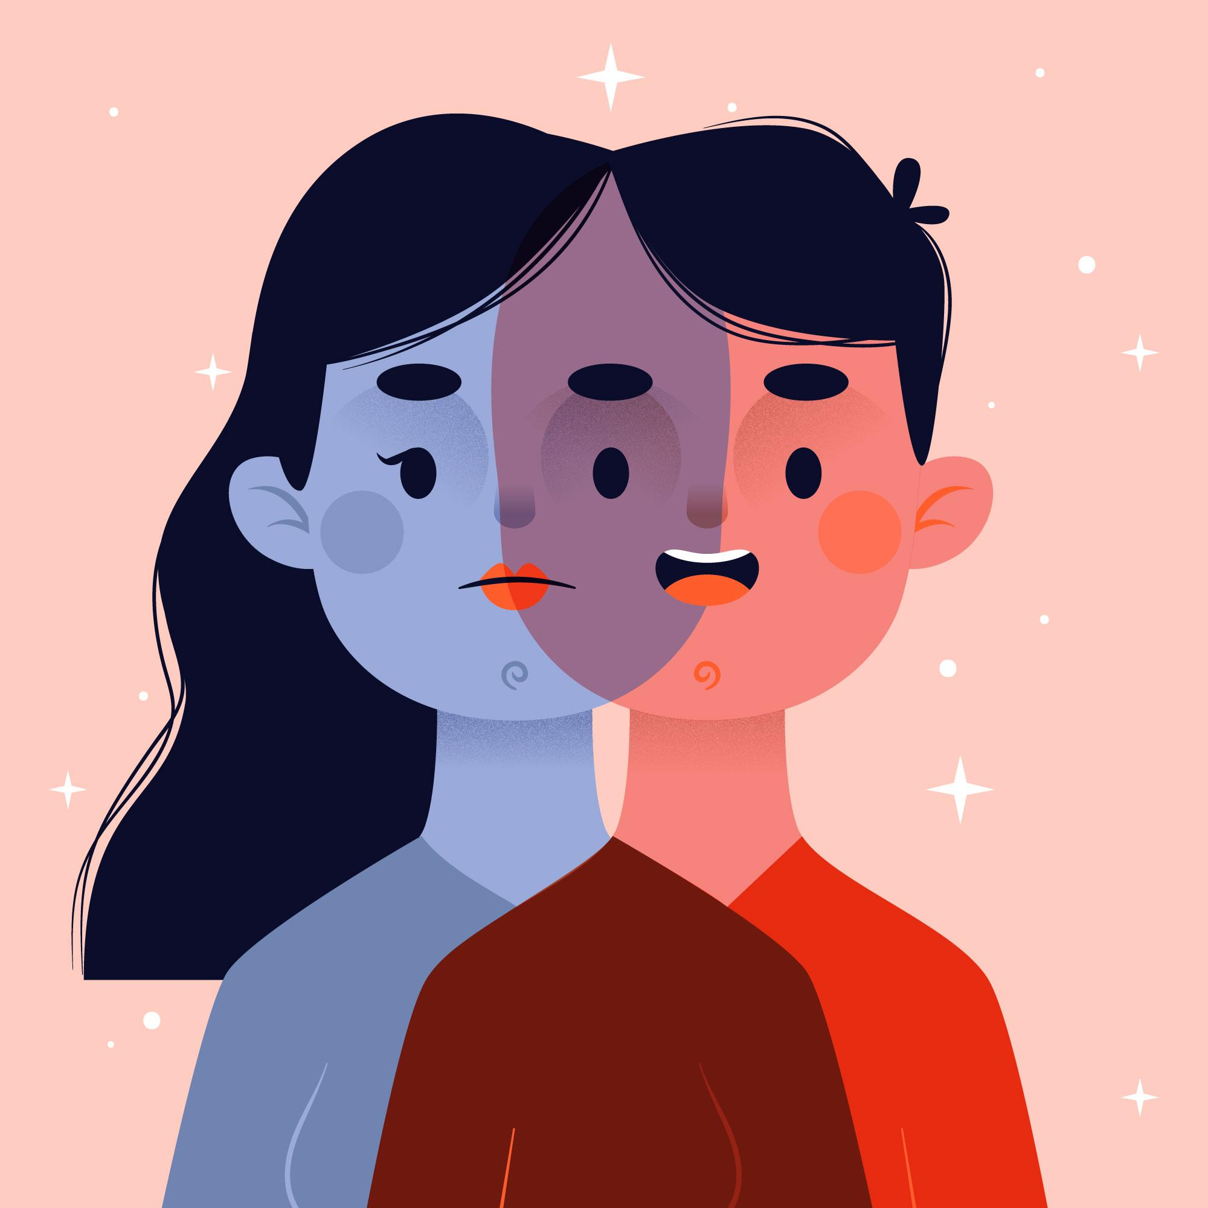
image source: <a href="https://www.freepik.com/free-vector/gender-identity-concept_7973904.htm - query=gender diversity&position=13&from_view=keyword&track=ais">Image by pikisuperstar</a> on Freepik

2.1. Lunar cycle, gender-specific findings
The moon plays a crucial role in the cyclical rhythms of nature.
Understanding the cyclical nature of the moon can also help us optimise our daily routines for better sleep, increased productivity, and a more resilient mindset. How it matters to you? Reflect on your experience, exchange with your fellow learners

ENGAGE:
Read the findings from a scientific study on poor sleep quality:

The Sleep Quality and Duration in European Adolescents study aimed to assess the perceived sleep quality and duration of 1717 European adolescents from three different European countries (Spain, Iceland and Estonia) aged 13- to 16 years (900 boys, 817 girls).
The study found poor sleep quality in 44% of the boys and 53% of the girls, whereas 68% and 69%, respectively, did not get the recommended hours of sleep (i.e., 8–10 h). No difference was found between adolescents from Estonia, Iceland and Spain regarding sleep duration. In contrast, Spanish and Estonian adolescents reported higher probabilities of having poor sleep quality. Finally, girls had a significantly higher probability of poor sleep quality than boys. Sex and age are shown to be determining factors that can considerably modify sleep quality results.
Source: Children Basel cross-sectoral study: https://www.ncbi.nlm.nih.gov/pmc/articles/PMC7999763/
Task1:
In light of the study results, reflect on your experience with sleep quality and your gender, and exchange your experiences and observations with your schoolmates. What do you think about gender, sex, and age as determining factors in sleep quality? How does it differ when you consider cultural diversity? What else can influence the sleep quality?
Exchange ideas, do research in your school, create a questionnaire with clusters that include gender and other categories you find relevant and evaluate your findings simply by calculating the per cent of F/M/other responses to your questions.
Useful tools for the creation of your questionnaire and the evaluation can be found here for the guide:
https://www.ispringsolutions.com/blog/8-ways-to-assess-online-student-learning - peer-evaluation-and-review
Enjoy the journey, and make a final statement together with your schoolmates on relevant findings from your research related to gender and connected categories (such as cultural background, economic status, etc.) as relevant and determining factors for sleep quality.

Task2:
Read the excerpt from the scientific article. Discuss the effects of the lunar cycle on mood with your colleagues, and exchange your experiences while referring to the gender-specific findings in the article below.
The lunar cycle has been known to affect women's menstrual cycle due to the synchronisation of the two cycles. This is because the moon's gravitational pull affects the tides and the water in our bodies, including the fluids in the reproductive system. Research has shown that during the full moon and new moon phases, women may experience changes in their menstrual cycle, including more intense cramps and heavier bleeding.
Moreover, the lunar cycle has also been linked to changes in mood and energy levels. Studies have shown that women may experience more intense emotions during the full moon phase, including heightened anxiety, depression, and irritability. On the other hand, some women may feel more energetic and creative during the new moon phase.
Research has shown that men may also experience changes in mood and behaviour during the full moon phase. Studies have found a correlation between full moon cycles and an increase in hospital admissions for behavioural issues, including aggression and violence.
Source: (Komada Y, Sato M, Ikeda Y, Kami A, Masuda C, Shibata S,2021) https://www.ncbi.nlm.nih.gov/pmc/articles/PMC8003924/

Make inquiry, observe your mood by full moon, just become aware of possible influence of the full moon on yours or someone else’s emotional state.

- MoonArts
How is the moon presented in arts?
Search for artworks inspired by the moon
Task: Listen to Ludwig van Beethoven's Moonlight Sonata, which captures a moonlit night's peaceful and introspective mood. How do you experience this composition? How does it affect your mood and emotional state (sleepy or wake, dreamy, …)? Get inspired, and create your artwork inspired by moonlight sonata, moon, sun or another light source. Invite your schoolmates to create an art performance inspired by the moon.
https://www.youtube.com/watch?v=4Tr0otuiQuU

Explore the Lunar effect in art. Do you know about the Moonwalk dance style?
Have you listened to classical music compositions inspired by the moon?
Find some, listen, and make notes about how it influences your mood. Watch a short video composed of images of the moon taken with your smartphone. Create your own moon-movie, -sketch, poem, …
Video source: https://www.youtube.com/watch?v=lGbJIXwtsAM

Night & Daydreams

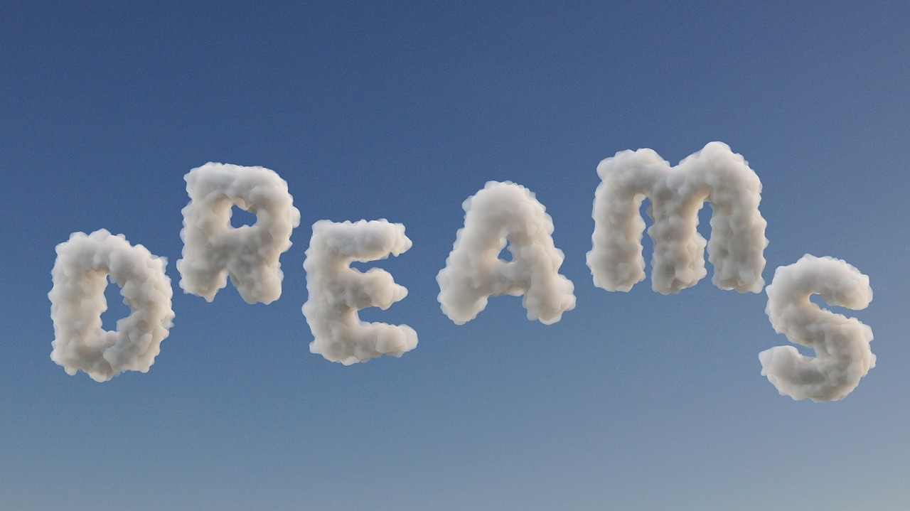

Read or listen the article, to gain some insights in dream state from the scientific perspective:
https://www.sleepfoundation.org/dreams
Watch/listen further videos:
Why Do We Dream? What Exactly are Dreams? World of Science
https://www.youtube.com/watch?v=knU5iVY8P8k;

Dreams- science documentary:
https://www.youtube.com/watch?v=0mKJm_Dstgk
How do blind dream video:
https://www.youtube.com/watch?v=uLKZ59OScQM
Read more about daydreaming: https://www.opencolleges.edu.au/informed/features/mind-wandering/

“I have always been a great dreamer. In dreams, I have always been more active
then in my real life,
and these shadows sapped me of my health and energy.”
Hermann Hesse
Featured in: Real Quotes, Hermann Hesse Quotes

Have you experienced daydreaming?
When? Reflect on your experience, exchange with your schoolmates. Collect images or notes on daydreaming places.

Task: watch/listen to videos on daydreaming science and practices, reflect on your experiences, exchange with your fellow learners, and create together a video talk, podcast, or poster with the benefits & challenges of daydreaming
1. TED ed: „The benefits of daydreaming“ by Elizabeth Cox on the science of daydreaming through the mind of a teenager: https://www.youtube.com/watch?v=oiAQlDBJ88U

2. TED talk „Daydreaming: The Bridge between imagining and creating” by Aimee Mullins
https://www.youtube.com/watch?v=g_rKE_AWUW0
3. Maladaptive daydreaming by Psych2go: a type of daydreaming that can interfere with your ability to carry out daily tasks, including your academics, work, and other regular activities. It occurs in people’s lives who have suffered from severe trauma. Daydreaming can be harmless, creative, and fun. But, too much of anything … can also have opposite effects. https://www.youtube.com/watch?v=VxVOuCg-NG0

Sources for further reading & research:
Watch the movie and video essay „The Secret Life of Walter Mitty” -
Task: have you experienced such a challenge in your life? Could you imagine overcoming some barriers and difficulties when practising a „daydream” as a tool for empowerment? Exchange your opinions and experiences about with your schoolmates.
Video Essay: The Secret Life of Walter Mitty pt.1
https://www.youtube.com/watch?v=C6twD25MRVk
Web article “Why daydreaming is good for you” by Time magazine: https://time.com/6256541/why-daydreaming-is-good-for-you/
Positive and negative effects of daydreaming by Everyday Health webpage article: https://www.everydayhealth.com/emotional-health/positive-negative-effects-daydreaming/
Nightmares: https://www.sleepfoundation.org/nightmares
Sleepwalking: https://www.sleepfoundation.org/parasomnias/sleepwalking
Web article “What do blind people dream” by sleep foundation:
https://www.sleepfoundation.org/dreams/can-blind-people-dream#:~:text=A%20dreaming%20blind%20person%20experiences,View%20Source%20and%20more%20nightmares
Science article, maladaptive daydreaming: https://www.sciencedirect.com/topics/psychology/maladaptive-daydreaming

EXTEND

Sleep-Awake Diary,
Before starting with further activities, create your sleep-awake diary to make notes during this lesson as your own evidence and the assessment, as well as a source for exchange with your schoolmates. A sleep-awake diary may help you to identify patterns in your sleep. Try keeping it for one week and see if you can notice how your sleep-awake cycle works and if any improvement is needed. The scientific study of sleep is called Somnologie. The subset of the Somnologie is the Sleep medicine, a study on disorders and irregularities of sleep.

Create some personalised title and the cover for your sleep-awake diary

How it works:
Download the Sleep Hub to get some inspiration: https://thesleepcharity.org.uk/wp-content/uploads/The-Teen-Sleep-Hub-eBook.pdf
Download the diary for teens (Pdf) here: https://thesleepcharity.org.uk/wp-content/uploads/The-Sleep-Charity-Teens-Sleep-Diary.pdf
Or create your own S-A-notebook, use the Sketchpad https://sketch.io/sketchpad/
Use some other digital tools, create a video, make your own creations

The composition of the following questions can serve as a guide for individual reflections on habits connected with the sleep-awake cycle, which can be followed by group discussions, with the aim to gain deeper awareness on “what matters and why” and how can the sleep-awake cycle be improved.

Questions for individual reflection on circadian rhythm – sleep-awake cycle
- What makes you feel tired during the day?
- How do you recognise “being tired”: is it what symptoms of your body?
- What do you do when feeling tired?
- Your sleep-awake rhythm in hours:
  - How many hours do you usually spend sleeping?
  - do you have any experiences of sleeping disorder?
If so, what do you do to improve your sleeping rhythm? Please share your experiences in 3-5 sentences:

- What makes you energized and awake, and what makes you relaxed?

- What makes you stressed?
How do you manage it to come down from stress and prevent such conditions?
Please share some of your experiences and good practices.

Summarise your findings and exchange them with your teacher and schoolmates.
Ideate: Explore the assumptions and develop new ideas together on how circadian rhythm can be improved by applying exchanged good practices. Look for further advice with your local experts. Investigate and detect the main challenges connected with existing disorders in a sleep-awake cycle with your colleagues.
Prototype: begin to develop solutions create a prototype for optimisation, such as a tool for better sleep and/or short breaks for rest
Test: Experiment with your solutions, within a week-long project

References for further readings:
Sleep, rhythms & school routines Web article by IBE Science of learning portal
https://solportal.ibe-unesco.org/articles/sleep-rhythms-and-school-routines/
https://www.sleepfoundation.org/wp-content/uploads/2023/01/7-Night-Sleep-Habit-Builder-Guidebook.pdf?utm_source=Klaviyo&utm_medium=email&utm_campaign=Introduction&utm_id=RatwLk&utm_kpi=01H0MPD39Z9F37EG1N0DRTJ98M&_kx=_FvZHLxCujV1SCd46obnzNY-iZK4IUjpqpiUC5JH3PqV2FSGC34T11qqbSxds8PS.TKJEB5

Web article: Effects of light on human circadian rhythms, sleep and mood
https://www.ncbi.nlm.nih.gov/pmc/articles/PMC6751071/
Mattress quiz: https://www.sleepfoundation.org/mattress-quiz
NASA: Moon: https://www.nasa.gov/mission_pages/moon/main/index.html
NASA: The Moon and Human Health: https://www.nasa.gov/feature/the-moon-and-human-health
NASA: Lunar Reconnaissance Orbiter: https://www.nasa.gov/mission_pages/LRO/main/index.html
ESA: Lunar Resources: https://www.esa.int/Science_Exploration/Human_and_Robotic_Exploration/Lunar_resources
ESA: Lunar Gateway: https://www.esa.int/Science_Exploration/Human_and_Robotic_Exploration/Exploration/Lunar_Gateway
ESA: Moon Village: https://www.esa.int/Science_Exploration/Human_and_Robotic_Exploration/Exploration/Moon_Village
ESA: A peek behind the lunar curtain: https://www.esa.int/Science_Exploration/Space_Science/The_moon/A_peek_behind_the_lunar_curtain
A critical blog post by Healthline titled "How the Moon Affects Human Behavior" which discusses the potential effects of the lunar cycle on mood and behavior, including those related to menstrual cycleshttps://www.rmg.co.uk/stories/topics/can-moon-affect-our-health-behaviour
Read the scientific studies: https://www.frontiersin.org/articles/10.3389/fped.2016.00024/full
https://www.science.org/doi/10.1126/sciadv.abe0465
The Secret Life of Walter Mitty | Overcoming Maladaptive Daydreaming
https://www.youtube.com/watch?v=Kj5XR32zs7E
ESA
Day, night & the seasons
https://www.esa.int/kids/en/learn/Lessons/Day_night_and_the_seasons
Moon
https://sci.esa.int/web/smart-1/-/31412-moon
Keeping the rhythm in space: circadian rhythm:
https://www.esa.int/Science_Exploration/Human_and_Robotic_Exploration/Research/Keeping_the_rhythm_in_space
Welcoming Hands produced by Louise Bourgeois.
https://www.eutouring.com/images_paris_statues_959.html

EVALUATE

Create summary of your works inspired by insights provided in 3 workshops,
Evaluate novel findings while exploring in your daily life your circadian rhythm, breathing cycle, dreams and daydreams, if your awareness and understanding about could be improved and help you better maintain your sleep-awake cycle, get inspirations from arts and sciences to learn about your dreams and daydreams, breathing and sleeping
Self-assessment tools can be created by each participant.
An art exhibition of collected works in a digital format could be suitable for the evaluation.
Be creative, find your best suitable form to approve your understanding, but also to implement your novel findings in your daily life.

Read more about the Air quality and its importance for human life in a colorful digital book of NASA: https://www.nasa.gov/stem-content/the-air-we-breathe-picture-book/
Source: NASA: Imagine these gases as a cozy blanket enveloping our planet, helping to maintain a warmer temperature than it would have otherwise. Greenhouse gases consist of carbon dioxide, methane, ozone, nitrous oxide, chlorofluorocarbons, and water vapor. Water vapor, which reacts to temperature changes, is referred to as a 'feedback', because it amplifies the effect of forces that initially caused the warming.
Source: Heart Foundation: https://www.heartfoundation.org.nz/wellbeing/managing-risk/how-to-check-your-pulse-heart-rate, https://www.hrsonline.org/
Read more about Featherflow exercises: https://www.tatjana-christelbauer.com/en/featherflight

