Project ID: 2021-1-CZ01-KA220-SCH-000034484
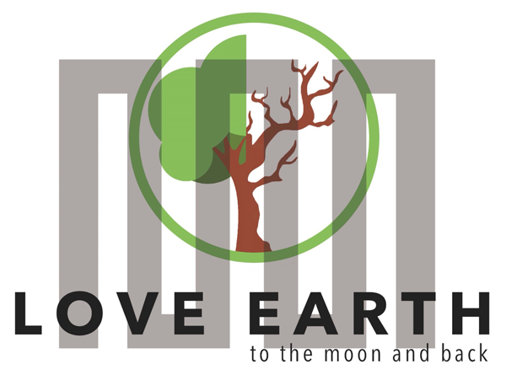

COURSE FOR ENVIRONMENTAL EDUCATION
e-Modules: Teaching Learning activities and their technology enhanced material set to develop

DISCLAIMER

Funded by the European Union. Views and opinions expressed are however those of the author(s) only and do not necessarily reflect those of the European Union or the European Education and Culture Executive Agency (EACEA). Neither the European Union nor EACEA can be held responsible for them.

COURSE AUTHORS
Lubomír Hájek, Petra Garay

COURSE SHARING LICENSE
 | You are free to:  - Share — copy and redistribute the material in any medium or format for any purpose, even commercially.  - Adapt — remix, transform, and build upon the material for any purpose, even commercially.

MODULE 2 | CYCLICAL NATURE
PART 5 | Ultimate source of energy and the form of energy while leaving the  ecosystem
Lesson 1 | Sun- the ultimate source of energy

SUMMARY

1. COURSE TIME, TARGET AND TOPIC 3

2. COURSE OBJECTIVES 3
Competences promoted in this lesson: 3
Lesson objectives: 3

3. LEARNING – TEACHING PROCESSES 3

4. EVALUATION 3

5. DOCUMENTS 4
ENGAGE 4
EXPLORE 5
EXPLAIN 5
EXTEND 6
EVALUATE 8

1. COURSE TIME, TARGET AND TOPIC
- Age of target students: 15+
- Teaching time: 1 hour
- Disciplines: Biology, Geography, Human sciences, Chemistry
- Title: Sun- ultimate source of energy

2. COURSE OBJECTIVES

Competences promoted in this lesson:
- Communication in foreign languages competency
- Digital competency
- Learning to learn competency.
- Initiative and entrepreneurship competencies
- Social and citizenship- related competence
- Cultural awareness

Lesson objectives:
- The students deepen their knowledge regarding the greenhouse effect.
- The students deepen their knowledge about the ecosystem in general.
- They apply the knowledge to practical activities.

3. LEARNING – TEACHING PROCESSES
There are 4 activities in this lesson:
- ENGAGE: discuss with your family members
- EXPLORE: the absence of the ozone layer
- EXPLAIN: the impact of the greenhouse effect on the Earth
- EXTEND: your knowledge on freons

4. EVALUATION
Mind map, Kahoot

5. DOCUMENTS

ENGAGE

Sun as the ultimate source of energy

How does the Sun make its energy?
Nuclear fusion of course! Now, we are not going to go too much in-depth about how nuclear fusion works, because that is a whole other topic all on its own. All you need to know is that the sun is so hot and dense, the atoms inside literally fuse, making new elements and releasing energy, this energy, in the form of light and heat, which then travels through the universe until it reaches the Earth, where some of it gets trapped in the atmosphere by greenhouse gasses. Along with the energy from the sun comes a fusion by-product – UV radiation. However, we are protected by the ozone layer, through which, the majority of UV light cannot pass through.
With this oversimplified explanation of why it hurts to look directly into the Sun, we can now focus of how we humans utilize this energy.

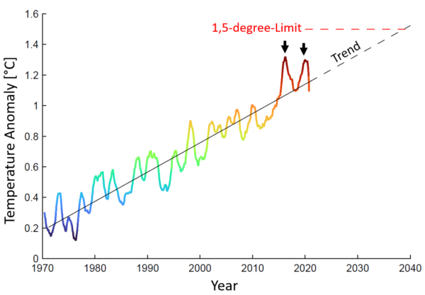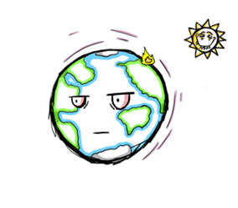
Task: Ask your parents and grandparents whether they noticed any changes in weather since they were young, discuss the changes.

EXPLORE

Protection
Without the Sun, life would not be possible, same as without the ozone layer. It is a layer that protects Earth and creates an atmosphere, which we can live in. What if it would not be there?
Task: Discuss the possible outcomes of the ozone layer being absent.
Watch the video and compare the information to your ideas.
https://youtu.be/Th18q0CFlZY

EXPLAIN

Greenhouse effect

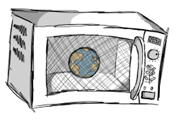
The ultimate source of energy, the Sun, has blessed humankind for a long time, and it plays a key part in a sustainable future. Today we will talk about how humanity and all ecosystems on the planet depend on it. We will talk about how we use the Sun for making energy, how the greenhouse effect works and how it affects us.
- Impacts on ecosystems:

- From 1950 increase in drought and extreme heat.
- Intensity and number of hurricanes is growing.
- According to IPCC sea level will grow up to 61-110 centimetres throughout 21. century
- If in ice cover in west Antarctica and Greenland temperature will grow higher up to 1,5- 2,0 Celsius, ecosystem is going to collapse.
- Famine- with drought and extreme weather we might lose big percent of agricultural soil.

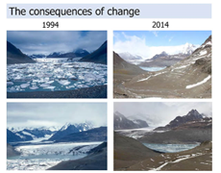
https://sundayguardianlive.com/news/antarctica-ice-melts-global-sea-level-will-rise-50-metres

Study this image to see the changes worldwide
https://images.app.goo.gl/truWHXBeC4az8Agm9

EXTEND

Greenhouse gases
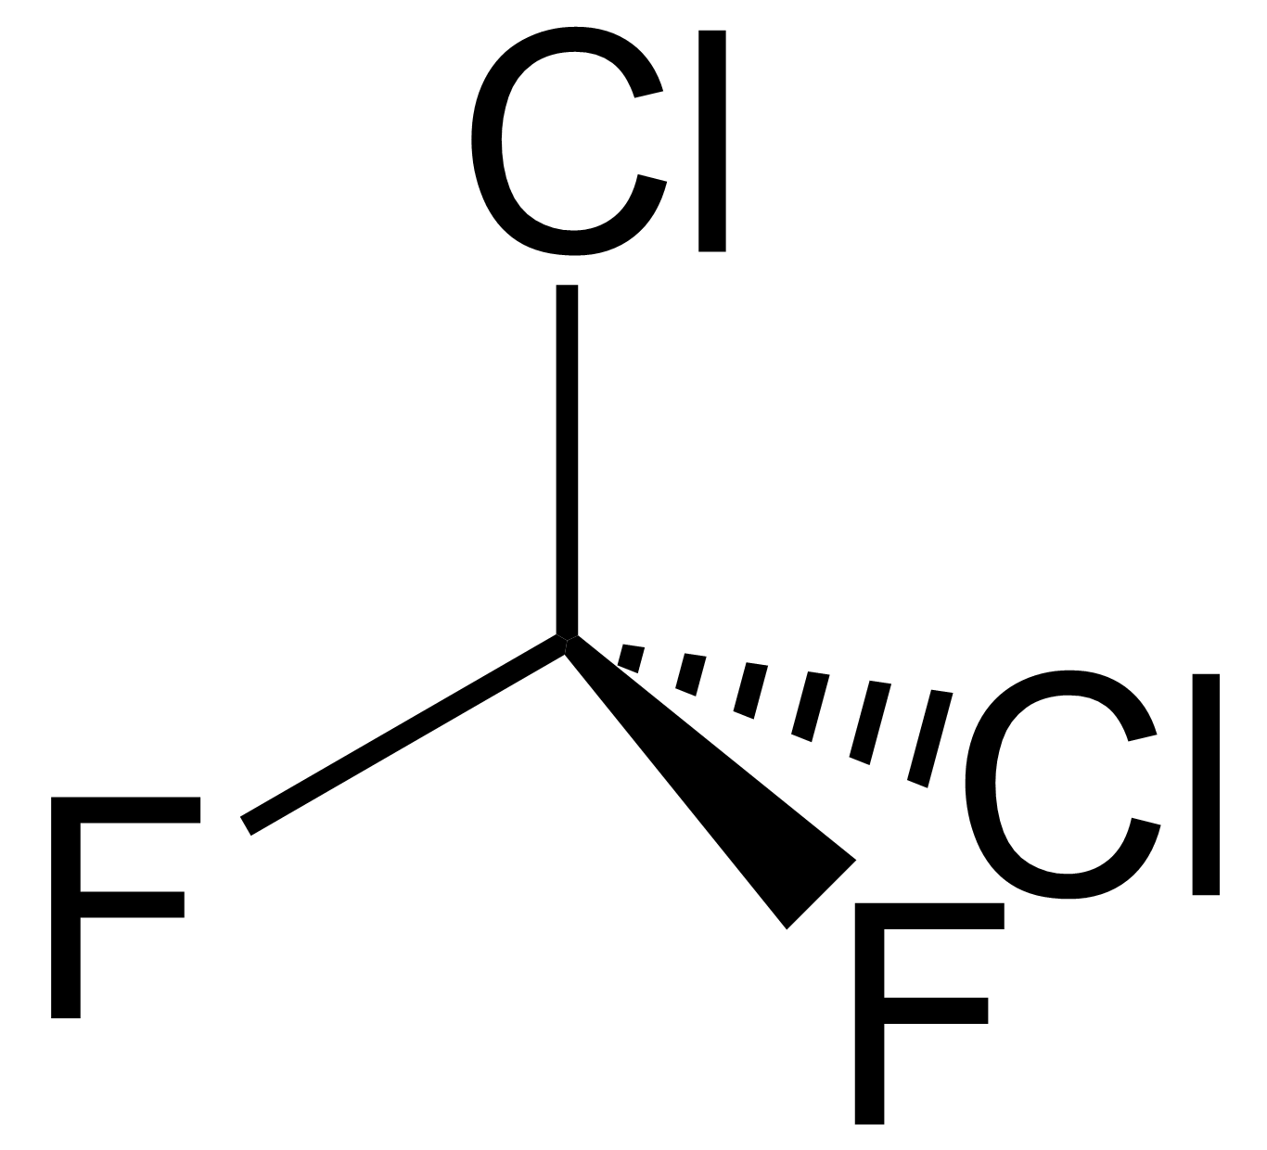
Freon is substance which gives away Cl in ozone layer, and that’s making it less powerful. Freon is one of the greenhouse gasses. It isn´t much toxic for human organism, only high concentration can cause problem with heart or brain. Are we trying to reduce it? We are! In 1985, it was approved (under OSN) convention that binding countries will limit the release of freons into the atmosphere.

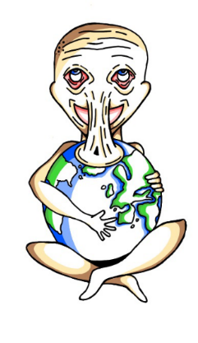

TASK 1: Discuss these questions, search for the right answers:

Additional questions:
- What is a O₃?
- How many degrees is it warmer now than fifty years ago?
- How much of CO₂ is in atmosphere?
- Is there a smog in your city, if yes, what is the cause?
- Describe what photosynthesis is and answer how are flowers, able to make sugar” from Sun light?
- Plant one flower on the sun and one in the shadow and watch what happens.
- Where is the largest/deepest ozone hole?

TASK 2: Discuss these questions, search for the right answers:

Are freons in fridges? Yes/No
Is O₂ waste of photosynthesis? Yes/No
Is every UV radiation dangerous? Yes/No
Greenhouse gases include water vapor. Yes/No
Are cows the producers of methane? Yes/No

EVALUATE
EVALUATION
- Play the Kahoot:
https://create.kahoot.it/share/the-ultimate-source-of-energy/09bf974f-1d5e-41be-99da-783860f7cbc0?fbclid=IwAR2UN_ba1ltQ8qLRZYyHtI2wyI10oyIgi0MVwyls0zIIZZ58hI6qKhxGpZY

- Make a mind map with all the processes you can think of that are depending on the Sun. Discuss how these processes depend on each other.

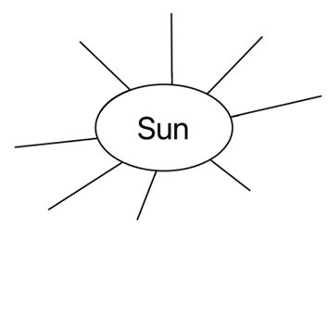

Sources:
https://education.nationalgeographic.org/resource/solar-energy/
https://nigms.nih.gov/education/fact-sheets/Pages/circadian-rhythms.aspx
https://eyesafe.com/bluelight/
https://my.clevelandclinic.org/health/body/22615-melanin
https://atlasbiomed.com/blog/what-is-a-circadian-rhythm/
https://unacademy.com/content/question-answer/biology/the-ultimate-source-of-our-energy-is/
https://pixabay.com/cs/
https://www.mdpi.com/2071-1050/11/22/6400
http://conxcorp.com/understanding-light-pollution/
https://www.medicinenet.com/melanin/definition.htm
https://www.nccih.nih.gov/health/melatonin-what-you-need-to-know
https://cosmofarmaintl.com/wp-content/uploads/2018/02/Melanocyte.jpg
https://www.lifelinecelltech.com/wp-content/uploads/2015/09/FC-0030-Adult-Melanocyte20X.png
https://www.google.com/url?sa=i&url=https%3A%2F%2Fwww.realclimate.org%2Findex.php%2Farchives%2F2021%2F04%2Ftwo-graphs-show-the-path-to-1-5-degrees%2F&psig=AOvVaw2sE_F6NAo7gJXFdE6gfaKL&ust=1681585537791000&source=images&cd=vfe&ved=0CBMQjhxqFwoTCKjL6baIqv4CFQAAAAAdAAAAABAw

