3.2. How to increase students’ engagement through customizable dashboards?
This section deals with Learning Analytics Dashboard (LAD) a new promising tool to engage learners and favour SRL skills. While the first subsection provides a definition of LADs (3.2.1), the second section will provide you with a few guidelines to take the most out of this tool, taking into account that research on LADs is still in its infancy.

3.2.1. What are LADs?
Learning Analytics Dashboards (LADs) are an important subset of learning analytics and refer to the visual representation of the data automatically generated by the system. LADs are data visualisation tools displaying and representing information in a user-friendly way and providing “meaningful and actionable insights at a glance” (Pokhrel & Awasthi, 2021:93).

It is possible to distinguish between teacher-facing dashboards and student-facing dashboards. As Wiedbusch et al. (2021) stress, teacher-facing dashboards are the online data that VLEs platforms show to positively influence teachers’ decision-making in order to foster students’ SRL by providing a holistic overview of students’ behaviour and online trace data.

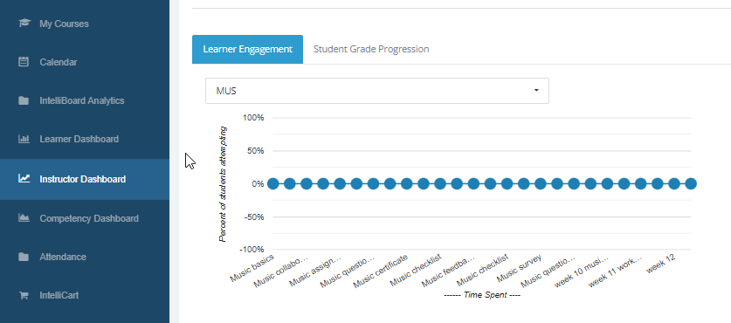
Figure 1. An example of a teacher-facing dashboard. eCreators Academy (2019). Intelliboard: the perfect solution for your reporting and analytics. [YouTube Webinar]. Retrieved from https://www.youtube.com/watch?v=L9owNpjMcPk

Instead, student-facing dashboards are represented by LMS and show students their performance data. Student-facing dashboards are more oriented toward Self-Regulated Learning (SRL) and provide more complex learning process data (CAMM) (Wiedbusch et al., 2021).

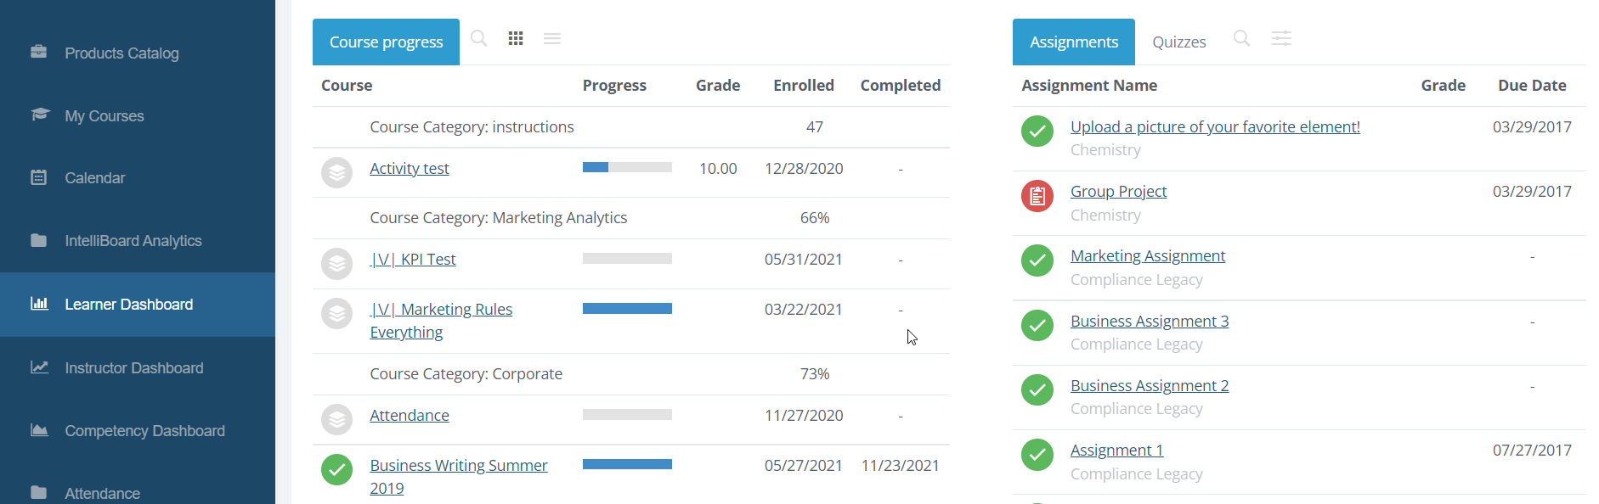
Figure 2. An example of a student-facing dashboard. Screen Capture from the IntelliBoard for Moodle
live demo site: https://moodle.intelliboard.net/login/auto.php

Given that dashboards have the potential of enabling and supporting SRL processes, on the one hand, it is essential to empower learners to actively take part in the feedback process, on the other hand, it is crucial to design effective learning analytics dashboards to improve learners’ SRL skills (Jivet et. al., 2021). Therefore, teachers’ role in this process is crucial because they have to engage learners, turn them into active agents of their own learning and help them introduce and then further reinforce SRL experiences (Wiedbusch et al., 2021).

For more specific information on how dashboards contribute to SRL, please see the conceptual introduction.

3.2.1. Engaging students through LADs
In LAD research, it has been mentioned that students will engage with LADs if they trust the data and understand how they are calculated (de Quincey et al., 2019; Rets et. al., 2021). This implies that teachers have to explain the reasons why students receive a particular recommendation. This will increase students’ trust in LADs and the likelihood of them following the recommendation (Rets et. al, 2021)
In addition, when teachers use LADs, they have to enable learners to plan and organise learning, provide personalised analyses of their learning and adaptive recommendations for study material (Schumacher & Ifenthaler, 2018). In other words, while LAD’s provide numerical feedback on “how students perform”, teachers have to complete this feedback by offering learners guidelines and recommendations on how they can perform better.
The literature (Sedrakyan et al., 2020) has pointed out that the LADs were more appealing to successful students and to those students who pursued outstanding performance. For this reason, it is important that teachers address the needs of both novice and expert learners. To this regard, a common dashboard for all learners is not always the best strategy. It is important to customise it according to learners’ level.
Skilled learners ⇒ to display information related to their achievement is beneficial
Novice learners ⇒to display comparative information related to their achievement can be frustrating and can lead to disengagement. It is important that teachers help them recognise the benefit of monitoring their learning behaviour and that at the same time these quantitative data are not the only way to measure their progress and their skills.
In order to foster learner engagement, customizable dashboards should show:
- Content progress indicators
- The percentage of learning activities completed
- The level of engagement in discussion
- The timing of completing activities
Most of all, as a recent study suggests (Re ts et al. 2021), teachers should set up the “Study Recommender”, which is a tool that reminds students of the learning materials they have missed and represents a direct way to access the learning content.
The next best practice, based on the study by (Jivet et al., 2021) will show the use of LADs as a feedback and engagement tool for students. Additional uses of LAD oriented towards “actionable insights to learners” are presented in Susnjak et al. (2022).

BEST PRACTICE EXAMPLE

Title: Learner Analytics Dashboards (LAD) as feedback and engagement tools for students (Jivet et al., 2021).
University: Erasmus University of Rotterdam
Section of the framework: G - LA generate data on student behaviour
(e.g. Activities for students are created to reflect on their progress of learning and strategies used for learning)
What competencies and learning outcomes of the Dig ompEdu Framework are we addressing?

COMPETENCIES | LEARNING OUTCOMES
Self-regulated learning  Actively engaging learners | PERFORMANCE - monitoring  - To use digital technologies to allow learners to collect evidence and record progress, e.g. audio or video recordings, photos.  - To use digital technologies (e.g. ePortfolios, learners’ blogs) to allow learners to record and showcase their work.  SELF-REFLECTION  - To use digital technologies to enable learners to reflect on and self-assess their learning process.  - To put learners’ active uses of digital technologies at the centre of the instructional process.

Key issues: This best practice regards a dashboard that was integrated in two Coursera MOOCs developed and run by Erasmus University of Rotterdam: a professional development course for higher education teachers on assessment (AHE) and a sustainability course on the role of businesses in achieving the Sustainable Development Goals (SDG). Both courses were in English and self-paced with flexible deadlines.
To begin with, as the authors of the study maintain, learning analytics dashboards (LADs) are feedback interventions designed to increase learner awareness, reflection and ability to self-regulate. However, LADs are passive displays of information and learners are seldom empowered to actively take part in the feedback process. Designing impactful student-facing LADs poses the challenges of selecting meaningful data for learners. Jivet et al. (2021) study addresses this issue and adopts a learner-centred approach by empowering learners to make their own decision about what information they wish to see on a LAD.
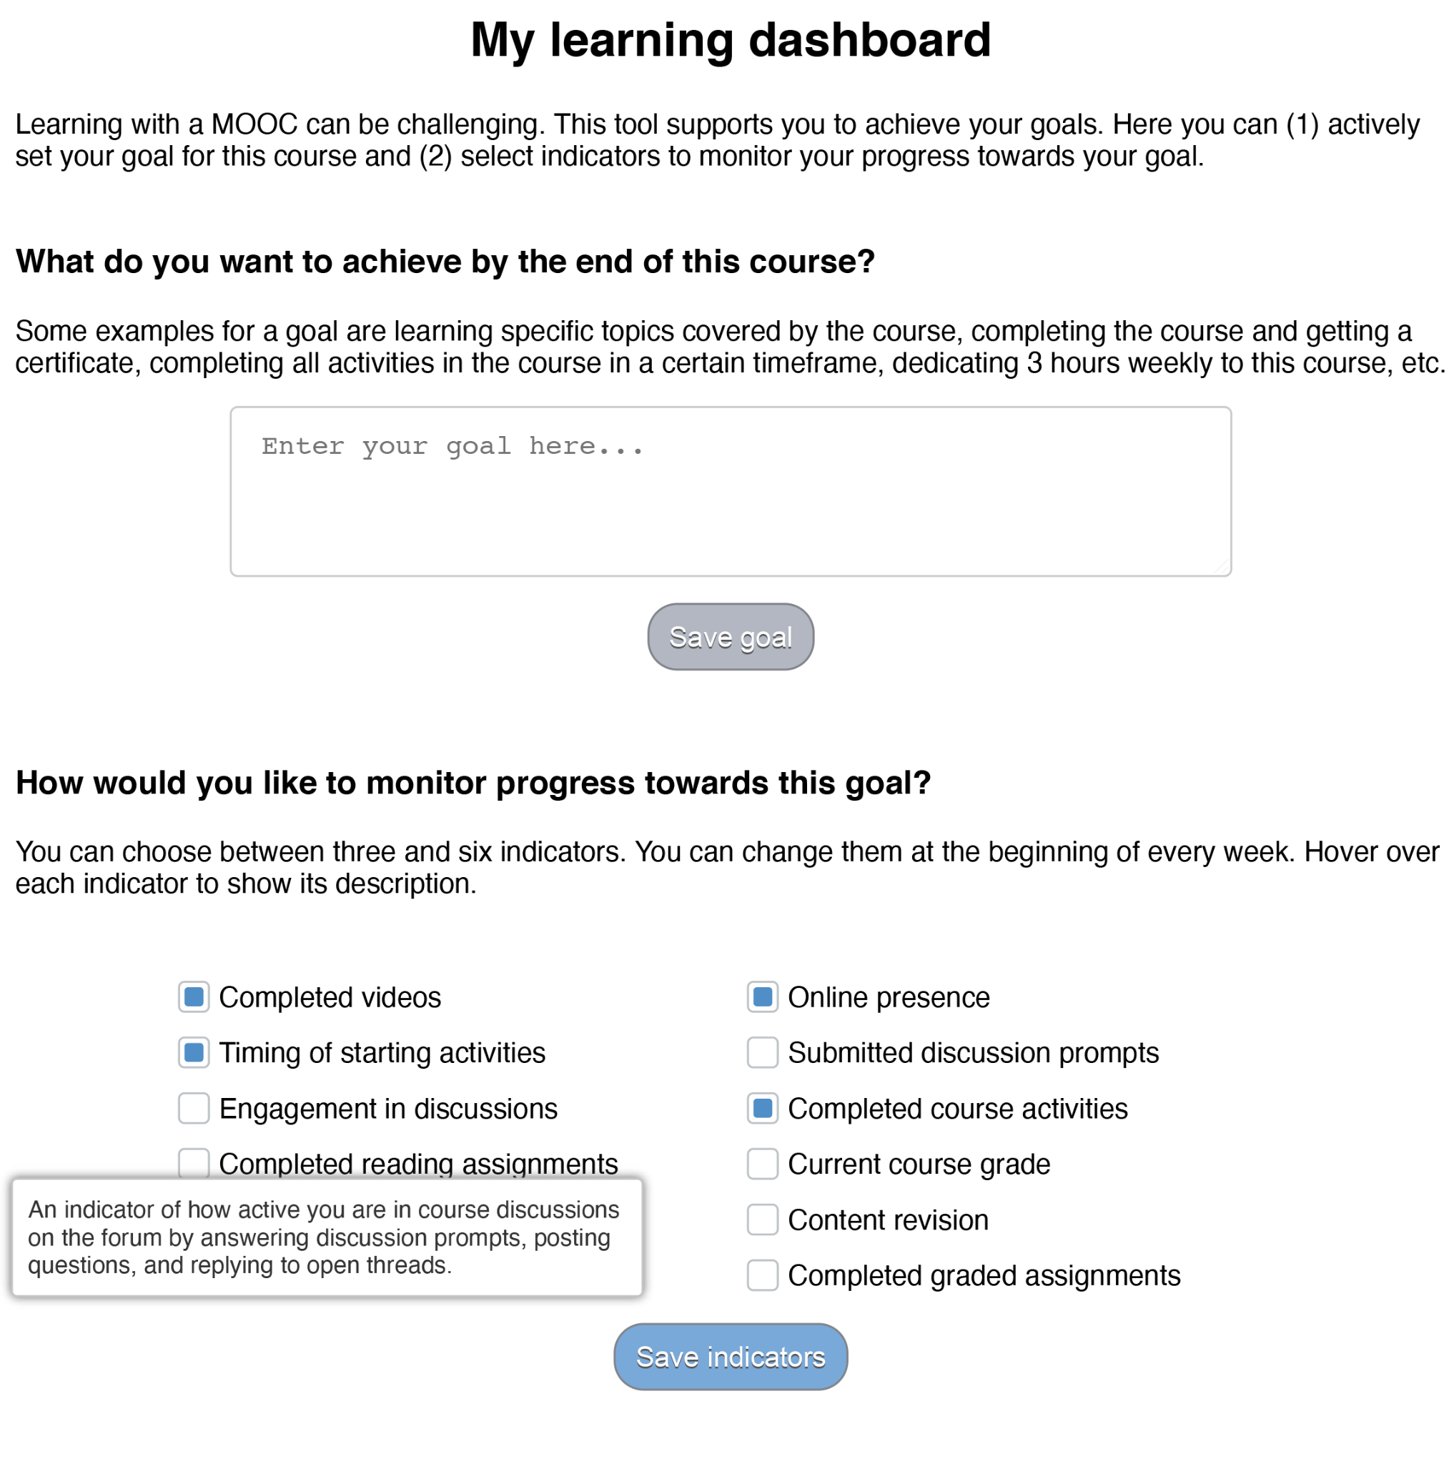
Figure 1. The configurable learning dashboard that greets learners from Jivet et al. (2021), p. 419.
Researchers have built a customisable dashboard on which learners can set goals and choose the information they wish to monitor as part of the process of (self-)regulating their learning towards achieving their goals. The LAD provides regularly updated feedback to learners. Based on the learners’ interactions with the dashboards, the researchers investigated the decisions learners took on the dashboard and the role of learner goals and self-regulated learning skills, two concepts closely connected to how learners process and use feedback.
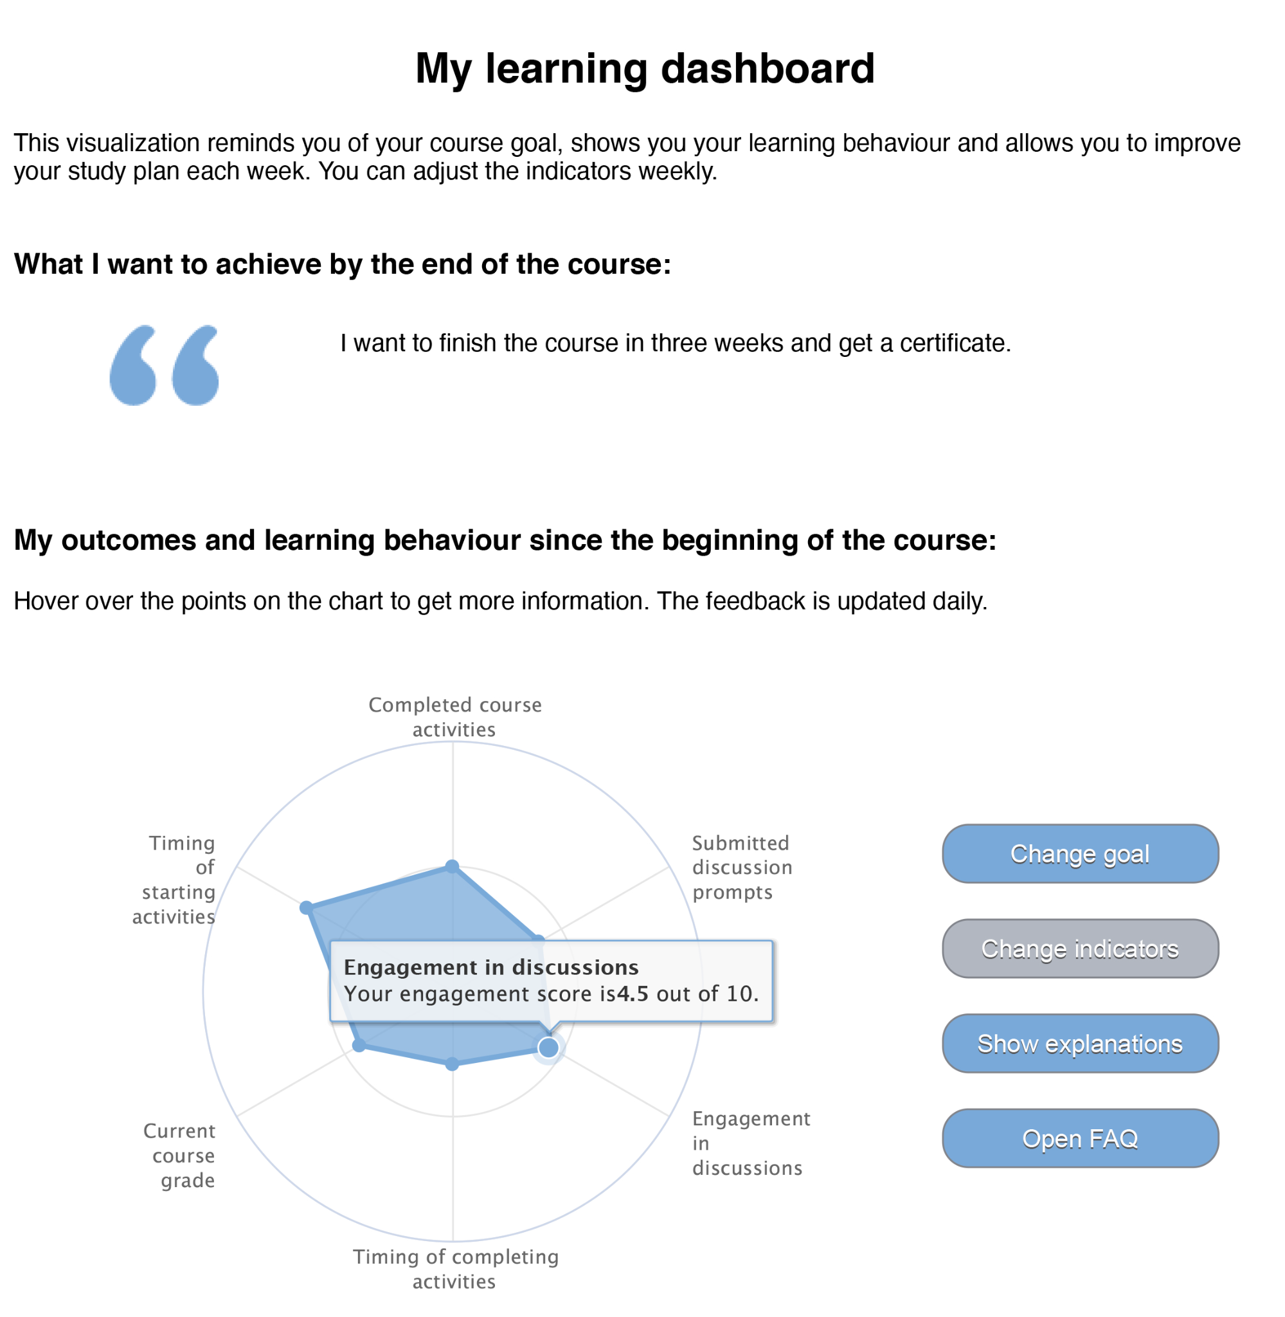
Figure 2. The widget after having been configured by learners from Jivet et al. (2021), p. 419.

This study shows that making LADs customisable for learners and monitoring their interactions with such devices can provide insights on how students use LADs. Learners chose overwhelmingly content progress indicators, focusing in particular on indicators that report on completed learning activities and not the course grade. The most frequent learning behaviour indicator was B3: Productivity, showing the percentage of learning activities completed on the same day on which they were started. When modelling the learning behaviour indicators selection, two insights are of particular interest. Firstly, results show that learners with higher help-seeking skills are significantly more likely to select and monitor B2: Engagement in discussions. Higher help-seeking skills allow learners to recognise their need for help and know where and when to look for it. This suggests that forums are seen as sources of help only by those learners that are skilled in looking for help. Secondly, time management skills and including a time frame in their goal are significant predictors for the selection of B6: Timing of completing activities. All three concepts are related to prioritising and efficiently allocating time to learning tasks. This indicator might provide learners with a cue for checking whether they are still on track and able to achieve their goals within the specified time frame.
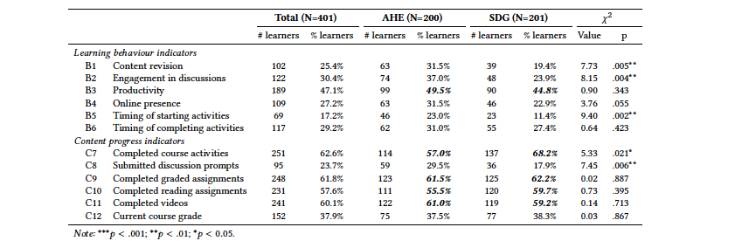
Figure 3. Most commonly selected indicators showing the number and the proportion of learners within each course that selected each indicator. From Jivet et al. (2021), p. 421.

Relevance for teachers: Designing ‘one-size-fits-all’ dashboards puts certain learners at a disadvantage, as skilled learners are more inclined to monitor behaviours associated with higher achievement. Designing impactful LADs need to address learners’ skills levels and also support novice learners in recognising the benefit of monitoring their learning behaviour and use of learning strategies.
Using a customisable dashboard, researchers and teachers collected information that sheds light on learners’ metacognitive processes and self-regulated learning. They could observe the decisions they made with regards to what information they monitor in a learning environment.

REFERENCES

De Quincey, E., Briggs, C., Kyriacou, T., & Waller, R. (2019). Student centred design of a learning analytics system. In: LAK19: 9th Learning Analytics and Knowledge Conference. Association for Computing Machinery, New York, NY, USA (pp. 353–362).

Jivet, I., Wong, J., Scheffel, M., Valle Torre M., Specht, M., and Drachsler, H. (2021). Quantum of Choice: How learners’ feedback monitoring decisions, goals and self-regulated learning skills are related. In LAK21: 11th International Learning Analytics and Knowledge Conference (LAK21), April 12–16, 2021, Irvine, CA, USA. ACM, New York, NY, USA, 12 pages. https://doi.org/10.1145/3448139.3448179

Pokhrel, J. & Awasthi, A. (2021). Effectiveness of Dashboard and Intervention Design. In Sahin, M. & Ifenthaler, D. (eds.), Visualizations and Dashboards for Learning Analytics, Advances in Analytics for Learning and Teaching. Chapter 5, pp. 93-116. https://doi.org/10.1007/978-3-030-81222-5_5

Rets, I., Herodotou, C., Bayer, V. et al. (2021). Exploring critical factors of the perceived usefulness of a learning analytics dashboard for distance university students. Int J Educ Technol High Educ, 18:46. https://doi.org/10.1186/s41239-021-00284-9

Schumacher, C., & Ifenthaler, D. (2018). The importance of students’ motivational dispositions for designing learning analytics. Journal of Computing in Higher Education, 30, pp. 599-619.
https://link.springer.com/article/10.1007/s12528-018-9188-y

Sedrakyan, G., Malmberg, J., Verbert, K., Järvelä, S., & Kirschner, P. (2018). Linking Learning Behavior Analytics and Learning Science Concepts: Designing a Learning Analytics Dashboard for Feedback to Support Learning Regulation. Computers in Human Behavior, 107. https://doi.org/10.1016/j.chb.2018.05.004

Susnjak, T., Ramaswami, G.S. & Mathrani, A. (2022). Learning analytics dashboard: a tool for providing actionable insights to learners. International Journal of Educational Technology in Higher Education 19(12). https://doi.org/10.1186/s41239-021-00313-7

Wiedbusch, MD., Kite, V., Yang, X., Park, S., Chi, M., Taub, M. and Azevedo, R. (2021). A Theoretical and Evidence-Based Conceptual Design of MetaDash: An Intelligent Teacher Dashboard to Support Teachers’ Decision Making and Students’ Self- Regulated Learning. Front. Educ., 19 February 2021. https://doi.org/10.3389/feduc.2021.570229

