2.2. How to make data-informed teaching and learning interventions through reports?
In the learning design phase (unit 1), teachers need to design metacognitive teaching and learning strategies and decide which data will be necessary and important for the analysis. Then, they have to configure and set up the learning environment accordingly before the data are collected. In the teaching and learning phase (unit 2), teachers have to examine the generated data and analyse them. During this phase, they can spot possible learning design problems, identify students who are succeeding or struggling and observe tendencies in accessing learning resources. According to these data, they can make informed decisions and interventions.
Subunit 2.1. introduced a list of Moodle reports that generate data about learners’ engagement and learning progress. As outlined in 2.1, it is important to analyse data at the group/class level and individual student level and data can provide important insights on students’ engagement, learning progress and overall performance. This subunit focuses on generated data that could inform teachers about the teaching and learning interventions needed.
2.2.1. Questions that teacher needs to ask themselves when analysing the data on teaching and learning
Subunit 2.1.1. introduced a set of questions that are important to think about when analysing data on learners’ engagement and learning progress. In this section, we will provide questions related to the teaching materials.
Teachers need to ask themselves relevant questions on what resources are most commonly used, what resources are considered less interesting and what resources students consult on their own initiative (fig. 1). Since learning analytics offer a lot of information on how students approach the learning materials it is important for a teacher to know what kind of questions he/she seeks to answer.
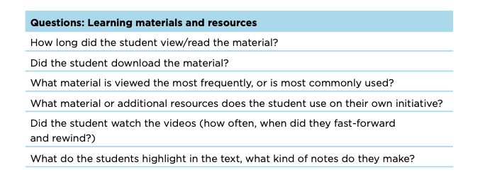
Figure 1. Set of questions to obtain evidence about learning materials and resources (Van den Bogaard et al., 2016, p.8)
2.2.2 Evidence-based decision making on teaching and learning
Activity report
One of the most important reports that teachers need to check (during the semester, at the end of the semester or before starting a new semester) is the Activity report. It shows how many times course activities (resources, assignments, files, etc.) have been accessed. Moreover, it shows how many users (students and teachers) have accessed this resource (fig. 2). This data evidence helps teachers to reflect on learning design, resources and activities. For example, if you notice that an important activity is not accessed by most of the students, you can decide to give more visibility to this resource by changing its label. You can also add an additional description to the resource and make it visible on the course platform, so that students know why this resource is important for their learning or what specific pages or minutes need to be studied. Finally, prompt messages and reminders in the discussion forum are useful to inform students that some materials need to be analysed for the next class. Of course, each student group is different and learning resources that are valuable to one group might be irrelevant for the other. Therefore, you need to be aware of the overall context and you need to take into consideration other reports as well.

Figure 2. An example of an activity report (Tamoliune, personal communication, 2022, BA study course “Open education policy”, Vytautas Magnus University)
This kind of report helps teachers discuss with students what their learning preferences are, which learning formats they prefer to study the most and how the overall learning process should be organised. If you want to include a learning resource that is not accessed by students a lot, you can use it for in-class discussion.
At the same time, you can see how many users have accessed the discussion forum. Of course, this data on its own does not say a lot about learners’ engagement in discussions, but it provides insights that might be useful to rethink strategies for nurturing the discussion.
Finally, you can create a quiz and ask students to give a quick feedback on which course activities they found most useful. Then, you can compare the data and make informed-decisions accordingly.
These reports represent a valuable tool to identify the students who viewed the resources or activities. Nevertheless, this tool is limited to quantitative data and it does not provide qualitative information on how “meaningful” student's engagement and participation were.
Course completion report
The data generated by this report informs teachers and learners on what needs to be done to have this course completed successfully (fig. 3). It keeps students informed on how they should plan their learning and helps them achieve all the compulsory requirements for the course completion. Moreover, this report is connected with digital badges or other digital credentials based on the course completion. Thanks to this report, it is easier to issue a badge automatically after the requirements are met.
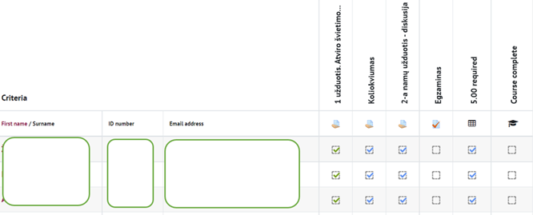
Figure 3. An example of the course completion report (Tamoliune, personal communication, 2022, BA study course “Open education policy”, , Vytautas Magnus University)
At the end of the semester, you can analyse how many students have finished their course successfully and what criteria were not achieved by those who failed. As mentioned before, this report does not provide the overall picture but should be analysed taking into consideration other contextual factors.
Important reminder. The Course completion report can only be accessed if “Course completion” has been specifically configured for the course. It should be configured by a teacher at the beginning of the course, when the teacher sets course completion criteria by selecting which activities or resources are compulsory to complete the course successfully.
Quiz
After students have finished the quiz, you can review the data on learners’ engagement with the quiz and its statistics (fig. 4). For example, you can review how long it takes for students to answer each given question, and then reflect if quiz duration amendments are needed. Similarly, you can observe if there were challenging questions or questions that all students failed to answer. Such data provide valuable information to teachers and help them detect if a student did not prepare well for the exam, if the quiz instructions were not clear or if the question is too complicated and needs to be revised.

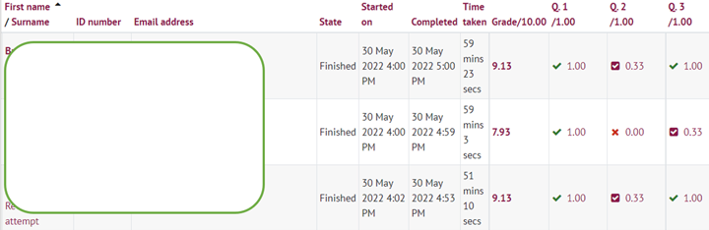
Figure 4. An example of the quiz report (Trepule & Tamoliune, personal communication, 2022, MA study course “Concepts of adult education”, Vytautas Magnus University)
Quiz data analysis can show learners’ behaviour when taking a quiz, so teachers can analyse if a student has accessed any other course or external resource or if any other devices were used. In other words, being aware of learners' behaviour during the quiz time allows teachers to decide how to improve the quiz.
Important! As mentioned in Unit 2.1, it may not always be sufficient to focus on the data from a single report and draw definitive conclusions from it. To draw more objective conclusions about the specific situation or problem under analysis, it is often useful to review and analyse the data generated by different reports and interpret it in a broader context.
References
Van den Bogaard, M., Drachsler, H., Duisterwinkel, H., Knobbout, J., Manderveld, J. & Wit, M. (2016). Report Learning analytics in education design: a guide.

BEST PRACTICE EXAMPLE
Title: LA-based interventions to improve learners’ performance (Oliva-Córdova et al., 2021)
University: Faculty of Engineering, University of San Carlos of Guatemala, Guatemala.
Section of the framework: LA generate data on student – teacher, student – student and student - content interventions
What competencies and learning outcomes of the DigicompEdu Framework are we addressing?
Competencies | Learning outcomes
Self-regulated learning  Analysing evidence  Feedback and planning | - To use digital technologies to allow learners to collect evidence and record progress, e.g. audio or video recordings, photos.  - To use digital technologies (e.g. ePortfolios, learners’ blogs) to allow learners to record and showcase their work.  - To analyse and interpret available evidence on learner activity and progress, including the data generated by the digital technologies used.  - To use digital technology to grade and give feedback on electronically submitted assignments.

Key issues:
This best practice based on Oliva-Córdova et al. (2021), emphasises that learning analytics help answer the following issues:
- How practical is a course?
- Is the course meeting the needs of the students?
- How can the needs of the students be supported?
- What type of interactions are engaging and productive?
To answer these questions, it is necessary to review and assess learners’ learning behaviour, their grades, the drop-out rate and the teacher's reflections at the end of the course. In such a way, LA can help to analyse student-student, student-teacher-student, and student-content interventions.
This best practice shows what kind of data teachers can collect to inform teaching and learning interventions (table 1).
Table 1. Data collecting method in relation to data analysis goal (based on Oliva-Cordoba, Garcia-Cabot & Amado-Salvatierra, 2021, p. 9)
Suggested independent variable / data analysis goal | Data collecting method / data that can be monitored and analysed to learn of the specific variable
Total studying time in LMS | Calculating the total number of hours employed between login and logout.
Interaction with virtual learning objects | Adding up the total interactions reported in the SCORM report of the virtual learning objects.
Interaction in forums/wiki | Adding up the total reported interactions with the forum analytics plugin.
Interaction with learning tasks | Adding up the total number of participants’ task submissions through the submission distribution block.
Learning Performance | Adding up all scores for assignments and assessments in the course.
Communication and feedback | Counting the number of messages and task feedback.
Mentoring | Counting the number of follow-up emails, phone calls, synchronous meetings, and participation in forums of questions.
Learning Design | Counting the number of resources designed for the course, readjusted educational resources, enriched videos, complementary readings, and designed extracurricular activities.
Motivation | Counting the number of motivation messages sent, extracurricular meetings, and game dynamics implemented.
This best practice shows that communication and feedback affect learning performance and that the role of teachers is crucial. They have to design the learning environment properly, they have to be able to manage LA tools, provide timely feedback and monitor learning performance. Students’ performance improves after LA-based interventions made by teachers.
Relevance for teachers:
LA-based interventions regard the content to deliver, the pedagogical strategies selected, the design of the didactic sequences, the type of assessment to choose, the tool to support the design. All these elements should be customizable and user-friendly. LA-based learning design has a direct positive impact on students’ learning outcomes. In other words, when teachers have an active role in learning design, students’ learning outcomes and performance improve.
References
Oliva-Córdova, L. M., Garcia-Cabot, A, & Amado-Salvatierra, H. R. (2021) Application of Learning Analytics in Virtual Tutoring: Moving toward a Model Based on Interventions and Learning Performance Analysis, Applied Sciences, 11, 1085. DOI:10.3390/app11041805

