2.1. How to analyse and interpret available evidence on learner activity and progress to support engagement?
After designing activities to generate and collect data on learners’ engagement and progress (see Unit 1), you need to select the LA generated data that provide the information you need.
In this subunit we will provide you with a set of questions to answer depending on the objectives of the evidence analysis (2.1.1). Then, the next subsection (2.1.2) will deal with the reports that can inform you on how engaged learners are with the learning activities and how data can be used to support SRL.

The possibility to access and analyse LA-generated data evidence should be seen as a solution to provide timely and personalised feedback to support students‘ self-regulated learning (SRL). When feedback is personalised, timely and targeted at developing learners’ SRL, it positively affects students‘ learning and time management strategies.

2.1.1. Questions that teacher needs to ask themselves when analysing the data on students’ engagement

Teachers need to ask themselves questions regarding the type of evidence they want learning analytics to show them.
Van de Bogaard et al. (2016) formulated a set of questions that teachers should ask themselves in each stage of the evidence analysis.
First of all, teachers can use LA to check whether the course documents that provide information on learning outcomes and assessment have been checked (see fig.1).
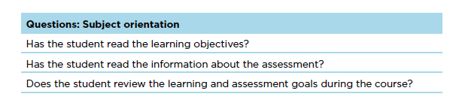
Figure 1. Set of questions to obtain evidence about students checking information on course orientation (Van den Bogaard et al., 2016, p.7)
The next bunch of questions (see fig. 2), regards the way students decide to orient themselves in relation to the training materials. It is also useful to spot the problem of “free riding” (Van den Bogaard et al., 2016: 7).
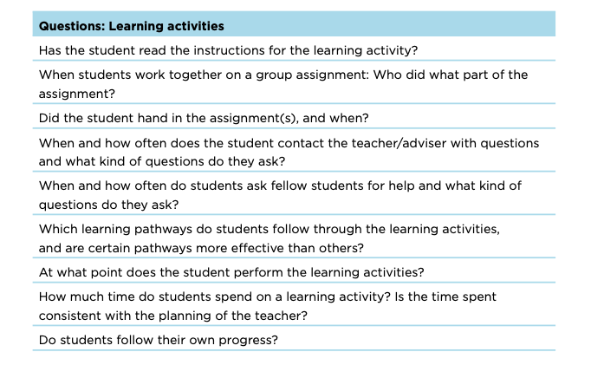
Figure 2. Set of questions to obtain evidence about students and learning activities (Van den Bogaard et al., 2016, p.7)
Learner analytics also allow students to answer many questions related to group work assignments and discussions. Teachers can check both the quantity and the quality of students’ interventions in a forum. The questions to guide them when analysing evidence should be those shown in fig 3.
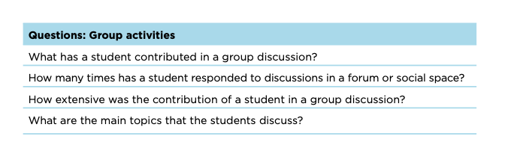
Figure. 3. Set of questions to obtain evidence about students’ participation in group activities (Van den Bogaard et al., 2016, p.8)
2.1.2 Evidence-based data on learner activity and progress
Moodle VLE allows teachers to retrieve multiple reports on the course and activity completion, logs and similar, which keep teachers informed on students’ engagement and learning progress.
To access the reports from the course page, the following instructions should be followed: Administration -> Course administration -> Reports -> Course completion OR Insights OR activity completion, etc. (fig. 4)
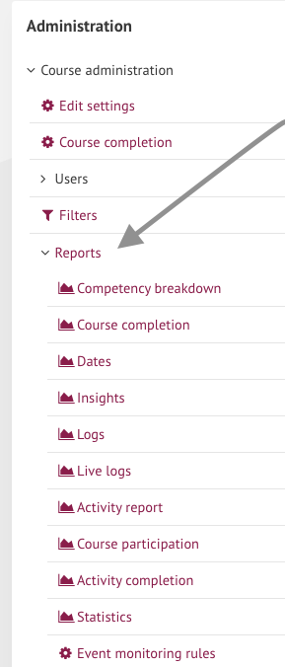
Figure 4. A list of course reports on Moodle
Reports generate visualisations that might be used to support SRL among learners. Number of logs, clicks, forum posts or connection time informs you with quantitative data about learners’ engagement and performance. It gives concrete numbers of access, however, to get a more in-depth understanding of the reasons that affect learners’ performance, teachers are recommended to collect more qualitative data in the form of open-ended surveys, interviews or focus groups.
Analysis and interpretations of these reports allow you to take informed actions to support SRL and students’ engagement. The main reports that can be used for this purpose are listed below:
- Activity completion report
The Activity completion report aids both teachers and students to monitor learning progress in the given course (fig. 5). It helps the teacher observe and assess the extent to which individual students or groups of students are engaging with the single modules, and hence with the course. Activities that are completed are ticked while others remain unchecked. Some assignments, like quizzes, are ticked automatically after a passing grade is achieved.
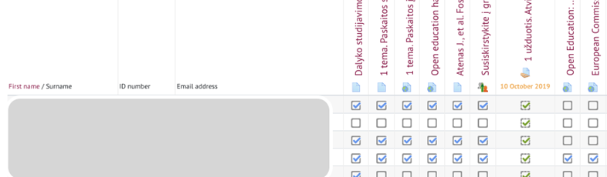
Figure 5. An example of an activity completion report (Tamoliune, personal communication, 2022, BA study course “Open education policy”, Vytautas Magnus University)
Important. The activity completion report can only be accessed if “Completion tracking” has been enabled in the course and at least one assignment, activity, or learning resource is configured in a way to track completion (for more details please check Unit 1).
The activity completion tracker gives students a sense of purpose about their learning, how much they have already covered and how much is left. At the same time, by having the possibility to tick the tasks that are completed or the material that is analysed, students are expected to take responsibility for their own learning and learning success. After checking the completion of an activity or assignment as ‘done’, a completion progress bar is automatically updated. This allows learners to see which activities have not been completed yet and pushes them to complete their work (fig. 6). While learners can see their personal completion progress bar, you can overview the progress of all students, compare it and discuss it with them, ensuring data confidentiality.
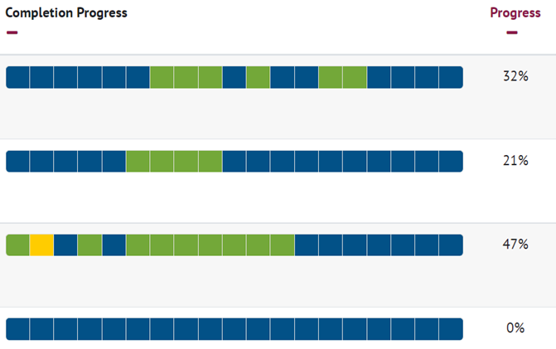
Figure 6. An example of a completion progress overview (Tamoliune, personal communication, 2022, BA study course “Open education policy”, Vytautas Magnus University)
Research proves that even a small intervention implemented in the online course positively affects learners’ course completion (Jansen et al., 2020).
- Course participation report
This report provides information about the students engaged with a particular learning resource or activity in a course. For example, you can analyse whether students have viewed the course resources (e.g., a course study guide), which helps students plan their learning by being aware of the course activities, assignments, deadlines, etc. (fig. 7). Even though students cannot access this report, you can decide to send a prompt email to students who are not fully engaged. In this way, instructional support may be provided based on learning analytics to support self-regulated learning among learners in online learning settings.

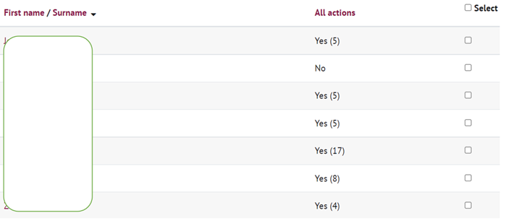
Figure 7. An example of a course participation report (Tamoliune, personal communication, 2022, BA study course “Open education policy”, Vytautas Magnus University)
Similarly, this report may inform teachers about learners’ engagement. For example, when students are asked to read some documents or watch a pre-recorded lecture or any other video before the class, you can check this report and see the students who have accessed the requested resources and those who have not. Based on this data, you can understand if some students are not prepared for the in-class activities and, at the same time, reflect on the possible interventions for learners’ engagement. For example, you can decide to use the forum to send reminders to students on what needs to be done before the next class.
- Logs reports
Logs reports can be analysed to see which activities have been accessed and viewed by which students and when. If you notice that a student is late with a deadline or a group of students is at risk of drop-out or failing, you can analyse a specific student’s activity in the course by selecting a specific date or the overall engagement (fig. 8).
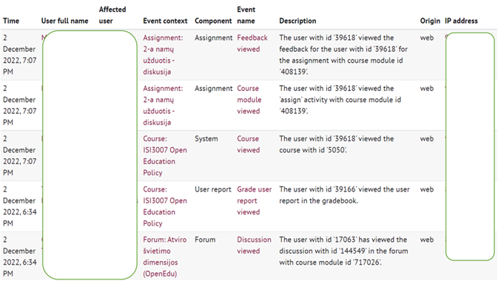
Figure 8. An example of a logs report (Tamoliune, personal communication, 2022, BA study course “Open education policy”, Vytautas Magnus University)
Reports help you identify students who are disengaged with learning resources and/or activities, or who try to deceive the system. However, an activity completion report alone is not sufficient to explain the reasons why students are engaged or not. After you obtain this type of evidence, it is necessary that you discuss the situation with your students. In order to do this, you can use prompt emails, set up an anonymous discussion forum, or check the overall group atmosphere or learning experiences by creating a short survey using an easy-to-access tool (e.g., Moodle Feedback activity, MsTeams forms, GoogleDocs Form, Mentimeter, Kahoot, etc.).

Moreover, the aforementioned examples allow you to make informed decisions on the basis of the resources that the students access most. According to the data that provide information on learners’ behaviour, you can make consequent decisions. For example, if students do not watch or read compulsory learning material, you can start a new discussion topic regarding that particular reading and/or video. Students are invited to share their ideas or create an activity based on that resource that previously they did not access. You can also configure the system in such a way that students are not able to skip to the next topic/unit until they have accessed that specific resource and completed the activity.

To conclude, it is up to a teacher to reflect on the data that is generated and think about how the data may inform teaching and learning.

BEST PRACTICE EXAMPLE
Title: DIANA application project (Cerro et al., 2020)
University: Open University of Catalonia (UOC), Spain
Section of the framework: E - Digital tools used to record, compare and synthesise data on learner progress
What competencies and learning outcomes of the DigicompEdu Framework are we addressing?

Competencies | Learning outcomes
Self-regulated learning  Assessment strategies  Analysing evidence | - To use digital technologies to allow learners to collect evidence and record progress, e.g. audio or video recordings, photos.  - To critically reflect on the appropriateness digital assessment approaches and adapt strategies accordingly.  - To critically value the evidence available to inform teaching and learning.

Key issues:
This is a best practice based on a research study carried out at the Universitat Oberta de Catalunya to design and implement a learning analytics solution for teachers. The aim was to facilitate their access to information for monitoring and assessing asynchronous online discussions, a type of collaborative learning activity in which students interact with each other to jointly construct meanings using dialogue and reflection.

This practice had two main objectives, the first of which was to design a learning analytics tool to analyse students’ communicative interaction online. The second objective was to have teachers implement the tool to monitor and assess asynchronous online discussions and in turn measure the impact of the tool’s use on university students.

In order to accomplish these objectives, teachers received specific training on learning analytics through a teaching guide on the academic use of DIANA 2.0 in the classroom, which improved their understanding of the student learning process. Some of the classrooms’ teachers used DIANA 2.0, allowing their students to be influenced by the personalised feedback that the teacher gave them based on the metrics that DIANA 2.0 reported on the online discussion activity. These classrooms were considered experimental classrooms. The classrooms whose teachers did not use DIANA 2.0 to monitor and evaluate the online discussion activity were considered control classrooms in order to compare the results with the rest of the online classrooms.
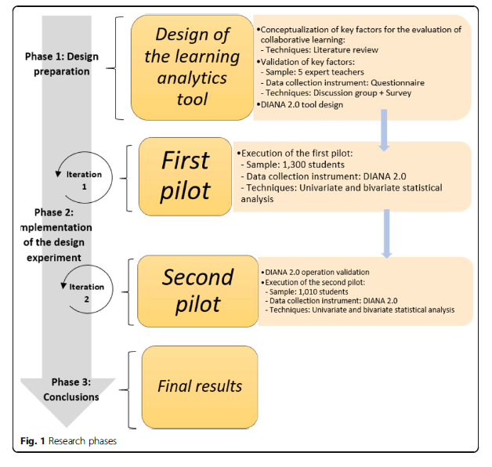
Figure 1. Research phases taken from Cerro et al. (2020, p.5).

If the activity score is compared with the level of participation, a correlation of 68% is obtained, which indicates that those students who interacted more in the online discussion activity were more likely to perform better than those with a lesser degree of participation. The students who scored best in the online discussion were those who not only exchanged a higher number of messages, and with more extensive arguments, but also those who generated the most impact within the conversation through the number of responses received (level of popularity), in comparison with students with a lower grade.

Some of the information produced by learning analytics was used by teachers to understand the learning process carried out by their students. The teachers then used this information to provide and improve the feedback sent to students, complemented by other qualitative information.
As this best practice shows, if teachers are trained on the adequate use of learning analytics instruments, the interaction with students in asynchronous online discussions improves as well. As a consequence, an improvement in individual performance occurs and dropout rates are reduced.

Relevance for teachers:
One of the objectives was to have teachers implement the tool to monitor and assess asynchronous online discussions and in turn measure the impact of the tool’s use on university students. During the pilots’ development, teachers received specific training on learning analytics through a teaching guide on the academic use of DIANA 2.0 in the classroom, which improved their understanding of the student learning process.

References
Cerro, J. P., Guitert, M., & Romeu, T. (2020). Impact of using learning analytics in asynchronous online discussions in higher education. International Journal of Educational Technology in Higher Education, 17(1), 261- 278. https://doi.org/10.1186/s41239-020-00217-y

Jansen, R.S., van Leeuwen, A., Janssen, J., Conijn, R., and Kester, L. (2020). Supporting learners’ self-regulated learning in Massive Open Online Courses. Computers & Education, 146, 103771. https://doi.org/10.1016/j.compedu.2019.103771

Van den Bogaard, M., Drachsler, H., Duisterwinkel, H., Knobbout, J., Manderveld, J. & Wit, M. (2016). Report Learning analytics in education design: a guide. SurfNet.
https://www.researchgate.net/publication/305391568_Report_Learning_analytics_in_education_design_a_guide

